Getting There Together

An overview of the Association’s Short Study Tour to Finland from Sunday 20th to Wednesday 23rd June 2010, by Barry LeJeune.

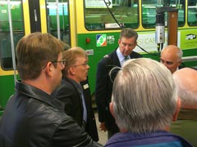
48 RSA members gathered in Helsinki; though, thanks to flight delays and varied personal itineraries, not all made it in time for the informal briefing in the restaurant of the Hotel Arthur on the Sunday evening.
The full party mustered for our first visit on Monday morning – to the Vallila depot of the Helsinki HKL tram company. There we were split into two groups, for a tour of the tram workshops by Petri Norenna, Workshop Manager; and for a presentation by Laurie Rati of Helsinki Regional Transport.
Helsinki has had some unfortunate experiences with their newer trams. The 2007 Bombarbier Variotrams have suffered from wheel/rail adhesion problems, causing heavy wheel and track wear. Tenders are out for a further batch of new trams; but, as a precaution, existing trams are being refurbished for a further ten years’ life. We saw the work in progress. Our visit also fortuitously co-incided with the departure on a low-loader of one historic car, purchased by a tram enthusiast for the sum of one Euro. (Buyer collects!) The contract additionally specifies that the tram must be restored in three years – it is not to become a toilet in the woods, as others have done.

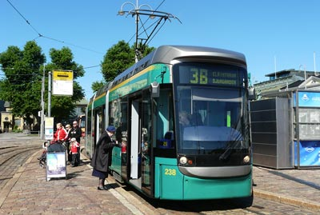
Laurie described the HRT organisation, which has many similarities with a PTE/ITA in the UK. HRT plans, organises and markets public transport in the Helsinki Region, buying in services on gross cost contacts from operators. Cost recovery from fares is 50%. There are plans to extend the Helsinki tram network, into the developing old harbour area and to replace some heavily-used bus services into new residential areas.
There followed a tour of part of the network, including the latest extension, in a private tram.

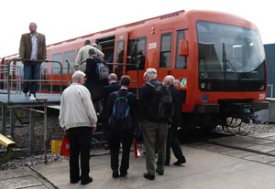
After lunch in the depot canteen, we were taken by coach to the Helsinki Metro depot and headquarters at Itakeskus. Elisa Vanhatalo gave a general presentation on metro operations and plans. The first metro line opened in 1982 and, with later extensions, now consists of a trunk line with two branches. It claims to be the most northerly metro in the world and is constructed to the Russian 1524mm gauge. Amongst the wealth of statistics we were given, it was especially noteworthy that 40 per cent of the metro drivers are women. A reliability figure of 99.97% is claimed, but this seemed to relate to operated mileage, rather than timekeeping. A westerly extension has recently been agreed and is under construction. Opening is scheduled for 2015, but this date is “subject to change”. The extension has attracted opposition from some residents – a stance which apparently relates to the metro’s very existence and not just to the disruption caused by its construction. Extreme nimbyism!

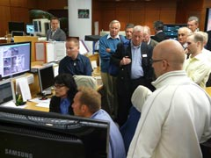
After a tour of the maintenance facility, we received a further presentation from Kimmo Reiman on plans to convert the metro to automatic operation, with no staff routinely present on the train. (The new extension will be automatic from the start; the existing lines will be converted.) Amongst the foreseen benefits are shorter headways; greater flexibility for frequency changes; a 15% reduction in energy costs; fewer human errors; and the ability to focus staff on customer-facing roles. It was clear from the presentation, and the close questioning which followed, that there remained a number of technical and operational issues to address. Some cynical members wondered whether the driverless lawn mower that was cutting the grass outside the office windows was an early trial of the technology!
The party was accorded the privilege of travelling from the depot by special train. The day’s business programme concluded with a visit to the Metro Control Centre at Hakaniemi.

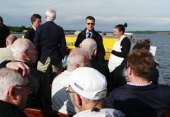
The evening featured water-borne transport, with a initial cruise on the motor vessel Victoria round the harbour and islands. This was followed by transfer to another vessel for a short trip to the island restaurant of Uunisaari, where, over dinner, we were able to return the hospitality offered to us by our business hosts.
On Tuesday we were the guests of Finnish railways (VR) at their offices adjacent to the iconic Helsinki terminal station. The present building, the second on the site, was designed by Eliel Saarinen in a “pure national romanticist” style. The building was completed in 1909, but did not open until after the First World War in 1919.

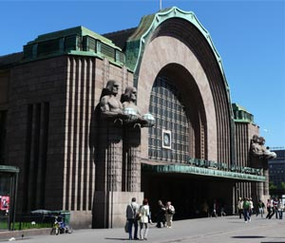
We received presentations from senior managers on: VR operations; the Finnish Transport Authority – a cross modal body responsible for road, rail and maritime infrastructure (FTA is moving its HQ from Helsinki to Lappeenranta close to the Russian border, as part of Government dispersal policy – a situation which resonated with Network Rail colleagues!); VR’s important operational and commercial links with Russian railways; rolling stock maintenance, with particular reference to winter conditions (Finland had its harshest winter for 40 years in 2009/2010 and, contrary to popular UK press belief in the resilience of railways abroad, coped only with difficulty and disruption); the maintenance of infrastructure, now totally outsourced by competitive tender; and, finally, on ERTMS, on which FTA professes itself to “one of the euro-sceptics” – the plan is to “advance cautiously, avoid risks and postpone costs”. A pilot scheme is running from 2007 to 2013, with full installation planned for 2019 to 2025.

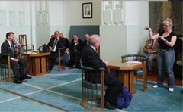
After a buffet lunch kindly provided by VR, we were promised a surprise. Some of that surprise had been diluted by one of the morning speakers referring to the Presidential Waiting Room “which we were to see”. Oops, hush her mouth! Built for the Grand Duke in Russian days, by the time the station was opened in 1919 the room was given over to Finnish Presidents’ use. It still sees occasional Presidential visits, but is also used as a corporate hospitality suite by the VR Managing Director.
In the afternoon we visited VR’s Ilmala depot, which is responsible for 80% of all passenger train maintenance. This is a new facility. Construction started in 2006 and, although the depot is fully operational, commissioning work is programmed to continue to 2011. We inspected the separate facilities for loco-hauled coaches, tilting trains and suburban rolling stock and were given demonstrations of the interlocking system and point-heaters.

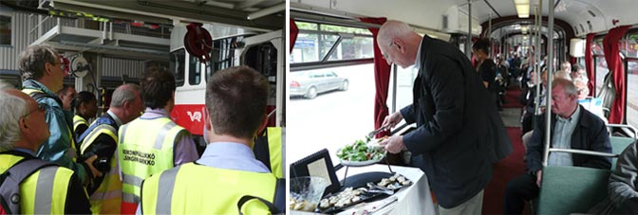

The evening’s entertainment was provided by a specially hired “party tram”, which toured the network for two hours. For those who need to know such detail, this is a converted DUWAG set from Mannheim. (Others from the same source were purchased for normal passenger operation.) The booked arrangement was for a buffet meal (no problems) and for a cash bar. Cash bar was off – apparently the tramway company is not licensed for the retail sale of alcoholic beverages. The RSA is always resourceful in the face of such challenges. A neat compromise was negotiated, whereby it was in order for the RSA to order wine and for the cost of same to be later invoiced in total. What the Association chose to do with the bottles thus procured was its own affair. So Richard “Birmingham” Brown (thus called to avoid confusion with our similarly named President) did a roaring trade discreetly selling on individual bottles of wine, for the very reasonably price (by Finnish standards) of 8 Euros.
With a co-operative driver, we were told we could direct the tram on whatever itinerary we wished. Gerald Daniels planned comprehensive tour covering most of the sections of operational track and a few rare curves and other connections. The dedicated were able to return with the tram to Koskela depot, with the added bonus of the opportunity there to inspect the historic tram fleet.

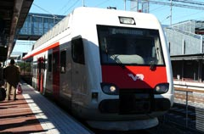
On Wednesday, the final day, we were again the guests of VR and travelled on the “Tringular Tour” from Helsinki over the high-speed line to Lahti and then on to Hyvinkaa (for the Finnish railway museum) and back to Helsinki.
The high-speed “cut-off” line was opened in 2006 and is used inter-city services (including the current three through trains each way per day to St. Petersburg/Moscow) but also local services and freight. Our VR guide was Eija Ahlburg who invited us to listen carefully to her on-board train announcements; for the voice was hers. Asked if she found it odd hearing herself on every train and station, she said not; but her husband found it very unnerving!

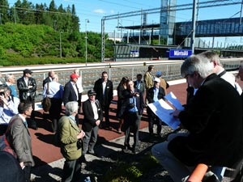
We were able, in groups of two and three, to visit the cab on our high-speed journey. We broke the trip at the one intermediate station at Mantsala, where – in a open-air briefing – VR’s Sakari Salo explained more about the high-speed line, the station facilities and the current project to build a line to Helsinki airport, on which construction work had just started, with a planned opening date of 2014. After the briefing, we had plenty of time to inspect the station, reminiscent in design, location and purpose of Ebbsfleet, though whether you would find in Kent a tractor in the park-and ride, as we did in Mantsala, is debateable!
After an early lunch in Lahti, we continued to the railway museum. First opened in Helsinki in 1898, this is one of the oldest museums in Finland. It was closed as a result of bomb damage in the Second World War and was pressed thereafter to relocate to a new site. The museum opened in its new location – a 19th century railway station in Hyvinkaa in 1974. It is professionally run (with the status of a National Museum) and with a responsibility for preserving historic railway artefacts. (There are four other railway museums in Finland run by enthusiast groups.)

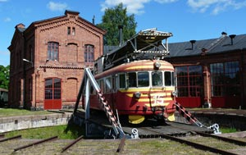
New halls have recently been added to the original roundhouse. The displays are predominantly of rolling stock, thought he original station building was restored with appropriate displays in 1990. Amongst the rolling stock on display is a steam locomotive built by Beyer and Peacock at Gorton, Manchester in 1868; and a former Presidential car in which sadly one former President (Kyosti Kallio) sadly died in 1940, after suffering a heart attack at Helsinki station.
The museum visit marked the end of the study tour arrangements. Thanks are expressed to Richard Brown (the Birmingham one) Catherine Fry and Dennis Ciborowski, who made all the arrangements and kept us on track. Particular thanks go to all our hosts, who were generous with their time and hospitality. The title of this report is taken from the VR “mission statement”. It seems an apt summary.

