AUTOMATION IN PORT INDUSTRY AND ITS IMPACT ON PORT SUSTAINABILITY

Yilin Wang and Chukwuneke Okorie
Plymouth Business School, University of Plymouth, UK

1.0 Introduction
When discussing port terminal automation, reference is often made to the container terminals due to the unique characteristics of containers such as its uniform shape and size. Containerisation has revolutionised the method of carriage of goods by sea, and by 2018, nearly 90% of commodities (by volume) are transported by container ships (Ics-shipping.org, 2018). Also, technology-based strategy is needed in order to cope with the increasing size of the container vessels, where for example the largest container vessel OOCL Hong Kong has the capacity of 21413 TUE (Oocl.com, 2018). As a result of increasing ship sizes and growth of global trade volume, the amount of cargo flowing through container ports is increasingly high, thus the demand for better handling efficiency is higher (Voß, Stahlbock and Steenken, 2004).

In the past decade, research and policies on automated container terminal have gained attention from many stakeholders. Many governments, such as Singapore and Netherland (Port of Rotterdam) started automating their ports to enhance port performance (Nightingale, 2014). In the same vein, sustainability has become a major issue in for attention in all areas of human endeavours (Asgari et al., 2015), and definitely a crucial discourse in port management (Peris-Mora et al., 2012). To adapt, ports need an equilibrium between limited land, labour and development of technology (Lun, 2011). From a technological angle, it becomes important to intensify analysis of the current trends of developing automation in ports using the triple-bottom-line framework. Therefore the aim of study is to examine the automation of container terminals so as to improve operations and port sustainability.

Literature review

Port automation
According to (Martín-Soberón et al., 2014), port automation usually refers to a container port terminal that has the capability of automated movement of cargo in the yard and the dock-yard interchanges. This automated system is usually made up with equipment such as Automated Stacking Cranes (ASCs) and Automated Guided Vehicles (AGVs) which enable the system to operate without direct human interventions.

Container Port and terminal automation
Port terminal refers to an intermodal facility that facilitate the flow of arriving cargo from ships or departing goods delivered the port by land (Montfort et al.,2001). Automation of container terminals reduces costs associated with the involvement of humans in cargo operation, while striving to achieve set standard, efficiency and service level (Martín-Soberón et al., 2014). Port automation can be traced back to the 1990s when the Delta Terminal in Port of Rotterdam introduced the concept of automated container terminal, providing Automated Guided Vehicles (AGVs) to facilitate unmanned operations in the yard area (Evers and Koppers, 1996). After the success of Rotterdam, automated terminal gained global popularity. In Europe and Southeast Asia, policies made by authorities supported the development of automation (European Commission, 2007). Recently, the Singapore maritime industry received a budget approval of 100 million SGD (76.12 Million USD) from the Maritime Port Authority to further develop its automation for the future (Hwee, 2018).

General Level of Automation
Level of automation is an important issue when considering deployment of automation in container terminals, with associated implications on price tags and performance levels. Lyndon (2015) stated that many port terminals have automated systems that can be rated at ‘level 3’, offering the most efficient and flexible service in terms of movement of cargo and materials. The ‘level 4’ and above are not practicable in port industry, but mostly implemented in banking and finance industry. Hence, a comprehensive automation index is needed in order to quantify the level of port automation to provide a tool for both the academia and maritime sector’s practitioners.

Levels | Descriptions
5 | Business system, strategy planning and corporation management
4 | Plant level, production and programming, ERP, MRP and MES
3 | Operation unit level
2 | Machine/ process Automation level
1 | Controller level
0 | Sensor/ actuator level
Source: Figueiredo et al. (2015)

Table 1: Level of Automation

Figueiredo et al. (2015) summarised automation into five levels based on the ISA95 (International Standard for Automation) as shown in the Table 1.

Towards an Automation Index
After reviewing the literature regarding terminal operation process, such as (Kim and Nguyen, 2008; Branch, 2012; Alderton and Saieva, 2013; Paixao and Bernard, 2003), we select some key processes illustrated in Figure 1 and in line with the working principle of an automated terminal described in Phan and Kim (2012).
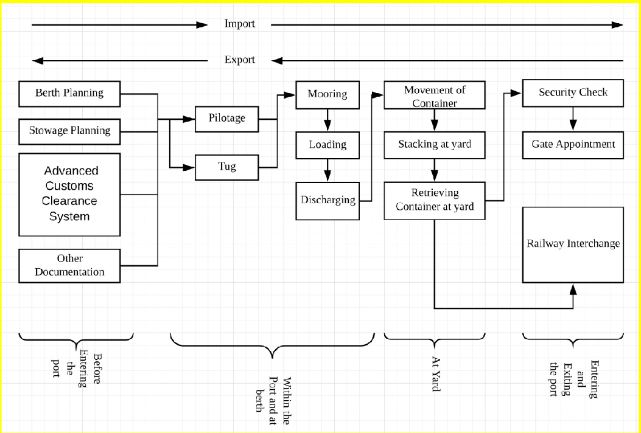

Figure 1. The basic process of port operation Source: Authors (2018)

The Figure 1 summarises key activities in general port operation, which from left to right represents the process of importing a container and from the right to left represents the process of exporting a container. By using the process summarised in Table 2, and in order to build a simple port automation index, each process will be evaluated to determine whether or not each individual process is automated. This evaluation and creation of a simple automation index is based on the compilation of findings from literature review and information available from ports. Each automated process will count as one point, and the total score is the number of counted automated processes.
 | Ports | A | B | C | D | E
Before Entering the Port | Berth Planning | 0 | 0 | 0 | 0 | 0
 | Stowage Planning | 1 | 1 | 1 | 1 | 1
 | Advanced Customs Clearance System | 0 | 0 | 0 | 0 | 0
 | Other Documentation | 0 | 0 | 0 | 0 | 0
Within the Port and at Berth | Pilotage | 0 | 0 | 0 | 0 | 0
 | Tug | 0 | 0 | 0 | 0 | 0
 | Mooring | 0 | 0 | 0 | 0 | 0
 | Loading | 1 | 0 | 0 | 0 | 0
 | Discharging | 1 | 0 | 0 | 0 | 0
At Yard | Movement of Container | 0 | 0 | 0 | 1 | 0
 | Stacking at Yard | 0 | 0 | 1 | 1 | 0
 | Retrieving container at yard | 0 | 0 | 1 | 1 | 0
Entering and Exiting the Port | Security Check | 0 | 0 | 0 | 0 | 0
 | Appointment System for trucks | 0 | 0 | 0 | 0 | 0
 | Gate | 0 | 0 | 0 | 0 | 0
 | Railway interchange | 1 | 0 | 1 | 1 | 0
 | Total Score | 3 | 1 | 4 | 5 | 1
Source: Authors (2018)

Table 2: Simple Automation Index of five selected UK ports

Table 2 shows the calculation process of the simple automation index, and the result of the five selected UK ports, namely Ports of Tees and Hartlepool (A); Port of Grimsby and Immingham (B); Port of London-London Gateway terminal (C); Port of Southampton (D); and Port of Milford haven (E). Findings show that the Port of Southampton is the most automated port with 5 points, indicating relatively high level of automation. Movement of cargo in port-yard is fully automated, and the intermodal connection with railway transportation is automated. On the other hand, the least automated ports are Port of Grimsby and Immingham, and Port of Milford haven with only one point each on process automation, being at the early phase (stowage planning) due to the sizes and throughputs of the ports.

Automated terminal and semi-automated terminal
In (Martín-Soberón et al., 2014), classification is made of terminal automation into only two levels namely, Automated terminal and Semi-automated terminal. An automated terminal refers to automated movement of cargo in the yard and dock and points of interchange. One example of such terminal is the Pasir Panjang terminal in Port of Singapore. Semi-automated terminal refers to the use of remote controlled equipment within a terminal or only some of the operations in a terminal are automated (Martin-soberon et al., 2014).

Greenfield and Brownfield Automation Project
Automation of port terminal projects can be categorised into Greenfield and Brownfield projects. While Greenfield projects refer to developing new automated terminal, brownfield projects are conversion of existing terminals to automated terminals with implementation of partial or fully automated equipment. Decision on whether or not to build a terminal with automation technology is extremely important at the design phase (De Sousa, 2000), as the cost of later conversions to automation (semi-automated or fully automated) is considerably high. In addition, the installation of relevant equipment and the whole conversion process at a later stage will affect the service level of the terminal resulting in further economic impact to the port. To overcome the problem, carrying out

the conversion in phases, while keeping part of the terminal in operation, is a sensible approach. One example of Brownfield project is the Antwerp Gateway terminal where RMGs (Rail Mounted Gantry cranes) replaced the existing straddle carriers (Saanen, 2010).

Current trend and common implications of port automation
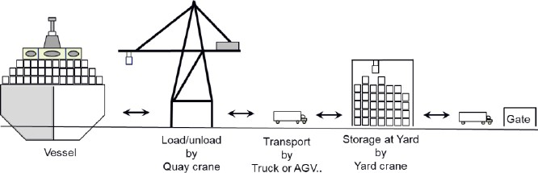There are three common areas in a terminal where automation usually take place, namely the gate; yard and quay. Automated security check, data exchange and appointment systems at terminal gate are able to increase efficiency of truck driver’s check-in process. Container yard is the most common area to have automation technology. As illustrated by Phan and Kim (2012) through Figure 2, the common processes of yard system automation are discussed. Firstly, containers are discharged from the vessel by quay cranes to AGVs (Automated guided Vehicles), then AGVs carry the containers to container yard, and finally a RMGs system or an automated straddle carrier system take these containers and stack them to their respective locations.

Figure 2: Working Principle of Automated Terminal. Source: (Phan and Kim, 2012)

The automation in Quay Crane in port terminal is by far the least developed due to the complexity of discharging and loading operations, with many stakeholders involved, higher risk for mistakes, and needing a 100% accuracy for smooth automation. Enormous effort is required to replicate the ability of a crane operator in terms of accuracy and flexibility (Zrnić, Petković, and Bošnjak., 2005). Prime- movers and normal straddle carriers are being replaced by for example Automated Guided Vehicles (AGVs) and Automated Rail mounted gantry crane systems (Ku et al., 2010), with common combinations such as Automated Straddle Carriers (ASCs) + AGVs; ASCs+ Automated lifting Vehicles (ALVs) or ASCs+ Automated shuttle Carriers (Martín-Soberón et al., 2014). As many ports consider these assortment of investments in automation, Zhu et al. (2010) assert that new container handling technologies such as twin 40-foot quay cranes, low bridge allocation system and twin 40-foot rail mounted gantry crane can increase the operation efficiency by about 50%.

Current Awareness of Port Sustainability
The concept of port sustainability can be broken down into three main area, firstly to be economically sustainable, secondly environmental preservation and lastly be socially responsible (Cheon and Dwakin, 2010). With the development of shipping industry, the function of port shifted from simply loading and discharging cargo/goods to an economic catalyst to a country and a link to international trade. The function of handling cargo remains but port also provide considerable amount of employment opportunity. Therefore, economic stability and social responsibility have been increasingly framed into port development plan and policy (Dinwoodie et al., 2012) which includes the development of automation in port industry.

Port Sustainability Goals
In relation the triple bottom line concept (Hall, 2011), sustainability has three core facets for attention, namely economic, social and the environment. While the environmental mainly seeks reduction in pollution (Adams et al., 2010), return on firm’s investment and welfare of local communities are also crucial sustainability goals. Consequent upon recent increased sustainability awareness, industries now constantly develop policies, regulations and innovations (Cheon and Deakin, 2010), and ports not

left out in seriously seeking strategies to meeting their sustainability goals. Decision on automation and level of automation of port operations is important today in meeting sustainability goals, with authors such as (Martín-Soberón et al., 2014; Figueiredo et al., 2015), highlighting both the pros and cons of port automation.

3 Research gap and approach
Port sustainability has been widely studied (Denktas-Sakar and Karatas-Cetin 2012; Sidney 2010; Kim, and Chiang, 2014; Dinwoodie et al., 2012; Laxe et al. 2016; Sislian et al., 2016; Lu te al. 2012; Acciaro et al., 2014) and also port automation (Nelmes, 2006; Hong, and Ngo, 2009; Chao, and Lin, 2017; Reboll-o et al., 2000; Martin-soberon et al., 2014). However, there appears to be a limited number of studies that have given attention to examining both port sustainability and port automation together. The aim of this research therefore is to investigate the current trend of port automation and possible implications on port sustainability by deploying the content analysis approach. Hence, the study provides a basic framework to further understand the impact of automation in the port industry in meeting port sustainability goals. Firstly, a detailed literature review is conducted. Secondly, highlights of relevant key concepts (including the advantages of automation and drawbacks) are made for analysis. Thirdly, the triple-bottom-line of sustainability framework is used in analysing key findings and meeting the aim of the research.

Results, findings and discussions
Key concepts in implementing port automation, in terms of major drivers are compiled in Table 3.

 | Automation key features
Operational performance | Better operational productivity
 | Land space optimisation due to high yard density
 | Better flexibility during high demand period
 | Constant readiness, reduce respond time of human operator
 | Achieve Resource utilisation
 | Better control over operations, due to the fact of continues communication between control system and equipment, making decision making process easier in real time.
Safety  and Security | Increase overall safety concern due to reduction of human involvement in  operation
 | Incorporation of security system
Environmental | Electric equipment reduces emission of Greenhouse gases
 | Best use of current spaces (fewer extension)
Economical | Less variable operation cost
 | Less maintenance operational cost
Source: Authors (2018)

Table 3: Major drivers for port automation

Table 3 presents a summary of the major drivers for port automation, representing key prospects for port management in the quest for sustainability in relation to the triple bottom-line.

Economic and flexibility perspective
The increased operational productivity due to the better efficiency by operating machines instead of human operators allows faster and smoother movement of goods within the terminal. Eventually, this will impact positively port revenue and economic prospects. However, automation could reduce flexibility where unexpected situations cannot be processed and handled by the computerised systems, needing human intervention. The deployment of automation in port supports land-space optimisation,
hence enhanced performance given limited land-space and high yard density. On the economical aspect, Greenfield automation project for instance, means less land is required to achieve the same level of performance as compared to a non-automated port. Hence less capital investment is required on purchase or leasing the land in the initial phase of a port project. Better flexibility during high demand period with automation allows the terminal to handle demand peaks smoothly and bring customer satisfaction and better performance. Terminal automation system also allows terminal to have constant readiness, reduced respond time of human operator. These will eventually enhance the service level of a terminal and bringing positive economic impact.

Human-engagement and social perspective
The implementation of port automation system reduces human labour required in the container-yard area. A bright social perspective is that it reduces the overall risk of injury and other safety issues. On the downside however, automation results in less employment opportunity for the local community. One can also argue that port-automation creates opportunity for high-tech ICT-related industry to support the implementation. As a result, there is a ripple effect in an increase in the demand of highly educated workforce, and a gradual displacement of those of lower skills.

Environmental perspective
By developing an automated port terminal, the installation of equipment that are powered by electricity such as AGVs will eventually reduce emission in the port region, hence achieving environment preservation goal of ports. To the surrounding community, electric-powered equipment also means lower noise levels as compared to traditional trucks and engine powered equipment. Additionally, less emission leads to positive social impact as local residents can be benefit from better air quality.

Conclusion
As a result of speed and overall efficiency gains from automation, ports make economic gains and the quest for extensive port-land expansion will be reduced. A resultant impact will be an environmental gain from low probability for land reclamation and related dredging operations, with an associated social benefit of local residents’ rest of mind on possible relocation. Despite the advantages, it’s crucial that port management analyses the needed capital cost of investment in automation equipment, which can only be recovered on long term basis.

Given advances in technology, the trend of developing automated terminal appears to be inevitable for most ports. Many leading ports such are port of Rotterdam and Singapore are already fully automated and still investing heavily in automation. This trend indicates that the policy of constructing a new terminal or upgrading an existing ones towards autonomy presents potential prospects. Although, automated terminals have some drawbacks in terms of sustainability, especially in the social aspect with machine-human displacement, its offers are compelling. In conclusion, automation in ports offers prospects for cleaner, faster, enhanced performance and support in the attainment of port’s overall sustainability goals.

References
- Acciaro, M., Vanelslander, T., Sys, C., Ferrari, C., Roumboutsos, A., Giuliano, G., Lam, J.S.L. and Kapros, S., 2014. Environmental sustainability in seaports: a framework for successful innovation. Maritime Policy & Management, 41(5), pp.480-500.
- Adams, M., Quinonez, P., Pallis, A. A. and Wakeman, T. H.,“Environmental Issues in Port Competitiveness”, Working Paper 7, 2010, Centre for International Trade and Transportation. Online available at: http://www.dal.ca/faculty/management/schools_and_centres/centre-for–international- trade-and-transportation.
- Alderton, P. and Saieva, G., 2013. Port management and operations. Taylor & Francis.
- Branch, A., 2012. Elements of port operation and management. Springer Science & Business Media. Chao, S.L. and Lin, Y.L., 2017. Gate automation system evaluation: A case of a container number recognition system in port terminals. Maritime Business Review, 2(1), pp.21-35.
- Cheon, S. H. and Dwakin, E., (2010) “Supply Chain Coordination for Port Sustainability,” Journal of ransport Research Board, Vol.2166, No.2, 2010, 10-19.
- De Sousa, C., 2000. Brownfield redevelopment versus greenfield development: A private sector perspective on the costs and risks associated with brownfield redevelopment in the Greater Toronto Area. Journal of Environmental Planning and Management, 43(6), pp.831-853.
- Denktas-Sakar, G. and Karatas-Cetin, C., 2012. Port sustainability and stakeholder management in supply chains: A framework on resource dependence theory. The Asian Journal of Shipping and Logistics, 28(3), pp.301-319.
- Dinwoodie, J., Tuck, S., Knowles, H., Benhin, J. and Sansom, M., 2012. Sustainable development of maritime operations in ports. Business Strategy and the Environment, 21(2), pp.111-126.
- Evers, J.J. and Koppers, S.A., 1996. Automated guided vehicle traffic control at a container terminal. Transportation Research Part A: Policy and Practice, 30(1), pp.21-34.
- Figueiredo, A.E., Carvalhal, R.D.D., Hoeflich, S., Figueiredo, L., Pereira, S.L. and Dias, E.M., 2015. Port operation–increase of automated systems, decline of workforce jobs?. In Proceedings of 19th Hall, T.J., 2011. The triple bottom line: what is it and how does it work?. Indiana business review, 86(1), p.4.
- Hong, K.S. and Ngo, Q.H., 2009, October. Port Automation: modeling and control of container cranes. In Inter. Conf. on Instrumentation, Control and Automation (pp. 19-26).
- Hwee, T. (2018). Singapore Budget 2018: Maritime industry gets S$100m more to push for automated, digital future. [online] The Business Times. Available at: http://www.businesstimes.com.sg/transport/singapore-budget-2018/singapore-budget-2018-maritime-industry-gets-s100m-more-to-push-for [Accessed 15 Mar. 2018].
- Ics-shipping.org. (2018). ICS | Shipping and World Trade. [online] Available at: http://www.ics- shipping.org/shipping-facts/shipping-and-world-trade [Accessed 5 May 2018].
- Kim, H. and Nguyen, D. (2008). Allocation Model of Container Yard for A TC Optimal Operation in Automated Container Terminal. Journal of Navigation and Port Research, 32(9), pp.737-742.
- Kim, S. and Chiang, B., 2014. Sustainability Practices to achieve Sustainability in International Port Operations. Economics, 30(3), pp.15-37.
- Ku, L.P., Lee, L.H., Chew, E.P. and Tan, K.C., 2010. An optimisation framework for yard planning in a container terminal: case with automated rail-mounted gantry cranes. OR spectrum, 32(3), pp.519-541.
- Laxe, F.G., Bermúdez, F.M., Palmero, F.M. and Novo-Corti, I., 2016. Sustainability and the Spanish port system. Analysis of the relationship between economic and environmental indicators. Marine pollution bulletin, 113(1-2), pp.232-239.
- Lu, C.S., Shang, K.C. and Lin, C.C., 2012, May. Identifying crucial sustainability assessment criteria for international ports. In International Forum on Shipping, Ports and Airports, Hong Kong (pp. 27-30).
- Lun, Y. H. V.,“Green Management Practices and Firm Performance: A Case of Container Terminal Operations,” Resource, Conservation and Recycling, Vol.,55, No.6, 2011, 559-566.
- Martín-Soberón, A., Monfort, A., Sapiña, R., Monterde, N. and Calduch, D. (2014). Automation in Port Container Terminals. Procedia - Social and Behavioral Sciences, 160, pp.195-204.
- Nelmes, G., 2006. Container port automation. In Field and Service Robotics (pp. 3-8). Springer, Berlin, Heidelberg.
- Nightingale, L. (2014). Rotterdam dockers unite in automation row. [online] Lloyd's List. Available at: https://lloydslist.maritimeintelligence.informa.com/LL048910/Rotterdam-dockers-unite-in- automation-row [Accessed 14 Mar. 2018].
- Paixao, A.C. and Bernard Marlow, P., 2003. Fourth generation ports–a question of agility?. International Journal of Physical Distribution & Logistics Management, 33(4), pp.355-376.
- Peris-Mora, E., Orejas, J.D., Subirats, A., Ibáñez, S. and Alvarez, P., 2005. Development of a system of indicators for sustainable port management. Marine Pollution Bulletin, 50(12), pp.1649-1660.
- Phan, M.H.T. and Kim, K.H., (2012) Estimating the Cycle Time of Container Handling in Terminals. Department of Industrial Engineering, Pusan National University.
- Oocl.com. (2018). OOCL Hong Kong. [online] Available at: http://www.oocl.com/eng/ourservices/vessels/gclass21413/Pages/ooclhongkong.aspx [Accessed 26 Jun. 2018].
- Rebollo, M., Julian, V., Carrascosa, C. and Botti, V., 2000, October. A multi-agent system for the automation of a port container terminal. In Autonomous Agents 2000 workshop on Agents in Industry (Vol. 1, pp. 1-7).
- Saanen, Y. (2010). “Robotization for small and medium sized terminals - beyond the obvious”. In Terminal Operations Conference (TOC), 8-10 June 2010, Valencia
- Shih-Liang Chao, Ya-Lan Lin, (2017) "Gate automation system evaluation: A case of a container number recognition system in port terminals", Maritime Business Review, Vol. 2 Issue: 1, pp.21-35,
- Sislian, L., Jaegler, A. and Cariou, P., 2016. A literature review on port sustainability and ocean's carrier network problem. Research in Transportation Business & Management, 19, pp.19-26.
- Voß, S., Stahlbock, R. and Steenken, D. (2004). Container terminal operation and operations research - a classification and literature review. OR Spectrum, 26(1), pp.3-49.
- Zrnić, N., Petković, Z. and Bošnjak, S., 2005. Automation of ship-to-shore container cranes: A review of state-of-the-art. FME Transactions, 33(3), pp.111-121.
- Asgari, N., Hassani, A., Jones, D. and Nguye, H.H., 2015. Sustainability ranking of the UK major ports: methodology and case study. Transportation research part E: logistics and transportation review, 78, pp.19-39.

