EXPLORING THE INFLUENCE OF INSTITUTIONAL FORCES AND COMPANY STRATEGY ON SUSTAINABLE SUPPLY CHAIN MANAGEMENT PRACTICE IMPLEMENTATION: EMPIRICAL EVIDENCE FROM CHINA

Haiyan Lu¹, Andrew Potter², Donna Marshall³, Helen Walker² and Vasco Sanches Rodrigues²
¹University of Plymouth, UK
²Cardiff University, UK
³University College Dublin, Ireland

Research background
From a historical perspective, the environmental and sustainable agenda has been shaped by the great waves of public pressure since 1960 (Elkington, 1994). Sustainability is one key area in which to explore why and how supply networks are influenced by institutional pressures and stakeholder expectations (Carter and Easton, 2011). Prominent studies have addressed the impact of stakeholders on organisations’ adoption and dissemination of environmental and social practices (Wolf, 2014; Varsei and Polyakovskiy, 2017). For example, Mani and Gunasekaran (2018) discussed the power of regulatory compliance to determine the extent to which a company practices SSCM. More generally, within the current literature, institutional forces are identified as the prime driver of SSCM (Sarkis, 2011; Touboulic and Walker, 2015).

Due to institutional forces, companies adjust their company strategies and implement and report economic, environmental and social sustainability performance to both internal and external stakeholders.

However, an ‘organization’s sustainability initiatives and its corporate strategy must be closely interwoven’ (Carter and Rogers 2008, p. 367). Therefore, another precursor to the implementation of SSCM practices is company strategy. This requires a company to be proactive and adjust its business model and adopt environmental and social SSCM practices (Pagell et al., 2009). For this research, we use the Reactive-Defensive-Accommodative-Proactive (RDAP) Scale developed by Clarkson (1995).
Even though the current literature has made significant contributions to the understanding of the literature on SSCM, research on organisational practices considering both external pressure and company strategy is still limited. To address the specific research gap, this study aims to answer the research question: how do companies address institutional forces using their company strategy and how does this impact the implementation of SSCM practices?

Institutional theory (DiMaggio and Powell, 1983; Bhakoo and Choi, 2013) and company strategy (Clarkson, 1995) are analysed in this study to help understand how and when organisations implement SSCM practices. Institutional theory states that organisational processes are institutionalised via consistent adaptation (Colwell and Joshi, 2013). These adaptive processes explain why organizations, on one hand, attempt to customise niche markets to gain competitive advantage, while on the other hand they gradually approach to organizational homogeneity toward government and regulatory norms (Kauppi, 2013; Dubey et al., 2015). Besides, company strategy nuances organisation practices in sustainability according to stakeholder pressures with balance of company capability and operational issues to solve with.

Research method
Given that different industries have various ways to implement SSCM practices (Easton, 2011), a focus on exemplars will allow for a reliable comparison across different sectors. Exemplars are organisations that are well ahead of their industry on either environmental and/or social performance. Multiple-case sampling was chosen as the most appropriate method to understand the complexity of the phenomenon and purposive sampling led to the focus on three specific supply networks (e.g. Walker et al., 2011; Pagell and Wu, 2009; Lazzarini et al. 2001).

This study used supply networks in the automotive, food, and beverage industries in China. 16 companies participated, framing 3 supply networks. Multiple sources of data were collected, included semi-structured interview, factory site visits, observation and documentation, in order to give a comprehensive view of each case. Pattern coding and theoretical coding methods were applied to control researchers’ biases (Miles and Huberman, 1994). All materials were coded and analysed in Nvivo 11.

Findings and analysis
Observation showed that coercive isomorphism was the dominant driver for SSCM implementation, meanwhile firms react on normative and mimetic isomorphism according to their company strategies. Examples of company strategy and the relative action were given in Table 1. Details in each case are explained afterward. In addition, reactive strategy was barely indicated from the participants to deny SSCM responsibility.

Table 1: Strategy type, actions and examples
Strategy Type | Actions | Case Examples
Defensive | Admit responsibility but fight it | Observation in the factory contradicted the participants’ claim that the employees were required to use masks and gloves in production (Plating B)
Accommodative | Accept  responsibility | ‘In fact, our business are in international standards after  joining the WTO….’ (Carton Package)
Proactive | Anticipate  responsibility | ‘I provide and tell them (the farmers) how to use the seeds  and pesticides […] In the long-term, as long as they planted them, I have to buy the vegetable, at least I have a reserve price for them’ (Vegetable Trader)

Table 1: Strategy type, actions and examples

Automotive
Coercive isomorphism and company strategy Automotive companies emphasise coercive isomorphisms (see Figure 1 below).
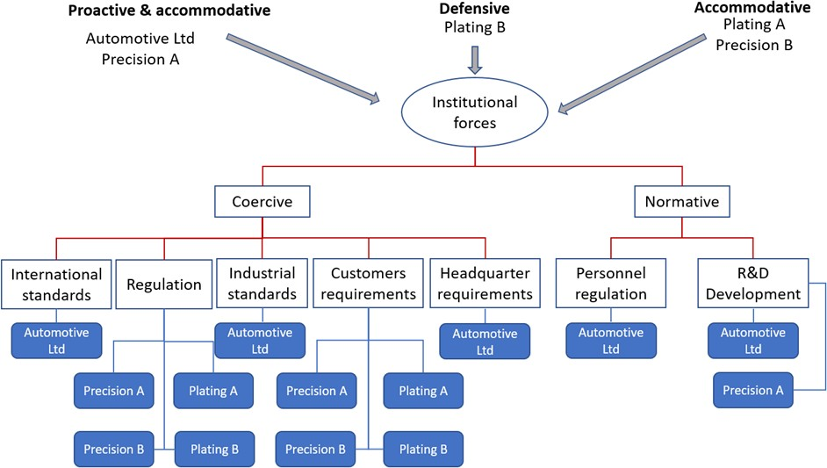

Figure 1: Forces and strategies in the sequential network

The primary reason for this is the focal company, Automotive Ltd, is foreign-owned and headquartered in Germany. In other words, coercive pressure is mainly from international regulations and industrial standards. Automotive Ltd participants stated: ‘Germany has a guiding program for specific approaches. Such as requiring use of a yellow line for any pedestrian region, but where to set up the yellow line is according to the actual situation of the factory.’ There is some degree of localisation, however, the headquarters have a guiding programme and standardised operation systems. For example, requests for RoHS and REACH compliance to address sustainable impact on both human health and the environment. Therefore, Automotive Ltd ensures compliance from its suppliers for environmental responsibility. ‘Social responsibility is also in the corresponding codes, but only when customers require will we then ask for compliance from our suppliers’, stated the Automotive Ltd quality control manager. As well as standardised compliance, the headquarters list the ‘must-have’ facilities for employees: in addition to the yellow lines there must be a designated area for casual interaction and on the back of each door in the washroom, a picture is presented to remind employees to drink sufficient water.

Coercive pressures for companies Plating A, Plating B, Precision A, Precision B are mainly from government regulations and customer requirements. However, different company strategies moderate the impact of institutional forces on SSCM practice implementation (Figure 1).

In the sequential network, a typical proactive company is Precision A. They stated: ‘for prime customers, it is very important for their corporate image. They have an annual review which includes the quality system review and reviews for environmental and CSR implementation’. However, pressures from local government are not a major concern: ‘It is more customer-driven and environment-driven because all our customers are high-end, and the products are exported to Europe. Each year we have to meet the declaration […] keeping pace is sustainability.’ For Precision A, being at the forefront of their industry is exhibited through implementing SSCM practices. Not only do they comply with customer requirements, but they also introduce new products to customers; for example, Precision A convinced their customers to use spray-free paint for products, in order to reduce environmental impacts as well as avoid damage to human health from chemical toxins, such as formaldehyde and p-Xylene.

Companies that adopt an accommodative strategy accept institutional forces and implement SSCM practices as required by regulations or contract terms, however, actions are remained in required standards; moreover, success is measured by meeting the highest level of requirements. Managers in Plating A explained that their implementation of ISO14001 and TS16949 is not because of customer requirements, but mainly ‘due to the development of the enterprise to some extent. If you want to continue to develop, you have to meet international and industry standards.’

Plating B adopted a defensive strategy towards institutional forces. Walker et al. (2008) suggested that some companies do not comply with institutional regulation, but implement environmental practices for cost-saving purposes. This was observed in Plating B. Even though managers stated positive attitudes towards national regulation and industrial requirements for environmental and social SSCM practice implementation, the company paid most attention to recycling as the raw materials are valuable commodities: silver and gold. ‘The annual recycling amount is more than 100 kilograms … if not recycled, it would be wasted.’ However, in terms of environmental issues, such as water discharge and gas disposal, the company relies solely on central processing within the manufacturing area. ISO 14001 standards are not adopted by the company because they are not required from customers. They update their ISO 9000 certificate every two years purely for quality control reasons. They also claimed that workers must wear masks and earplugs during production, however, observation within the manufacturing facility did not corroborate their statement. Employees were surrounded by gas and noise pollution without any visible protection.

Mimetic isomorphism and company strategy No mimetic isomorphism was found in this case. The reason could be that SSCM standards and regulation has been developed well in automotive industry, which has been strictly followed by companies and implied in their corporate code of conducts. Another reason could because of the exemplar nature of Automotive Ltd., who are leaders in SSCM practice implementation in the automotive industry. According to the manager in the Automotive Ltd, the headquarter has a guiding programme and standardised operation systems for the Chinese plant, including the SSCM certification and implementation.

Normative isomorphism and company strategy There is no evidence of normative pressures influencing defensive companies. This is not surprising since these companies are doing the least required rather than actively dealing with environmental and social issues.

However, companies with a hybrid accommodative and proactive strategies endeavour to improve both social and environmental SSCM practice implementation. For example, Automotive Ltd accommodative their environmental sustainability by establishing company regulations in a specific Environment Health and Safety (EHS) function, which is responsible for dealing with the company’s internal health, safety and environmental issues. Engineers are responsible for conducting special management approaches for dangerous operations. Meanwhile, the company proactively reacts on normative isomorphism. As specified in the EHS statement, all employees benefit from the same type of health insurance and annual health check, regardless of their positions, in consideration of human health and equity. Similarly, Plating A company holds a hybrid strategy: a combination of accommodative and proactive strategies, in their SSCM practice implementation. In terms of environmental practices, the company follows international standards and believes these are higher than national standards. Therefore, they obtain international certificates, such as RoHS, REACH and TS 16949, to meet customer requirements. The company also applies a recycling policy. Similarly, in their social practices, the company is proactive and doing more than required. Not only do they adhere to Chinese labour laws, but they also offer various compensation schemes to employees: when they get married, when family members suffer serious illnesses or pass away, when giving birth, and on Children’s Day.

Proactive organizations, such as Precision A, established a research and development (R&D) centre to invest in environmentally-friendly solutions for their product range. At the same time, they try to increase their professionalisation of the field by sending representatives from the R&D centre to participate in relevant seminars each year.

Food case
Coercive isomorphism and company strategy With regard to companies in the food industry, coerciveisomorphism is the major institutional force for driving firms’ implementation of SSCM practice implementation (see Figure 2 below), which is consistent with previous studies (Carter and Easten, 2011; Touboulic and Walker, 2015; Varsei et al., 2014).

However, this industry is unusual as there is a lack of standardisation in both regulations and industry standards. Under this circumstance, accommodative firms implied regulation, industrial standards and customers requirement to comply SSCM implementation. However, for companies including the Restaurant Owners, Food processor and Vegetable Ltd that adopted a hybrid of proactive and accommodative strategy, they believed that: ‘This is the problem with our laws and regulations […] when cooperatives have spent money but no one does anything [the authority does not regulate and there are no clearly set standards for environmental and social practices] … [so we] cannot achieve the desired goals’. This has resulted in SSCM practice inconsistencies and coordination difficulties throughout the industry. In this case, for companies with accommodative strategies or a hybrid strategy, including Vegetable Ltd, Carton Packaging, Food Processor, Restaurants Owner and IT provider, the levels of their SSCM practice implementation are relatively low compared with the automotive and beverage sectors.

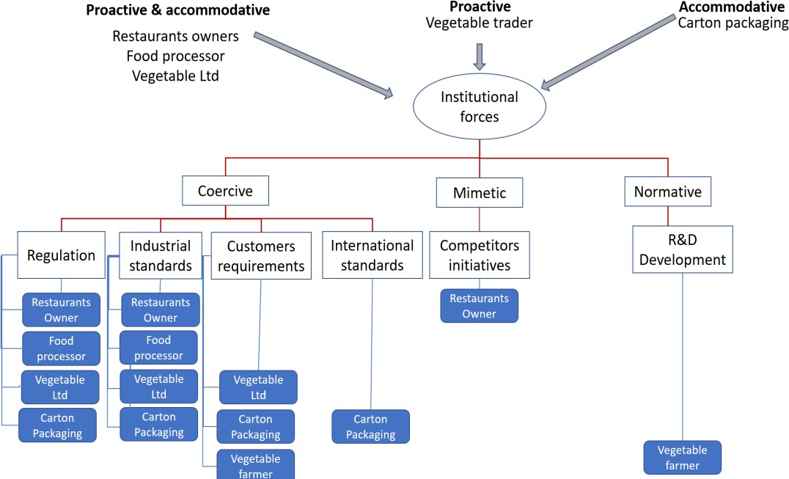
Figure 2: Forces and strategies in the reciprocal network

Mimetic isomorphism and company strategy Restaurants Owner experienced a high level of mimetic isomorphism because of its competitors, such as McDonald’s, who they benchmark against in terms of SSCM practices. For example, Restaurants Owner has a proactive strategy for food quality and security. One manager emphasised the supply of hygienic food by adopting the 5S – sort, set in order, shine, standardize and sustain in production throughout their restaurant chain.

Normative isomorphism and company strategy Surprisingly, Vegetable Trader, who directly trade vegetables from farm to Vegetable Ltd, is the only player with a proactive strategy. Not only have they established long-term relationships with the farmers but they also gave environmentally-friendly seeds to farmers to avoid land pollution. Professional and technical staff were also invited to observe and measure whether the land was suitable for farming and with which crops. Vegetable Trader then assigned work according to each farmers’ decision regarding they type and quantity of crops, matching the farmers’ working capabilities with their expectation. Furthermore, Vegetable Trader has implemented social SSCM practices by guaranteeing a minimum price for all products the farmers have produced. Farmers are considered as vulnerable both to natural disasters, such as typhoons in the summer, when many vegetables are damaged; or when there is overproduction. Vegetable Trader stated: ‘It is difficult for the farmers to pay for the loss and uncertainty, so I guarantee a minimum price for the vegetables, whether they are damaged or overproduced, as long as the farmers work closely with me’.

Beverage Industry
Coercive isomorphism and company strategy Coercive isomorphism is the primary factor for implementing SSCM in the beverage industry. In this industry, domestic companies primarily react to national regulations (see Figure 3 below).For example, firms acting proactively to regulations, such as the focal firm Beverage A, set up a legal department to interpret and discuss government regulations and policies. Sugar Processor, which conducts business internationally, stated that requirements from customers are increasingly rising. In this example, Sugar Processor provided non-negotiable environmental guidelines and customers used authorised third parties to evaluate performance each year. SSCM should be planned strategically. Sugar Trader stated: ‘the sustainability and implementation strategy should be set before we start our business activities; otherwise, we will be ruled out’.

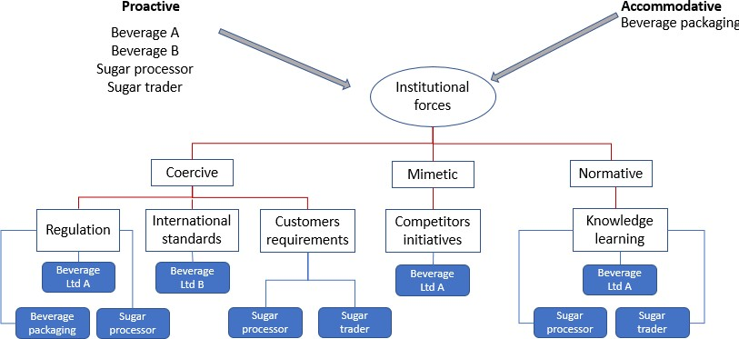
Figure 3: Forces and strategies in the pooled network

Mimetic isomorphisms and company strategy For proactive firms, not only suppliers comply SSCM corporate code of conducts because of coercive isomorphism, but suppliers copy customers and that customers show by setting a good example mimetic force. For Beverage A, Sugar Processor and Sugar Trader, mimetic isomorphisms are essential for guiding environmental and social SSCM practice implementation. Sustainability was ‘a company-wide strategy’, not for an individual department or a company. For Beverage A, even though they have a strong market position as a domestic firm, there is substantial competition from international brands. Therefore, environmental issues, such as measuring and assessing chemical composition, are critical before procuring raw materials. The companies are also continually learning and imitating SSCM practice implementation from their competitors.

Normative isomorphisms and company strategy Good practices from customers set benchmarks for proactive suppliers entailing professional skills to implement SSCM for proactive suppliers, shown in the Beverage A, Sugar Processor and Sugar Trader. These companies have also recruited professional staff or external bodies to collect market information and develop their SSCM practices, to enhance company competitiveness. Sugar Processor has also published a sustainability report in order to show transparency and professionalism in their SSCM practices.

Beverage B, the second focal firm, is an international company with well-developed environmental and social SSCM practices. The company has balanced the three institutional pressures with a proactive strategy for sustainable practices with an emphasis on normative isomorphism to maintain their leading position in the market. Being a global leader, the company has applied considerable energy to implementing SSCM practices. An annual report was published to indicate their efforts. As a pioneer in promoting sustainability, the company not only implements environmental SSCM practices, such as reducing usage of electricity and water throughout their supply chain, but also promotes social SSCM practices, by community involvement in raising awareness of how to live a ‘Healthy Life’. Beverage B organised charitable outdoor activities in more than 30 cities throughout their supply chain in China; donating clean water for areas in drought and; training employees to lecture as volunteer teachers in impoverished areas. Brand image and corporate reputation are of such importance that the company employed an engineering company to help design and meet the requirements from EHS security.

Discussion and conclusion
Aligning with current literature (Beamon, 1999; Green et al., 1996; Zhu et al., 2005; Walker et al., 2008), this study found that government regulation and customers requirement are the major forces for companies to comply with environmental and social demands. Industry standards also required supply chain actors to carry out audits and gain certifications (Hassini et al., 2012). However, coercive regulatory forces only drive SSCM practice implementation when government leadership and regulation are well developed, as in the automotive industry. In contrast, food companies face obstacles when implementing SSCM due to a lack of industry standards and government regulation in China. Even though China’s food safety regulatory system has experienced major changes over the past 50 years, there remain areas of inconsistencies within the National Food Control Systems and robustness of food safety standards (Zhang et al., 2018). Thereby, for companies adopting accommodative or defensive strategies, the implementation of environmental and social sustainability needs further address on environmental issues and health risk reduction.

Normative and mimetic isomorphisms make up for the regulatory shortfall guiding SSCM practice implementation, which is driven by company’s strategy. Company strategy impacts the effect of institutional forces by influencing how companies act when faced with coercive, mimetic or normative isomorphisms. Proactive food and beverage companies invested in professional learning and imitating competitors and customers to gain competitive advantage instead of responding to regulatory needs. Actors in these cases, worked together for information and knowledge sharing for social and environmental practices, joint R&D and integrated production processes for reducing environmental impacts. It is an integrated and collaborative processes to develop intra- and inter-firm capabilities to implement SSCM (Luzzini et al., 2015).

Besides, company can employ a hybrid strategy to SSCM depending on institutional force and internal capabilities. In food and beverage firms, financial factors and company image are the primary considerations for SSCM implementation, thereby companies accommodate regulation and customer’s requirement for complying with environmental sustainability. However, for social sustainability where institutional legitimacy has not yet covered, proactive firms make efforts to satisfy employees, suppliers, farmers and the communities where their business operate. ‘Doing the right thing’ seems to be embraced as the business ethics for considering the development for next generation.

As a conclusion, this study investigates the interaction of institutional force and company strategy and their impact on SSCM. It is rather complex where dynamic situations have been discussed in the automotive, food and beverage cases. The novelty of this research emphases on the consideration not only about external forces but also internal capabilities when implementing environmental and social sustainability in supply chains. The research also shows the evidence when company strategy complements institutional shortfall for SSCM implementation.

Selected key References
- Beske P., Land A. and Seuring S. (2013), Sustainable supply chain management practices and dynamic capabilities in the food industry: A critical analysis of the literature, International Journal of Production Economics, 152, pp.131-143.
- Carter, C. R. and Liane Easton, P. (2011), Sustainable supply chain management: evolution and future directions, International Journal of Physical Distribution & Logistics Management, 41, pp. 46–62.
- Clarkson, M. E. (1995), A Stakeholder framework for analysing and evaluating corporate social performance, Academy of Management Review, 20, pp. 92–117.
- DiMaggio J. P. and Powell W. W. (1983), The iron cage revisited: Institutional isomorphism and collective rationality in organizational fields. American Sociological Review, 48, 147-160.
- Glover, J. L., Champion, D., Daniels, K. J. and Dainty, A. J. D. (2014) An Institutional Theory perspective on sustainable practices across the dairy supply chain, International Journal of Production Economics, 152, pp. 102–111.
- Luzzini D., Brandon-Jones E., Brandon-Jones A., and Spina G. (2015), From sustainability commitment to performance: The role of intra-and inter-firm collaborative capabilities in the upstream supply chain, International Journal of Production Economics, 165, pp.51-63.
- Roth A. V., Tsay A. A., Pullman M. and Gray J. V. (2008), Unravelling the food supply chain: Strategic insights from China and the 2007 recall, Journal of Supply Chain Management, 44, pp. 22- 38.
- Sarkis, J., Zhu, Q. and Lai, K. H. (2011), An organizational theoretic review of green supply chain management literature, International Journal of Production Economics. Elsevier, 130, pp. 1–15.
- Varsei, M. and Polyakovskiy, S. (2017) Sustainable supply chain network design: A case of the wine industry in Australi, Omega, 66, pp. 236–247.
- Zhang Z., Godefroy B.S., Lyu H., Sun B., Fan Y. (2018), Transformation of China’s food safety standard setting system – Review of 50 years of change, opportunities and challenges ahead, Food Control, 93, pp.106-111.

