UTILIZATION OF RAILWAY FOR BULK PETROLEUM PRODUCT TRANSFERS IN SRI LANKA

Janak Dharmaprema and Varuna Gunasekara

Ceylon Petroleum Storage Terminals Limited, Colombo, Sri Lanka

Introduction
A Sri Lankan railway was introduced by the British during the colonial times to facilitate their business objectives. The main focus was on the plantation industry and transportation of related goods. Sri Lankan petroleum industry was operated by 03 multi-national companies (Namely Caltex, Mobil and Shell) until the nationalization in 1961. They had identified the cost effectiveness of rail transport and had located the petroleum infrastructure beside the railway lines and Colombo port. Oil facilities were installed at the Chinabay, Trincomalee as per the strategically needs of the British during the World War II, which included tanker unloading and rail transport. Later facilities were developed to cater the fuel requirement of the Katunayake international airport via rail.
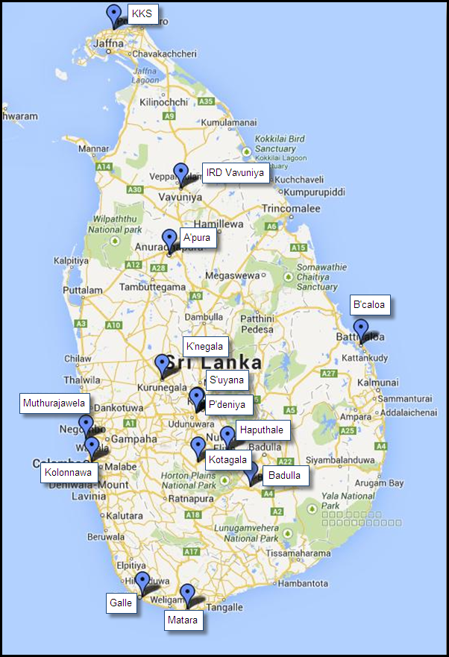
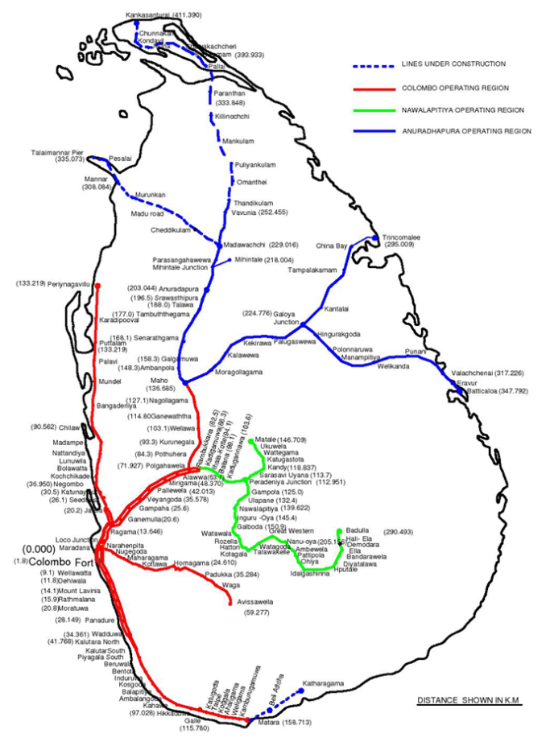

Fig. 1: Sri Lanka Railways Map and the Island-wide CPSTL Bulk Depots

Overview of Operations
CPSTL Kolonnawa installation is connected to the Sri Lanka railways network. Currently 10 out of the 12 CPSTL bulk depots and the Katunayake international airport are reachable via rail. The logistics operation is achieved by 05 trains which are operated on a daily basis. The SLR operations are carried out via the SLR sub station located inside the CPSTL Kolonnawa terminal premises. The up- country terrain constitute of relatively lower capacity wagons, due the train engine capability and the steepness of the journey.

Train | Wagon Capacity  (Litres) | Railway Engine No. | Railway Unit Allocation | Destinations | Weekly Availability
Up-Country | 26,370  22,275  22,460 | 160 | 42 Units | - Peradeniya  - Kotagala  - Haputhale  - Badulla | 06 days
North-Central | 45,400  50,000 | 497 | 60 Units | - Anuradhapura  - Vavuniya | 06 days
Batticaloa | 45,400  50,000 | 493 | 40 Units | - Batticaloa | 03 days
Galle | 45,400  50,000 | 776 | 40 Units | - Galle  - Matara | 06 days
Katunayake | 45,400  50,000 | 492, 413, 421, 429 | 40 Units | - Katunayake Aviation | 07 days

Table 1: Rail facilities used for bulk petroleum product delivery

There are dedicated wagons for delivering Jet-A1 and furnace oil. As per the case of petrol, diesel and kerosene, the same wagon is utilized randomly.

Product | Capacity  (ltrs) | Quantity
Jet-A1 | 45,400 | 31
Petrol/Diesel/Kerosene | 26,370 | 135
 | 45,400 | 81
 | 50,000 | 16
Furnace Oil | 26,370 | 3
 | 45,400 | 3
Total |  | 263

Table 2: Railways wagon availability

Cost concerns
SLR wagon transport tariff is based on the tonnage of the wagons. Therefore, unlike the road transportation which is fixed for all the products, it varies from product to product.

CPSTL is the higher revenue generator for SLR. This is the most cost efficient mode of transportation for CPSTL while comparing the cost against road transportation. Therefore, the CPSTL strategy is to maximize the utilization of rail transport, for its bulk product transfers.

Plant | Distance  (Km) | Cost per Litre  (Rs.)
 |  | LS | LAD | LK | Avg.
A’pura | 207 | 0.6755 | 0.7877 | 0.7285 | 0.7306
Badulla | 294 | 1.0725 | 1.2506 | 1.1567 | 1.1599
Batticaloa | 351 | 1.1454 | 1.3356 | 1.2353 | 1.2388
Galle | 127 | 0.4144 | 0.4833 | 0.4470 | 0.4482
Haputhale | 250 | 0.9050 | 1.0553 | 0.0000 | 0.6534
KKS | - | - | - | - | -
Kotagala | 182 | 0.6461 | 0.7534 | 0.6968 | 0.6988
Kurunegala | 97 | 0.3165 | 0.3691 | 0.3414 | 0.3423
Matara | 170 | 0.5547 | 0.6469 | - | 0.4005
Peradeniya | 116 | 0.3948 | 0.4604 | 0.4258 | 0.4270
Sarasavi Uyana | - | - | - | - | -
IRD V’niya | 256 | - | 0.9741 | 0.9010 | 0.6250
Total |  | 0.6125 | 0.8116 | 0.5932 | 0.6725

Table 3: Distance and cost details for bulk product delivery

Factors affecting petroleum product delivery via rail.
There are various factors affecting the rail transportation of the bulk petroleum products.

- Trade union actions of SLR employees.
- Low priority given for petroleum product transfer against passenger transportation.
- Less availability of railway wagons during festive seasons. (Ex: April, December)
- Difficulty of locating the whereabouts of the railway wagons.
- Difficulty of placing wagons to bulk depots after arriving at the railway station.
- Difficulty of collecting and returning empty railway wagons.
- Maintenance issues with where some become unusable due to valve/tank related issues.

CPSTL is directly communicating with the SLR authorities regarding the optimization and maximum utilization of railway wagon related operations.

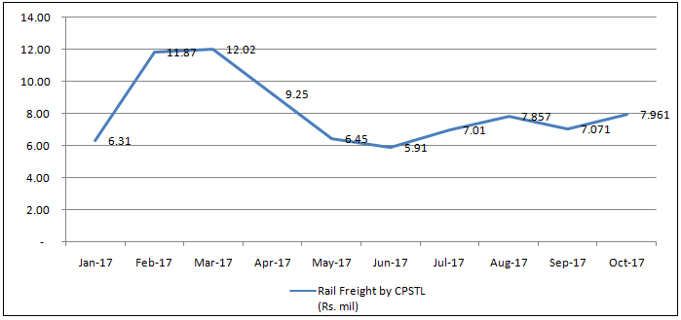

Fig. 2: 2017 Railway freight tariff for CPSTL
Optimization of railway wagon operations
CPSTL utilizes the SAP ERP system to facilitate their sales and bulk product transfer process. The system provides solutions to schedule the railway wagons and monitors the bulk transfer operation.

Fig. 3: Payments and reconciliation of wagon deliveries.

The payment and reconciliation process is being catered via the SAP ERP system. The daily scheduling of railway wagons as per their arrival and the product requirement of the CPSTL bulk depots is performed via the system. The good issue and good receipt operations determine the actual product delivery via wagons. Each CPSTL destination has a trip time for which the relevant wagon to reach its destination. Railway wagons failing to do so will be captured by the system. SLR is notified regarding the delays via system generated reports.

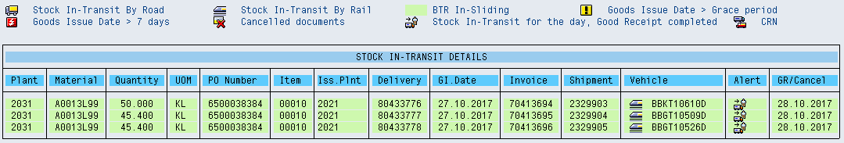

Fig. 4: Wagon in-transit details via SAP ERP system.

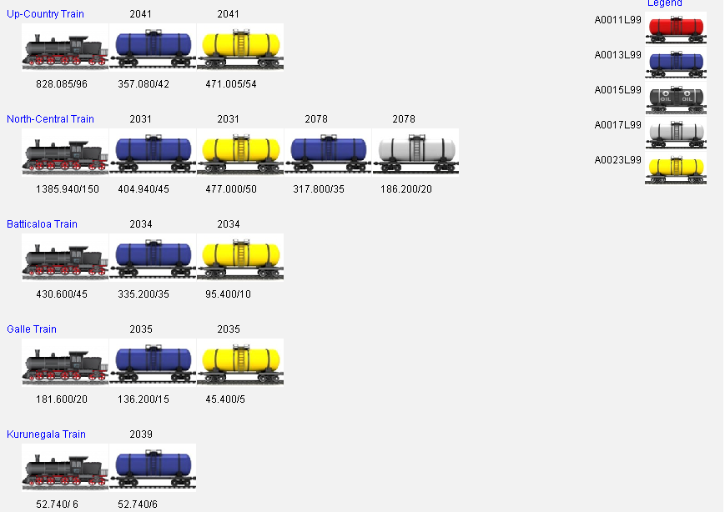

Fig. 5: Wagon scheduling via SAP ERP system.

Although, there are systems in place at CPSTL, the authority of the wagons are with SLR, once it leaves the Kolonnawa terminal. Tracking the whereabouts of the wagons is a difficult task. Currently a system has been proposed to locate the railways wagons via a GPS system.

Recommendations
- Replenishing of CPSTL Bulk Depot Batticaloa via rail.
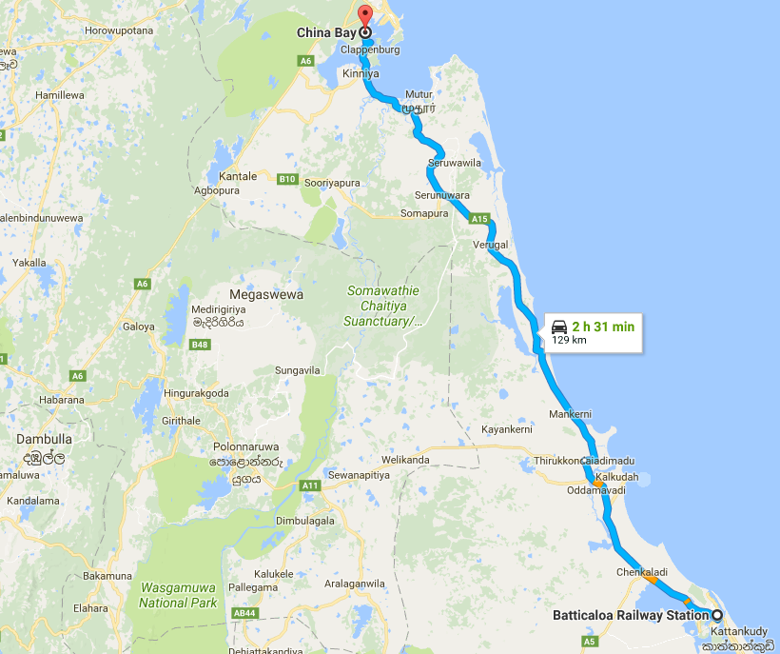

Fig. 6: Road distance from Chinabay terminal Batticaloa bulk depot.

The CPSTL Batticaloa bulk depot replenishment can be performed via rail from the LIOC Chinabay terminal. This rail track existed before the break of war. If the train infrastructure and the facilities are in place, it is a quite viable and cost effective method.
Mode of Transport | Source | Distance (km) | Cost per 1km per 1 litre (Rs.)
Rail | Chinabay Terminal | 186.5 | 0.66
Hired Tank Lorry | Chinabay Terminal | 129.0 | 1.36
Rail | Kolonnawa Terminal | 351.0 | 1.24
Hired Tank Lorry | Kolonnawa Terminal | 310.5 | 3.28
Hired Tank Lorry | Muthurajawela Terminal | 317.0 | 3.34
Average cost Saving (via Rail) |  |  | 0.58
Average cost Saving (via Hired Tank Lorry) |  |  | 1.92

Table 4: Cost comparison for replenishing Batticaloa bulk depot.

The above table depicts the costs incurred by currently adopted methods and the proposed methods.

Product | Avg. qty per month  (litres) | Cost of delivery from Kolonnawa via Rail (Rs.) | Cost of delivery from Chinabay via Rail (Rs.) | Cost saving for CPSTL  Via Rail (Rs.)
Lanka Auto Diesel | 3,936,041.11 | 4,875,491.47 | 2,590,538.91 | 2,284,952.55
Petrol 92 Octane | 3,001,818.89 | 3,718,290.02 | 2,447,224.18 | 1,271,065.84
Total | 6,937,860.00 | 8,593,781.49 | 5,037,763.10 | 3,556,018.39

Table 5: Simulated savings for replenishing Batticaloa bulk depot.

By adopting the above proposed methods, CPSTL can save approximately Rs. 3.5 million out of their transport tariff.

- Replenishing of CPSTL Bulk Depot Kankasanthurayi (KKS) via rail.
Replenishing the KKS bulk depot has been an important factor since it’s critical to national security and facilitating the fuel requirement of the Jaffna peninsula. The direct railway facilities were destroyed due to the war activities. Although the rail track is being established up to KKS, the infrastructure has not been developed for bulk petroleum product transport via rail.
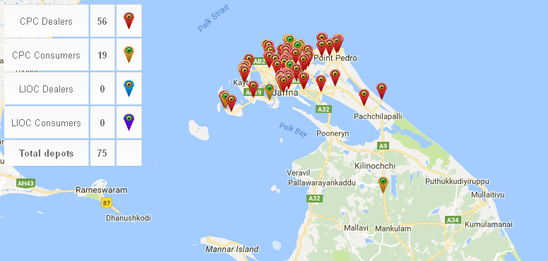

Fig. 7: Customers served by CPSTL bulk depot KKS.
Mode of Transport | Source | Destination | Distance (km) | Cost per 1km per 1 litre (Rs.) | Final Cost per 1km per 1 litre (Rs.)
Rail | Kolonnawa Terminal | KKS Bulk Depot | 412 | 1.45 | 1.45
Combined method | Kolonnawa Terminal | IRD Vavuniya | 256 | 0.90
 | IRD Vavuniya | KKS Bulk Depot | 152 | 1.60 | 2.51
Combined method | Kolonnawa Terminal | A'pura Bulk Depot | 196 | 0.69
 | A'pura Bulk Depot | KKS Bulk Depot | 206 | 2.17 | 2.86
Average of the Above 02 methods |  |  |  |  | 2.69
Cost Saving |  |  |  |  | 1.23

Table 6: Cost comparison for replenishing KKS bulk depot.

- Replenishing of Galle and Matara bulk depots entirely via rail.
Currently the Galle train is operating for 06 days a week. It has a high potential to be operated twice a day with comparison to the other trains. If an extra train engine can be placed to collect the empty wagons and return them to Kolonnawa terminal, the daily delivery can be expanded by 100%.

Currently the Galle train is operating for 06 days a week. It has a high potential to be operated twice a day with comparison to the other trains. If an extra train engine can be placed to collect the empty wagons and return them to Kolonnawa terminal, the daily delivery can be expanded by 100%.

Product | Total deliveries for Jan. - Oct 2017  (Kl) | Monthly delivery Avg.  (Kl) | Daily Avg. delivery qty.  (Kl) | Current Daily delivery capability (Kl) | Proposed Daily delivery capability (Kl)
Auto Diesel | 183,292.88 | 18,329.29 | 704.97 | - | -
Super Diesel | 3,603.60 | 360.36 | 13.86 | - | -
Petrol 92 Oct. | 8,626.20 | 862.62 | 33.18 | - | -
Kerosene | 89,074.73 | 8,907.47 | 342.60 | - | -
Total | 284,597.41 | 28,459.74 | 1,094.61 | 363.20 | 726.40

Table 7: Statistics and feasibility of proposal for Galle and Matara bulk depots.

As per the statistics, only a portion of the daily product demand is catered via rail and there is sufficient capacity to be delivered via rail. These will double the SLR revenue for the Galle train. Since it is cheaper to utilize rail, it will drastically reduce CPSTL transport tariff.

Conclusion
Transportation of bulk petroleum products via railways has been an effective strategy since its inception. Its relevance is applicable to the date due to cost concerns and convenience. Delay of infrastructure development has withheld the Sri Lanka railways from reaping the maximum benefits. It is of high important to expedite developments related to Sri Lanka railways and the Sri Lankan petroleum industry, in order to productively cater to ever rising energy demand of the country.

References

Ceylon Petroleum Storage Terminals Ltd. (2017) Retrieved from http://www.cpstl.lk/ aboutcpstl.php

Ceylon Petroleum Storage Terminals Ltd. (2017) Executive Summary Report – September 2017.
- Sri Lanka Railways. (2017) Retrieved from http://www.railway.gov.lk/web/index.php? lang=enhttp://www.railway.gov.lk/web/ index.php?lang=en

