MODIFICATION OF PORT SUSTAINABILITY MANAGEMENT SYSTEM (PSMS)

Ridvan Karacay , John Dinwoodie and Lynne Butel
Department of International Shipping, Logistics and Operations, Plymouth Business School

Introduction
This project aims to investigate the systems and processes which ports deploy to investigate and manage sustainability issues. As the largest ports industry in Europe, the UK hosts over 700 smaller and medium sized ports (Ports UK, 2014). This project builds on award winning research (Kuznetsov, 2014), which aimed to assist smaller ports in Cornwall and Devon (CAD) to ensure more sustainable maritime operations and development, helping them to survive and grow by safeguarding vital commercial revenue streams. This work will assess the planning, processes and systems required to disseminate PSMS beyond CAD into the UK and Turkey by assessing any requirements for modifications, the benefits offered, and barriers to implementation.

The importance of sustainability is continuously increasing in the ports industry. Several port sustainability systems are designed to assist ports to become more sustainable by putting the environment first as their priority. One of these sustainability management systems is the Port Sustainability Management System (PSMS). PSMS is designed to assist harbour masters to identify and document any concerns they may have (Kuznetsov, 2014). PSMS is a system, which is designed to help harbour masters to execute their practical responsibilities in managing ports sustainably. PSMS assists harbour masters to see their organisation’s current achievement level in terms of sustainability, based on eleven pillars, which encourage harbour masters to plan future development within areas that need to be improved. The eleven-pillars (Figure 1) relate to harbour operations, to achieve the goal of a sustainable harbour (Kuznetsov, 2014). The aim of the PSMS is to create a system that assists harbour masters to self-evaluate the sustainability of their organisation and to designate priority areas that require improvement, indicated by a system that is designed to be appropriate for a range of ports.

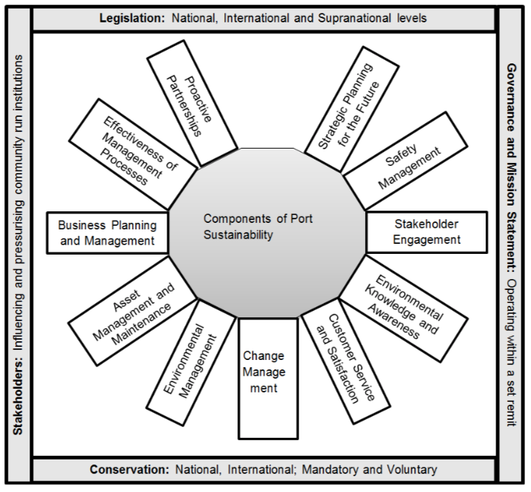
Figure 1: Eleven Components of port sustainability Source: Kuznetsov, 2014 p.161.
PSMS invites harbour masters to select scores to rate the sustainability of their organisation after undertaking a self-evaluation procedure using a bulls-eye chart (Figure 2). This chart assists harbour masters to assess their organisation’s current situation and the areas that need to be improved. Harbour masters can review previous charts to check for on-going improvements. In this way PSMS charts an endless circle of development for harbour masters.

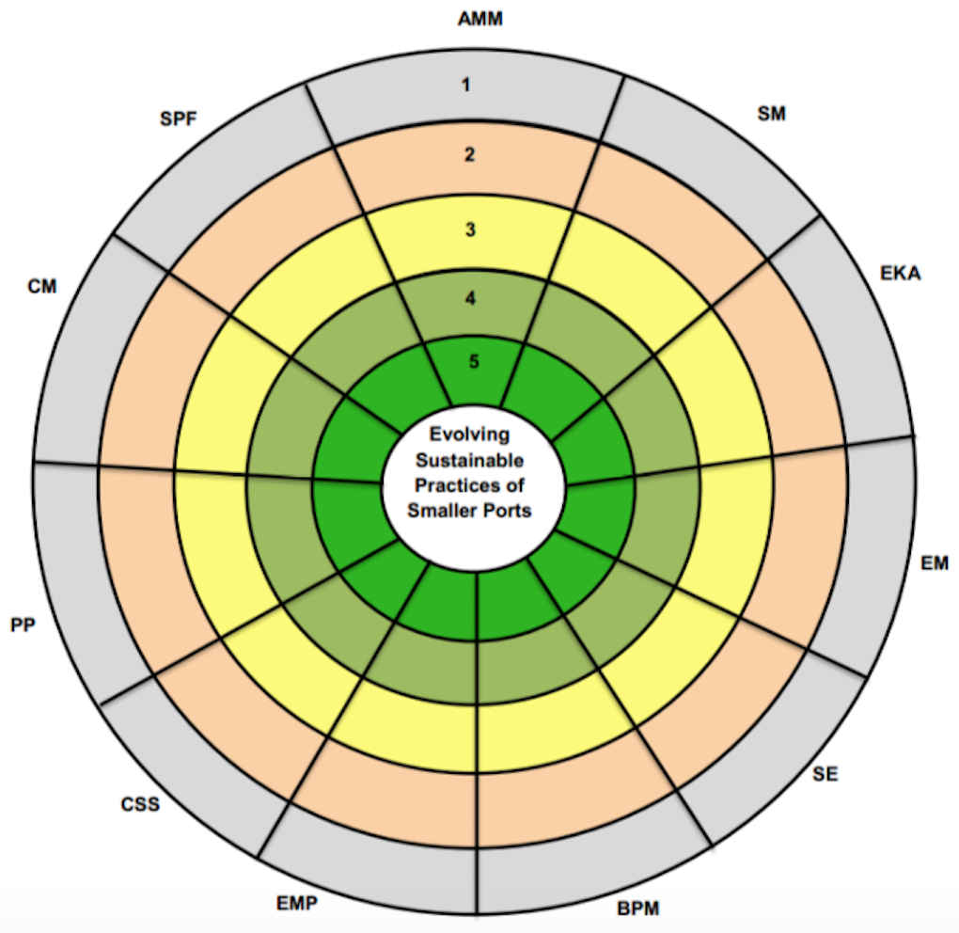

Figure 2: PSMS v5 Source: Kuznetsov, 2014, p.398.

Acronym | Description | Score
AMM | Asset Management and Maintenance
SM | Safety Management
EKA | Environmental Knowledge and Awareness
EM | Environmental Management
SE | Stakeholder Management
BPM | Business Planning and Management
EMP | Effectiveness of Management Processes
CSS | Customer Service and Satisfaction
PP | Proactive Partnerships
CM | Change Management
SPF | Strategic Planning for the Future

Table 1: Score Sheet of Eleven Pillars in PSMS v5 Source: Kuznetsov, 2014, p.398.
Table 1 above illustrates the PSMS v5 score sheet of eleven pillars . After the self-evaluation process of the PSMS, harbour masters add up the scores and then divide the total score by 11 to get the overall average rating of their harbour results. PSMS also lets harbour masters to focus on their missing pillar and show harbour masters to fix/improve the required pillars.

PSMS also facilitates comparisons of port performance if ports are willing to set benchmarking standards against, which to compare their performance. Alternatively, PSMS offers a tool to self-evaluate a port’s sustainability.

The research problem
To assess the extent to which PSMS offers a self-evaluation tool to assess port sustainability, nine interviews were conducted either face-to-face or by telephone and email. Interviews were undertaken in three British ports, five Turkish ports and with one lecturer in a Turkish university to combine practitioner and academic perspectives. From the nine interviews, one interview is selected from both countries for this paper. The interviews reported engaged the chief executive of Poole Harbour Commissioners and the general manager of the Port of Akdeniz in Antalya, Turkey.

To assess the current level of sustainability awareness the Turkish and British ports were compared. Both ports are medium-sized port according to the definition of medium-sized port used by the European Union. The turnover of Poole port is around GBP 11 million, whereas the Port of Akdeniz turns over USD 53.4 million. Both ports deliver multiple services including commercial and cruise business. Both ports have development plans, which aim to be more sustainable and to benefit from the latest updates in the port industry, and both ports want to succeed through becoming more sustainable.

Antalya is one of the most desirable cities in Turkey and has seen remarkable improvements attracting tourists from around the world with its natural beaches. Port Akdeniz is one of the main actors in these improvements, delivering a quality service to its customers as a cruise port and dry bulk port. To deliver more quality service as commercial and cruise port, Global Investment Holdings (GIH, the owner of the port), made big investments to increase the port capacity of the Port of Akdeniz. With the investment the whole marine area is approximately 136,000 m² (Çaglayan, 2018).

Poole has one of the largest natural harbours and delivers several services in a conflicting interests situation involving commercial, recreational, military and environmental dimensions, and also has a significant importance for nature conservation, as most of the foreshore is designated a SPA (Special Protection Area) under the European Habitats Directive and sites around the harbour are also designated as Areas of Outstanding Natural Beauty whilst the southern shores have Heritage Coast status (Phc.co.uk, 2018).

Methodology
There are numerous ways to analyse the recordings of interviewees discussing their various experiences. Thematic analysis is one such method. Further, research discoveries can result from differing levels of data transformation undertaken during the process of data analysis, ranging from simple description through to interpretation (Vaismoradi et. al., 2013, p. 399). Thematic analysis is a qualitative descriptive approach, appropriate for researchers who seek to engage in low-level interpretation.

Thematic analysis is used to examine classifications and impart patterns (themes) that interact within a data set. Thematic analysis shows the data in detail and can cope with diverse subjects by interpretation (Alhojailan, 2012, p.40). Braun & Clarke (2006) view thematic analysis as theoretically flexible, because during the search for, and testing of themes, the use of language does not require any specific language theory, or particular framework within which to categorise the descriptive meaning of people, experiences or actions. Consequently, thematic analysis can be used within a variety of theoretical frameworks and even thematic discourse analysis is achievable. Thematic analysis can be studied without reference to some of the possibly confusing prior theoretical knowledge required in other qualitative approaches, thereby assisting new students (Braun & Clarke, 2013, p.120). Braun and Clarke (2006) identified six phases of thematic analysis. These ‘six phases’ should not be seen as a linear system, where one cannot continue to the next level without finishing the previous phase correctly; rather, analysis is a recursive process. Braun and Clarke’s (2006, p.87) model is used to analyse the port interviews discussed below and spans six phases:

- Familiarisation with the data
- Coding
- Searching for themes or patterns
- Reviewing themes
- Defining and naming themes
- Writing up

The aim of data collection is to gather general data about sustainable port management and sustainability in port planning and to observe the level of awareness of sustainability in ports in the two case study ports. Data was collected in interviews with the Chief Executive of Poole Harbour Commissioners and the General Manager of the Port of Akdeniz, the leaders of these organisations, as primary data. Interview prompt sheets guided face-to-face meetings, which were recorded using a voice recorder after permission had been granted.

Problem Description or challenge
One aim of this paper is to capture industrial views of PSMS in relation to port management and another is to review the suitability of an existing bespoke PSMS with a view to further applications in the port industry involving wider perspectives for self-evaluation in terms of port size (small/ medium/ large), type (container/ dry bulk/ cruise) and governance (municipal/ trust/ private). Possible amendments to PSMS involve review of the 11 pillars of sustainability, with scope for adding an additional pillar(s) or sub-pillar(s) after reviewing the current PSMS systems from a wider set of perspectives.

Results/analysis
Whilst gathering data it emerged that each port has different priorities which depend on size, type and governance, which implies that a single inflexible PSMS is unlikely to be reliable given the differing size, type and governance of ports. Also by comparing British and Turkish ports, different levels of awareness emerged between the countries. In this paper, these differences are examined using the interview data gathered from Poole and Port Akdeniz (Antalya).

The interview with the General Manager of Port Akdeniz identified bureaucracy as a major obstacle to achieving sustainability goals as his organisation progresses in the port industry. Due to lengthy bureaucratic processes, it might take four years to conclude the paper work required for an investment, before construction can start or port infrastructure can be restructured. The length of the bureaucratic process is becoming a crucial factor especially in a country such as Turkey, where medium and long-term planning is difficult.

Conversely, bureaucracy was not mentioned as an obstacle in the interview with the Chief Executive Officer of the Poole Harbour Commissioners. One of the reasons might relate to the market approach of the two countries. The UK government is happy to let industry lead the market, whereas in Turkey, government is reluctant to delegate that authority to industry, and seeks to retain more control over the market. For this reason, bureaucracy can be a potential addition to the PSMS to adapt it to suit the wider perspectives of countries, which have different levels of bureaucratic processes.

“Governance” emerged as a useful addition to the PSMS because it influences ports when setting their organisational priorities. Poole port is a trust port in which any profits have to be spent on new investments and improvements to the infrastructures. Conversely, Port Akdeniz is a private port. Global Ports Holding (GPH) acquired a 40% stake in Port Akdeniz in 2006 and subsequently increased its share to 100% in July 2010. Hence, GPH’s priority is to recoup the costs of their investments as soon as possible for the purpose of satisfying their shareholders. These different priorities arise due to the governance type of the port, and as such governance offers an important potential addition to the PSMS to assist harbour masters in self-assessments of their organisations.

Culture emerges as the last potential addition to 11 pillars of PSMS. During the interviews with the Chief Executive of Poole Harbour Commissioners and the General Manager of Port Akdeniz, cultural differences were found to influence sustainability goals. Especially during the Port Akdeniz interview, responses to the prompt: “Do you believe that there is enough collaboration between organisations?’ culture emerged as a potential addition to the PSMS. The reason proffered for a lack of healthy collaboration is the oriental working culture in Turkey.

One characteristic of Turkish industry is that typically, for many managers, incurring a capital loss is preferable to being forced into collaboration. This might reflect cultural influences of managing organisations within a one-man system, where everything is connected to that specific person who is in charge. The oriental working culture presents the biggest challenge for the industry. If a solution can be found to overcome the oriental working culture issue, other secondary issues will be resolved much more easily according to the general manager of Port Akdeniz.

Another type of culture, which has an impact on the industry, is the organisational culture. Organisational culture can be a good influence on sustainability in terms of efficiency. Organisations should consider oriental working culture while establishing an organisational culture especially in circumstances such as entering a new market in a new country in order to become more sustainable.

Discussion
The potential impact of this paper is to note that in modifying PSMS to suit possible applications globally, a broader perspective of sustainability is needed, compared with applications solely to smaller ports in the South West UK. Further, port self-assessments depend on geographic location, port size, port type and governance type.

The PSMS is a reliable self-assessment system for smaller ports in the South West UK. Modifying and adapting PSMS to suit more ports globally also assists in setting worldwide standards with which to compare ports from a broader perspective.
To ensure more reliable results, the systems for port self-assessments should consider the geographic location of ports. For instance, a reliable system will offer a different process of self- assessment for a port with a deep berth depth compared with a port, which is struggling with its berth depth. Also geographic location is important due to external threats such as terrorism, which may arise far away from the main transportation routes.

Different size of ports should be evaluated using different standards. Small ports may have an overriding priority of survival, but medium or large sized ports probably prioritize shareholders’ satisfaction. The reason for evaluating different size of ports using different standards is because their priorities and opportunities depend on their size. Similarly, different types of ports have different priorities concerning their infrastructure investments and customer satisfaction. Applying the same process to self-assessment of container ports, where most shipping transportation ends, and dry bulk ports, which are becoming less attractive to industry, may preclude reliable evaluation or reduce the validity of the evaluation. Lastly, there should be different standards for different governance type of ports. Evaluations of trust ports, which have no shareholders and plough back profits into organisational investments, differ from private ports, which strive to maximize shareholder satisfaction. One solution might be to vary the importance of one of the 11 pillars in a modified PSMS, as port governance varies. For instance, customer satisfaction may be weighted more highly when evaluating a private port because this pillar is crucial in achieving the sustainability aspirations of the port.

Conclusion
Bureaucracy, culture and governance are possible additions to the original 11 pillars of PSMS following the data analysis. Future outputs will include recommendations regarding how global applications of PSMS would require modifications to ensure reliability in terms of sustainability awareness, management, systems and processes in ports.

In these potential three additions, “culture” may be the 12th pillar of the system with two sub-pillars underneath, namely “organisational culture” and “oriental working culture”. Bureaucracy can be added as a sub-pillar under the pillar of “effectiveness of management processes” because it affects the efficiency of the management processes. Regarding potential modification of “governance”, it may be appropriate to modify the standards of the current 11 pillar PSMS dependant on the governance type of a port. Lastly, updated model of PSMS is illustrated in Figure 3 to give idea about the modified PSMS.

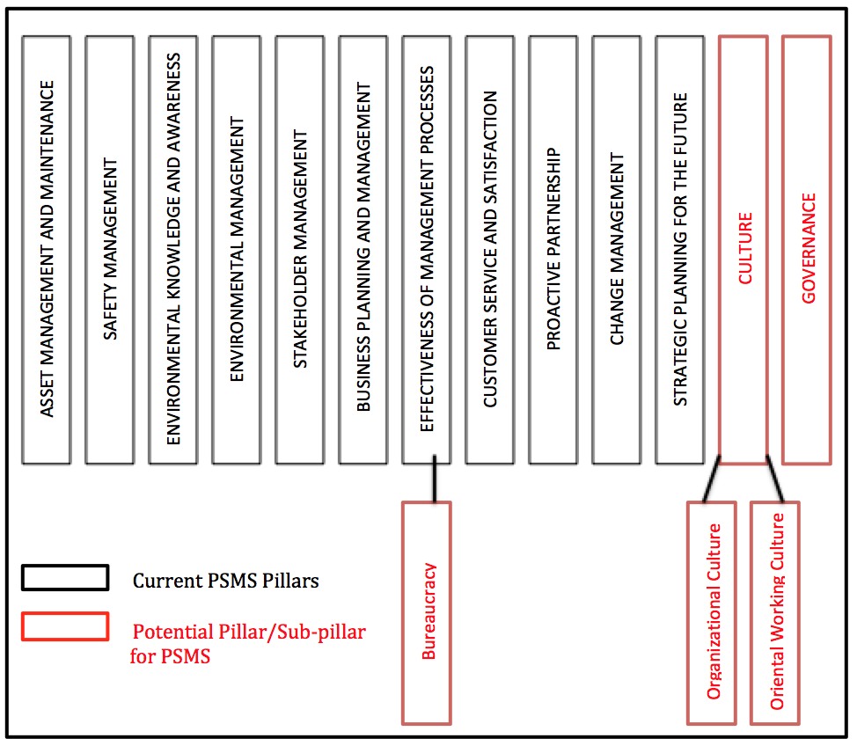
Figure 4: Potential Pillar/Sub-pillar Additions to PSMS
Ongoing research will be required to test potential additions and modifications to the PSMS to enable PSMS to reliably incorporate sustainability awareness, management, systems and processes in ports globally.

References
- Alhojailan, M. I. (2012), ‘Thematic Analysis: A Critical Review of Its Process and Evaluation’. West East Journal of Social Sciences Vol. 1 No. 1 p.40.
- Braun, V. & Clarke V. (2006), ‘Using Thematic Analysis in Psychology’, Qualitative Research in Psychology Vol. 3, pp. 77-101.
- Çağlayan, E. (2018). Global Investment Holdings - Port Akdeniz. [online] Globalyatirim.com.tr. Available at: https://www.globalyatirim.com.tr/en/investments/ports/global-ports-holding/77-port-akdeniz [Accessed 7 Jun. 2018].
- Clarke, V. & Braun, V. (2013), ‘Teaching thematic analysis: Overcoming challenges and developing strategies for effective learning’, The Psychologist, Vol. 26 No. 2, p. 120.
- Kuznetsov, A., (2014). Port Sustainability Management System for smaller ports in Cornwall and Devon. PhD thesis. Plymouth University. https://pearl.plymouth.ac.uk/handle/10026.1/3136
- Phc.co.uk. (2018). Poole Harbour Commissioners - About Us. [online] Available at: https://phc.co.uk/about.html [Accessed 12 Jun. 2018].
- Ports.Org (2014), Ports and Harbours of the UK, Available at: http://ports.org.uk/
- Vaismoradi, M., Turunen H. & Bondas T. (2013), ‘Content Analysis and Thematic Analysis: Implications For Conducting a Qualitative Descriptive Study’, Nursing and Health Sciences Vol. 15, p. 399.

