LONG-TERM FORECAST OF THE UNITED KINGDOM CONTAINER PORTS THROUGHPUT

Manuel Buitrago Moreno and John Preston
Transportation Research Group, Faculty of Engineering and the Environment, University of Southampton, UK

Throughput forecasting: a valuable tool for the strategic planning of the maritime transport sector of the United Kingdom within the current port governance models
Container ports act as the primary gateway for most of the United Kingdom (UK) trade (Eddington, 2006) and are key for the competitiveness of the UK’s economy and its supply chains in a globalised, trade‐dependent world. The ports of the United Kingdom handle around 95% of the total volume of UK trade and 71.87% of its value. (Department for Transport, 2016). Moreover, the port sector exerts significant economic influence in the UK. It is estimated that in 2016 the ports industry directly contributed approximately £22.6 billion in business turnover, £7.6 billion in gross value added (GVA) and supported 101,000 direct jobs (Cebr, 2017).

Port governance in the UK belongs to the Anglo‐Saxon doctrine. This means that UK container ports are private service ports (Thomas, 1994) and the few companies who own the UK port infrastructure propose the development and enlargement of their facilities.

The addition of new infrastructure by expanding container port capacity has a tremendous economic and environmental cost. Liverpool2 container terminal is an example of the substantial financial commitment that the construction and equipment of a container terminal involves. This is the latest development of a container terminal in the United Kingdom. Situated in the port of Liverpool, the terminal cost in excess £400m (Peel Ports Group, 2016). Regarding the externalities caused by new container port development, the public opinion has contested expansion schemes in the United Kingdom in recent years, such the proposed new deep‐water container terminal at Dibden Bay (Southampton).

The ultimate decision to grant permission for the expansion of container terminal capacity lies in the Government. Therefore, a country‐level port development policy ought to be informed by models capable of forecasting future container throughput at country level and appraisal the current container terminal capacity of the container port system accurately. A better understanding of the UK container port system and the demand that it must accommodate in the next decades is a cornerstone step towards a clearer strategic port planning that will seek to enable container port capacity expansions when needed.

The UK range
The UK range is defined as the set of container ports (lo‐lo) located in the UK (figure 1), which serve primarily the hinterland of Great Britain and to a lesser extent Ireland. In terms of throughput, the UK container port system is highly concentrated in the South East of the Isle of Great Britain, where the ports of Southampton, Felixstowe and London enjoy a privileged location, close to the maritime routes that flow from the Far East to Northern Europe across the English Channel (figure 1). The UK port range has seen during the last decade the considerable decline of some ports (in Thamesport, Tilbury and Tyne) as new deep‐water capacity was built, such as London Gateway (2013) and the expansions at Southampton (SCT5, 2014) and Felixstowe (Berths 8&9, 2011). A detailed study of the dynamics within the UK port range can be found in Buitrago and Preston (2018). The degree of concentration of the UK container port system is high, but has been relatively stable during the last years and has only slightly increased.

Previous studies on container throughput forecasting
Since its first steps in the 1980s, container throughput forecasting research has considerably expanded. However, there has been no standardised methodology for the calculation of container port throughput yet. Maritime trade forecasting techniques can be divided in qualitative or quantitative. Quantitative forecasting techniques can be classified into causal methods, time‐series methods and nonlinear dynamic methods. (Abraham et al., 1983). Time series models include exponential smoothing, autoregressive integrated moving average (Klein, 1996; Veenstra et al., 2001; Amoako, 2002; Rashed et al., 2017) seasonal autoregressive integrated moving average (SARIMA) (Schulze et al., 2009), vector autoregressive (VAR) (Syafi’i et al., 2005), decomposition (Peng et al., 2009) and grey forecasting (Guo et al., 2005; Zhang et al., 2013; Twrdy et al., 2016).

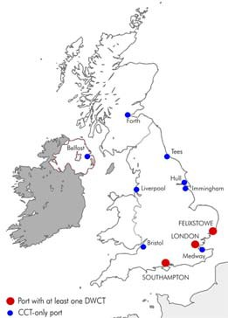
10000

7500

5000

2500

0

FLXTW SOTON LONDON LPOOL

Figure 1: a) The UK container port system b) Throughput evolution in the UK container port system the UK (1982‐2016) in kTEU. Data: Department for Transport, OECD

Causal models bind the container throughput with explanatory variables, using regression techniques and sometimes elasticity analysis. Normally, port authorities, consultants and transport departments explore the causal relations between the throughput and socio‐economic indicators. Causal models have been applied to several geographical scopes. Seabrooke et al. (2003) forecast the traffic of the port of Hong Hong, Gosasang et al. (2011) analysed the volumes of the port of Bangkok, Patil and Sahu (2015) investigated the port of Mumbai, Chou, Chu and Liang (2008) dealt with the main ports of Taiwan and van Dorsser et al. (2012) computed a long‐term forecast of the Hamburg – Le Havre range.

Finally, there has been a constant interest in the application of nonlinear dynamic models to port traffic forecasting. Under this category, neural networks is the most used technique (Gosasang et al., 2011; Ping et al., 2013; Mo et al., 2018). Other methods include genetic programming (GP) (Chen et al., 2010) and support vector regression (SVR) (Mak et al., 2007).

Manifold variables have been used in the literature as explaining variables for container throughput. A selection of variables includes: import prices (Coto‐Millán et al., 2005), trade value (Seabrooke et al., 2003), population (Seabrooke et al., 2003; Gosasang et al., 2011) exchange, interest and inflation rates (Gosasang et al., 2011) or the production of oil (Patil et al., 2015).

The studies in container traffic forecasting can be further classified according to the time scale and the geographical scope. In the temporal scope, we can differentiate short‐, mid‐ and long‐term forecasting. Time series is mainly used in short‐term forecasting (1 ‐ 5 years). Causal methods establish an explanatory relationship between the response variable and the predictors (also called explanatory variables). Therefore, causal methods are applied to port throughput forecasting with a horizon year greater than 5 years (mid‐term and long‐term port traffic forecasts). The geographical scope of the previous forecasting studies varies considerably. Scholars have tried to forecast individual terminal or ports (Hui et al., 2004; Lam et al., 2004; Patil et al., 2015), a set of ports or a port region (Liu et al., 2011), the throughput in a specific country (S. Chen et al., 2010) or finally, a whole port range, which can be comprised in one country or extend between several (Langen et al., 2012; van Dorsser et al., 2012; Twrdy et al., 2016).

Methodology.
This paper presents a long‐term country level forecast of the container throughput of the United Kingdom container port system up to 2050 by means of a several multivariate linear and non‐linear regression models, which employ key macroeconomic predictors. These econometric models rest on the causality between the macroeconomic explanatory variables and the container throughput.

The predictors considered to predict the container throughput (TEU) were the UK gross domestic product (GDP), the energy cost (FC) and the UK population (POP).

The response variable (TEU) represents the aggregated container throughput in the UK, measured in twenty‐ foot equivalent unit (TEU). This is an inexact way of measuring cargo throughput for at least the following reasons:

- Diversity of containers sizes. Container of several measures exist, being the most popular in maritime transport those of 20 and 40 feet. For containers of 40 feet, two TEU are accounted.

- Empty containers. The imbalance of trade between the economies of the Far East and Europe cause that a fraction of the containers handled at UK ports are in fact empty.

- Transshipment. Containers that are transferred to another maritime transport mode (including container feeder vessels and barges) are accounted two times for the throughput, as they are handled twice.

- It is suspected that port authorities aggregate container throughput data from roll on‐roll off (RoRo) to lift‐on/lift‐off (LoLo) figures.

In the majority of forecasting models found in the literature, unitised traffic has mainly been expressed in tonnes rather than in units or TEU. However, TEU should be preferred to tonnes for reasons of statistical compatibility, as the methodology to account for tonnage differs from port to port (Coeck et al., 1995). For the variable TEU, 45 years of aggregated container throughput data for the UK has been used, corresponding to the period 1971 – 2016 (Department for Transport, 2017; OECD, 2018).

Gross Domestic Product (GDP) is monetary appraisal (normally in US$) of the market value of all goods and services produced in a country during a year. There are three approaches to measure GDP: the production approach, the income approach and the expenditure approach. Most countries follow the System of National Accounts (European Commission et al., 1993) as an international standard for measuring GDP.

There is a direct relationship between GDP and international trade. As freight transport is a derived demand, subsequently GDP and the transport of goods are correlated (Ickert et al., 2007; Rijsenbrij et al., 2011). GDP and international trade have a bidirectional relationship. However, it must be noted that GDP reflects wider changes in the domestic activity, which are not necessarily linked to the volume of imports and exports.

Frequently used in throughput forecasting, the so‐called GDP multiplier is the ratio between the compound annual growth rate (CAGR) of global container trade and the CAGR of the global real GDP. The multiplier was 2.16 between 1985 – 1989, surged to 4.22 in the next decade as maritime trade enabled the second phase of globalisation and slowed down to 2.92 during the 2000s up to the Great Recession (2008‐2011). Finally, we entered a new paradigm for the period 2012 – 2016 when the multiplier has been rather low (1.66) and even sank below 1.0 occasionally (figure 2).

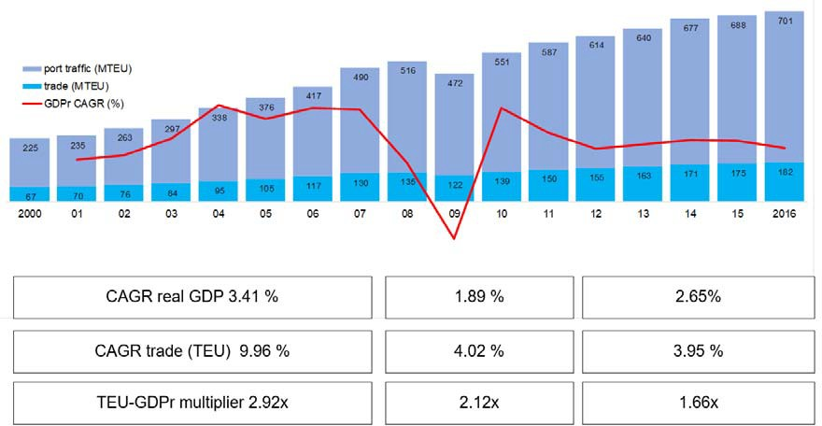

Figure 2: Global port traffic and trade in MTEU (2000 ‐ 2016). Data: Port traffic, GDP: World Bank; trade traffic: Alphaliner

Perhaps excessive importance has been placed in this multiplier when forecasting cargo. It must be observed that container trade represents trade flows, full containers moving from origin to destination. On the other hand, container port traffic includes every move of a box, whether import, export or transshipment. Port traffic is always a multiple of trade flows given that a container can be processed twice in one or several ports within the supply chain. Container trade increased globally in volume by 172% during the period 2000 – 2016, but the container port traffic did by 212%. The surge in container traffic was partially caused by a reshuffle of maritime shipping lines networks. The higher reliance of the supply chains on hub and spoke maritime networks increases the number of times a container is handled from origin to destination and the transshipment volumes. The demand growth is weaker than during the period 2001 ‐ 2007, when global container port throughput grew at an impressive CAGR of 11.8%. Since then, a slower growth pace has become the new normal (~ 4%).

At the beginning, a better fit was obtained when GDP PPP (purchasing power parity) was used instead of real GDP. However, using GDP PPP for building the model would be problematic, as it would rely on the International Monetary Fund (IMF) projection, which only stretches until 2022, short of the desired forecasting horizon year. It became clear during the construction of the econometric model that it is necessary for throughput forecasting to use real GDP instead of nominal GDP, in order to avoid the effect of inflation. Furthermore, it is even more important to use GDP expressed in the national currency. This is crucial if big currency devaluations against the USD took place in the period of study.

Various organisations elaborate short‐term and long‐term projections for the GDP of the UK. There are numerous short‐term GDP forecasts available. We computed the average of the UK GDP growth rate projected by Office for Budget Responsibility (OBR), Oxford Economics, Bank of England, European Commission, the National Institute of Economic and Social Research (NIESR), OECD and IMF for the period 2017 – 2022. The OBR’s GDP long‐term forecast was used for the period 2023 – 2050.

The variable fuel cost (FC) accounts for the energy price in the model. The Brent Oil spot price, which is the reference for the European markets, was chosen as the reference for computing the fuel cost. The data for both the historical data and the price projection have been extracted from the Annual Energy Outlook of the U.S. Energy Information Administration (EIA), (2017).

The variable population (POP) accounts for the mid‐year population of the United Kingdom. This variable collects the statistical information about the population of the UK. Under neoclassic economic theory the population of country is an explanatory variable for the GDP calculation in the Solow‐The Solow–Swan model (Solow, 1956; Swan, 1956). Should the population of a country grow, there will be an increment of the labour hours, which will be translated into GDP growth. However, the relationship between population and GDP growth and has been challenged by Peterson (2017). In recent years, technological progress has enabled GDP increments without an increment of the labour factor. The variable POP was disregarded in the final models because it provoked multicollinearity, as GDP is highly linearly related to population. The correlation between the explanatory variable GDP and the dependent variable TEU for the period 1971 – 2016 is very strong (figure 3). Consequently adding more variables to the model yields a limited benefit in terms of increasing the explanatory power of model, while its complexity would increase. In the discussed models, one domestic variable (GDP) and one international commodity (fuel cost) were chosen as predictors.
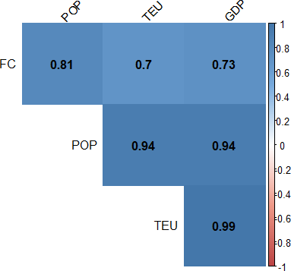

Figure 3: Correlation matrix of the studied explanatory variables

Regression models
The proposed multivariate regression models are:

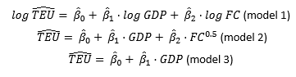
Where:

- TEU is the container throughput in the UK container port system in a given year j, in TEU.

- GDP is the real gross domestic product of the UK in a given year j, in 2010 £m.

- FC is the average price of a barrel of Brent crude oil in a given year j, in 2017 USD /barrel.

Applying the model to the available set of data, the following regression coefficients where obtained (table 1):

 | Model 1: | Model 2: | Model 3:
Intercept | ‐14.46507 | ‐2.696E+03 | ‐2.657E+03
GDP | 1.65270 | 6.761E‐03 | 6.364E‐03
FC | ‐0.0636 | ‐84.04 | ‐
R2 | 0.9883 | 0.9823 | 0.9805
RMSE | 250.129 | 316.816 | 339.5416

Table 1: Regression coefficients

The model 1 has both the best adjusted R‐squared and the minimum root‐mean‐squared error (RMSE).

Projections elaborated by reputed institutions are used to predict the throughput using the models. The GDP projection uses the estimated growth rate for two separated periods 2017 – 2022 and 2023 – 2050. The GDP growth rate of the period 2017 – 2022 was calculated as the average of the projections provided by the Office for Budget Responsibility (OBR), Oxford Economics, Bank of England, European Commission, the National Institute of Economic and Social Research (NIESR), the OECD and the IMF. The OBR long‐term GDP projection was used for the period 2023 ‐2050. The projection of the fuel cost, namely the cost of a Brent oil barrel was given by the forecast of the EIA (2018).

The projected values of the model one can be seen in figure 4:
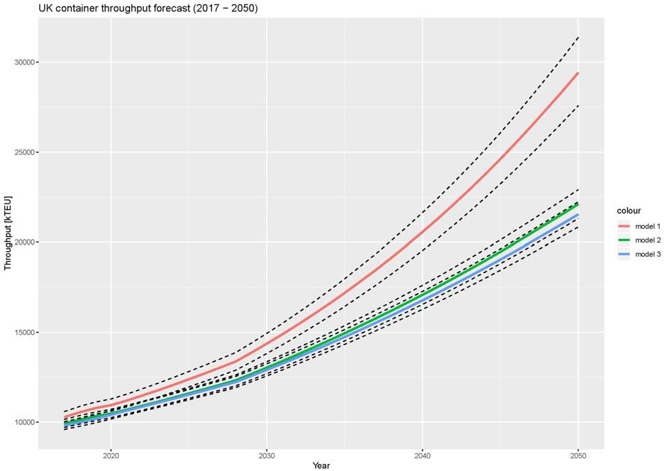

Figure 2: Projections (2017 ‐2050) of the models and the confidence intervals

Van Dorsser et al., (2010) suggested that apart from GDP, other variables should be included in the modelling of port throughput using regression methods.

Other variables that could be included in the model, as they could have a significant effect on the projection of container traffic, are:

- Containerised commodities and goods factor, also known as commodity effect. This factor would reckon changes in containerisation ratio, as more commodities shifted to containers during the last decades and this trend may continue until it reaches a point of saturation.

- Hinterland boundaries. It would reflect how the development of the hinterland infrastructure expands its boundaries, which affects the flows of cargo that go through the port.

- Automation of ships – it could lead to an increase in capacity of containers ships as crew areas an certain machinery would not be longer needed.

- Impact of the Chinese government‐backed policy “One Belt One Road” (OBOR). The OBOR policy includes the further development of the maritime route between China and Europe. The impact of the OBOR could be twofold. It will generate a terrestrial alternative to the maritime route. This “New Silk Road” allowed freight trains to link for the first time in history the United Kingdom and China. The freight train took 17 days, which is significantly less than the maritime alternative. Secondly, the enhanced maritime route might increase the maritime trade worldwide, having a relative impact in the UK container flows.

- New maritime routes. The opening of new maritime routes such as the Artic route or the Northwest Passage would reshuffle the cargo flows in North Europe affecting the number of calls and volumes at UK container ports.

- Technological disruptions. The rise of additive manufacturing enabled by 3D printing technology would potentially reduce the amount transportation needed to deliver some goods to final consumers or other stages of the production chain. This implies that some production centres would be relocated back to Western countries if the manufacturing cost were substantially reduced. The location of manufacturing locations would be reshuffled and global trade patterns might substantially evolve. According to Ye (2015) the disruptive effect of 3D printing in global container throughput will be limited. Ye (2015) foresees a reduction of 0.511% of the total world throughput in 2035 compared to 2006 for the central scenario, with a maximum drop of 10.295% for a scenario that account for an extreme widespread use of 3D printing.

- Resources. The resources of the world are being depleted at higher rates to fuel economic growth but Earth is finite. Better appraisal of GDP should take into account that the resources will be the limiting factor of never‐ ending over‐optimistic exponential growth. Reviewed GDP forecast would have a dramatic impact in container throughput forecast (Galbraith, 2015).

- Trade wars. A return to protectionism policies worldwide could sever trade at a global scale, and as result, it would lead to a lesser need for maritime freight transportation.

Prudence should preside over the assessment of future container flows and traffic volumes. Forecasting methods usually display an apparent mathematical rigour but they do not incorporate innovation and economic cycles (Notteboom et al., 2009). Likewise, linear models cannot take into account external shocks (e.g. economic crisis, recessions, liberalisation or protectionism of trade) neither disruptive technologies and innovation. Furthermore, some developments driven by technological innovation could result in unforeseen side effects (Merton, 1936), what are not captured by the proposed model. Because of the above‐mentioned reasons, it is common practice to complement and affect the results obtained by a linear model with qualitative data, often pulled together by a panel of experts. The qualitative assessment of exogenous shocks incorporates punctual macroeconomic‐relevant events and help to identify structural breaks. However, the departure from quantitative forecasting methods comes at the price of introducing an undesired element of subjectivity in the traffic forecast. Several scenarios have been built (table 2) to reflect these uncertainties.

Scenario | GDP projection | FC projection | OBOR impact | 3D printing
Central | Central | Central | From 2020 onwards | From 2030 onwards
Low GDP + High FC | Low | High | From 2020 onwards | From 2030 onwards
Hard Brexit | 50% lesser immigration from EU | High | From 2020 onwards | From 2030 onwards

Table 2: Scenarios

- Conclusions
This paper has introduced a novel method to forecast container throughput at a national scale, including for the first time a fuel cost variable. Shedding light into how the container volumes absorbed by the UK container port system may evolve in the future, a methodology has been presented, which permits to forecast the traffic throughput in the UK container port system up to the horizon year 2050.

The evolution of the demand of container traffic in the UK indicates that container traffic at UK seaports will grow steadily up to 2050, surpassing 20 MTEU in all the three models by the horizon year. It is reasonable to assume, looking at the historical trends and current trading patterns, that 70‐80% of the total demand would be attended by a reduced number of deep‐water capable ports. The projections elaborated provide a valuable tool for policy makers as it is possible to reconcile these forecasts with the available capacity of the container system to evaluate the capacity margin, leading finally to a decision on when to grant permissions to add additional capacity.

Port infrastructure is costly in financial terms and lengthy in time to build and expand and better guidance is needed of when and where these key investments should be deployed (Meersman, Van de Voorde and Vanelslander, 2014). Even when the UK has a privatised container port system, the Government should monitor available capacity and develop independent container throughput forecasts. This paper provides a rationale on which to decide granting permission for future port development and might entice the UK’s government to play a bigger role in the planning of container port infrastructure, helping to rationalise the bids for new container terminals in the future.

Acknowledgments
The authors would like the Southampton Marine and Maritime Institute (SMMI) of the University of Southampton and ITRC Mistral for funding this research.

References
- Abraham, B. and Ledolter, J. (1983) Statistical Methods for Forecasting. New York: Wiley.
- Amoako, J. (2002) ‘Forecasting Australia’s international container trade’, 25th Australasian Transport Research Forum. Canberra.
- Buitrago, M. and Preston, J. (2018) ‘Forecasting the throughput of the United Kingdom container ports system up to 2050’, in. Antwerp.
- Cebr (2017) The Economic Contribution of the UK Maritime Sector. London.
- Chen, S. and Chen, J. (2010) ‘Expert Systems with Applications Forecasting container throughputs at ports using genetic programming’, Expert Systems With Applications. Elsevier Ltd, 37(3), pp. 2054– 2058. doi: 10.1016/j.eswa.2009.06.054.
- Chen, S. H. and Chen, J. N. (2010) ‘Forecasting container throughputs at ports using genetic programming’, Expert Systems With Applications. Elsevier Ltd, 37(3), pp. 2054–2058. doi: 10.1016/j.eswa.2009.06.054.
- Chou, C. C., Chu, C. W. and Liang, G. S. (2008) ‘A modified regression model for forecasting the volumes of Taiwan ’ s import containers’, Mathematical and Computer Modelling, 47(9–10), pp. 797–807. doi: 10.1016/j.mcm.2007.05.005.
- Coeck, C. et al. (1995) ‘The unreliability of maritime trade statistics: an extension of results’, International Journal of Transport Economics / Rivista internazionale di economia dei trasporti, 22(2), pp. 217–224.
- Coto‐Millán, P., Baños‐Pino, J. and Castro, J. V. (2005) ‘Determinants of the demand for maritime imports and exports’, Transportation Research Part E: Logistics and Transportation Review, 41(4), pp. 357–372. doi: 10.1016/j.tre.2004.05.002.
- Department for Transport (2012) National Policy Statement for Ports. Available at: https://www.gov.uk/government/uploads/system/uploads/attachment_data/file/3931/national‐ policy‐statement‐ports.pdf.
- Department for Transport (2017) ‘UK Port Freight Statistics: 2016 final figures (Revised)’. London.
- Department for Transport (2018) Maritime 2050: Call for evidence. London.
- van Dorsser, C., Wolters, M. and van Wee, B. (2012) ‘A Very Long Term Forecast of the Port Throughput in the Le Havre ‐ Hamburg Range up to 2100’, European Journal of Transport and Infrastructure Research, 12(1), pp. 88–110.
- van Dorsser, M. and Wolters, M. (2010) ‘A Very Long Term Forecast for the development of the Cargo Flows in the le‐Havre – Hamburg range’, in Port infrastructure Seminar 2010. Delft. Available at: https://repository.tudelft.nl/islandora/object/uuid%3Ad3810cd0‐b0ff‐4daf‐9341‐ 4729b6148fc3.
- Eddington, R. (2006) The Eddington Transport Study ‐ the Case for Action.
- European Commission et al. (1993) ‘System of national accounts, 1993’, Journal of Government
- Information, p. 814. doi: 10.1016/1352‐0237(95)90103‐5.
- Eurostat (2018) What is the ‘Rotterdam effect’? Available at: http://ec.europa.eu/eurostat/stat istics‐explained/index.php/International_trade_statistics_‐_background#What_is_the_.27Rotterdam_effect.27.3F (Accessed: 2 March 2018).
- Galbraith, J. K. (2015) The End of Normal: The Great Crisis and the Future of Growth. Simon & Schuster.
- Gosasang, V., Chandraprakaikul, W. and Kiattisin, S. (2011) ‘A comparison of traditional and neural networks forecasting techniques for container throughput at Bangkok port’, Asian Journal of Shipping and Logistics, 27(3), pp. 463–482. doi: 10.1016/S2092‐5212(11)80022‐2.
- Guo, Z., Song, X. and Ye, J. (2005) ‘A Verhulst Model On Time Series Error Corrected For Port Throughput Forecasting’, J. of the Eastern Asia Society for Transportation Studies, 6, pp. 881–891.
- Herfindahl, O. C. (1950) ‘Concentration in the U.S. Steel Industry’. Colombia University Press, New York.
- Hirschman, A. O. (1945) ‘National Power and the Structure of Foreign Trade’. Publications of the Bureau of Business and Economic Research. University of California Press, Berkeley.
- Hui, E. C. M., Seabrooke, W. and Wong, G. K. C. (2004) ‘Forecasting Cargo Throughput for the Port of Hong Kong: Error Correction Model Approach’, Journal of Urban Planning and Development, 130(December), pp. 195–203. doi: 10.1061/(ASCE)0733‐9488(2004)130:4(195).
- Ickert, L. et al. (2007) Abschätzung der langfristigen Entwicklung des Güterverkehrs in Deutschland bis 2050. Basel.
- Klein, A. (1996) ‘Forecasting the Antwerp maritime traffic flows using transformations and intervention models’, Journal of Forecasting, 15(5), pp. 395–412. doi: 10.1002/(SICI)1099‐ 131X(199609)15:5<395::AID‐FOR628>3.3.CO;2‐Z.
- Lam, W. H. K. et al. (2004) ‘Forecasts and Reliability Analysis of Port Cargo Throughput in Hong Kong’, Journal of Urban Planning and Development, 130(3), pp. 133–144. doi: 10.1061.
- Langen, P. W. De, Range, L. H. and Langen, P. W. De (2012) ‘Combining Models and Commodity Chain Research for Making Long‐Term Projections of Port Throughput: an Application to the Hamburg‐ Le Havre Range’, 12(12), pp. 310–331.
- Liu, L. and Park, G. K. (2011) ‘Empirical analysis of influence factors to container throughput in Korea and China ports’, Asian Journal of Shipping and Logistics, 27(2), pp. 279–304. doi: 10.1016/S2092‐ 5212(11)80013‐1.
- Mak, K. L. and Yang, D. H. (2007) ‘Forecasting Hong Kong’s Container Throughput with Approximate Least Squares Support Vector Machines.’, World Congress on Engineering 2007 (Volume 1), I, pp. 7–12. Available at: http://search.ebscohost.com/login.aspx?direct=true&db= a9h&AN=32040347&site=ehost‐ live.
- MDS Transmodal (2016) The value of goods passing through UK ports. London.
- Meersman, H., Van de Voorde, E. and Vanelslander, T. (2014) Port Infrastructure Finance. Informa Law from Routledge.
- Merton, R. K. (1936) ‘The Unanticipated Consequences of Purposive Social Action’, American Sociological Review, pp. 894–904. doi: 10.2307/2084615.
- Mo, L. et al. (2018) ‘GMDH‐based hybrid model for container throughput forecasting: Selective combination forecasting in nonlinear subseries’, Applied Soft Computing Journal. Elsevier B.V., 62, pp. 478–490. doi: 10.1016/j.asoc.2017.10.033.
- Notteboom, T. E. (1997) ‘Concentration and load centre development in the European container port system’, Journal of Transport Geography, 5(2), pp. 99–115. doi: 10.1016/S0966‐6923(96)00 072‐ 5.
- Notteboom, T. E. (2010) ‘Concentration and the formation of multi‐port gateway regions in the European container port system: An update’, Journal of Transport Geography. Elsevier Ltd, 18(4), pp. 567–583. doi: 10.1016/j.jtrangeo.2010.03.003.
- Notteboom, T. E., Parola, F. and Satta, G. (2013) Synthesis of the information regarding the container transshipment volumes.
- Notteboom, T. and Rodrigue, J. P. (2009) ‘The future of containerization: Perspectives from maritime and inland freight distribution’, GeoJournal, 74(1), pp. 7–22. doi: 10.1007/s10708‐008‐ 9211‐3.
- OECD (2018) Container transport (indicator). doi: 10.1787/26de63f3‐en.
- Patil, G. R. and Sahu, P. K. (2015) ‘Estimation of freight demand at Mumbai Port using regression and time series models’, KSCE Journal of Civil Engineering, 20(5), pp. 2022–2032. doi: 10.1007/s 12205‐ 015‐0386‐0.
- Peel Ports Group (2016) Official Opening of Peel Ports £400 million Liverpool container terminal. Available at: https://www.peelports.com/news/2016/official‐opening‐of‐peel‐ports‐400‐million‐ liverpool‐container‐terminal (Accessed: 29 October 2017).
- Peng, W. Y. and Chu, C. W. (2009) ‘A comparison of univariate methods for forecasting container throughput volumes’, Mathematical and Computer Modelling. Elsevier Ltd, 50(7–8), pp. 1045–1057. doi: 10.1016/j.mcm.2009.05.027.
- Peterson, E. W. F. (2017) ‘The role of population in economic growth’, SAGE Open, 7(4). doi: 10.1177/2158244017736094.
- Ping, F. F. and Fei, F. X. (2013) ‘Multivariant Forecasting Mode of Guangdong Province Port throughput with Genetic Algorithms and Back Propagation Neural Network’, Procedia ‐ Social and Behavioral Sciences. Elsevier B.V., 96(Cictp), pp. 1165–1174. doi: 10.1016/j.sbspro.2013.08.133.
- Rashed, Y. et al. (2017) ‘Short‐term forecast of container throughout: An ARIMA‐intervention model for the port of Antwerp oa’, Maritime Economics and Logistics. Nature Publishing Group, 19(4), pp. 749–764. doi: 10.1057/mel.2016.8.
- Rijsenbrij, J. . and Wieschemann, A. (2011) ‘Sustainable Container Terminals: A Design Approach’, in Böse, J. W. (ed.) Handbook of Terminal Planning. Springer.
- Schulze, P. M. and Prinz, A. (2009) ‘Forecasting container transshipment in Germany’, Applied Economics, 41(22), pp. 2809–2815. doi: 10.1080/00036840802260932.
- Seabrooke, W. et al. (2003) ‘Forecasting cargo growth and regional role of the port of Hong Kong’,
- Cities, 20(1), pp. 51–64. doi: 10.1016/S0264‐2751(02)00097‐5.
- Solow, R. M. (1956) ‘A Contribution to the Theory of Economic Growth’, The Quarterly Journal of Economics, 70(1), pp. 65–94.
- Swan, T. W. (1956) ‘Economic growth and capital accumulation’, Economic Record, 32(2), pp. 334– 361. Available at: https://doi.org/10.1111/j.1475‐4932.1956.tb00434.x.
- Syafi’i, Kuroda, K. and Takebayashi, M. (2005) ‘Forecasting the demand of container throughput in indonesia’, Memoirs of Construction Engineering Research Institute, 47.
- Thomas, B. J. (1994) ‘The privatization of United Kingdom seaports’, Maritime Policy and Management, 21(2), pp. 135–148. doi: 10.1080/03088839400000030.
- Twrdy, E. and Batista, M. (2016) ‘Modeling of container throughput in Northern Adriatic ports over the period 1990‐2013’, Journal of Transport Geography. Elsevier B.V., 52, pp. 131–142. doi: 10.1016/j.jtrangeo.2016.03.005.
- U.S. Energy Information Administration (EIA) (2018) Annual Energy Outlook 2018.
- Veenstra, A. W. and Haralambides, H. E. (2001) ‘Multivariate autoregressive models for forecasting seaborne trade flows’, Transportation Research Part E: Logistics and Transportation Review, 37(4), pp. 311–319. doi: 10.1016/S1366‐5545(00)00020‐X.
- Ye, M. (2015) The impact of 3D printing on the world container transport [Master Thesis]. Delft University of Technology. doi: 10.4172/2324‐8777.1000163.
- Zhang, C., Huang, L. and Zhao, Z. (2013) ‘Research on combination forecast of port cargo throughput based on time series and causality analysis’, Journal of Industrial Engineering and Management, 6(1 LISS 2012), pp. 124–134. doi: 10.3926/jiem.687.

