MODAL SHIFT TO INLAND WATERWAYS: DEALING WITH BARRIERS IN TWO SWEDISH CASES

Sara Rogerson¹, Vendela Santén¹, Martin Svanberg¹, Jon Williamsson² and Johan Woxenius²
¹SSPA Sweden AB, Göteborg, Sweden
²Department of Business Administration, School of Business, Economics and Law, University of Gothenburg, Göteborg, Sweden

Introduction
One way to reduce environmental impact from freight transport is to shift transport of goods from road to sea. In comparison, sea transport most often generates less emissions such as CO₂ (Medda and Trujillo, 2010) and hence, shifting from road to different types of sea transport has been advocated by both national and international authorities. The EU has over the last two decades promoted different types of initiatives such as the Marco-Polo, Ten-T and Motorways of the Sea to induce a shift from road to short sea shipping (SSS) (Baird, 2007, Garcia-Menendez and Feo-Valero, 2009). Inland waterway (IWW) shares similarities with SSS in terms of comparable sizes of vessels and competition with road transport, but also has an unutilised potential for a modal shift. In particular, road and rail infrastructure can be relieved from congestion, which is of importance in urban areas, where ports often are located (Browne, et al., 2017).

While IWW transport is more common in Northwestern Europe, it is less common in Sweden. IWW transport in Northwestern Europe provides transport along rivers and canals and between ports and their hinterlands. In the Netherlands, with the largest share of inland waterway transportation in Europe, 18% of the goods volume is transported on IWW (CBS, 2016). In Sweden, the figures are much smaller, only 3% of the goods volumes make use of domestic sea transportation, in which 0,7 % is transported on IWW (Trafikanalys, 2016). In Sweden, from the 14th century until the early 1990s, rivers were used for floating logs to iron mills and paper and saw mills on the coast, but nowadays the majority of the small volume of IWW transport consists of transports of soil, stone, gravel and sand (Trafikanalys, 2017). As a result, container transport by IWW is rare.

Previous research on IWW transport has identified various types of barriers for a modal shift from road to sea: regulatory, financial, service and market related (described further later in the paper). In order for a modal shift to take place, actors need to take external prerequisites into account, but foremost, offer competitive services that can overcome the barriers. In Sweden, actors have to take major steps to attract a larger volume of goods that will enable the shift to IWW transportation. Barriers and key issues for implementation need to be understood from the perspective of how actors can overcome them. Therefore, the aim of this paper is to analyse how barriers for a modal shift can be overcome, by studying actors in the start-up phase of offering IWW transport services.

This study contains the following steps, 1) a literature review, 2) collecting data in two case studies, 3) collecting data from actors involved in Swedish IWW transportation, and 4) analysing collected data with regards to actor interactions to overcome barriers. Interviews were made several times and over 12-18 months for each case study and also, data was gathered from presentations and reports that the two entrepreneurs were producing. Moreover, data relevant to the two cases was collected from ports, logistics operators, goods owners and authorities, through two workshops and five interviews. Data was analysed, primarily to identify the barriers faced by the firms involved in the two case studies and their approaches to manage these barriers.

The following sections describe IWW and what hampers its growth in Sweden, and analyse ways forward in the empirical context of two case studies on the start-up phase of IWW transport services. The paper continues with the case study results and a concluding discussion.

Barriers and key issues for Inland waterway transportation
This section details earlier findings of relevance to IWW, based on studies of IWW in Sweden and Europe. Earlier studies have identified various barriers and key issues for modal shift from road to sea, among which four main categories can be identified: regulatory, financial, service quality and market characteristics. The barriers are summarised in Figure 1.

There are regulatory issues, specific to the Swedish setting, which create barriers. First of all there is uncertainty regarding regulation which by itself causes problem (Otterström and Torpfält, 2016). The background is that the regulation of IWW vessels is relatively new and has not been tested in Sweden. This creates uncertainty regarding for example cabotage (Garberg, 2016) or requirements on personnel (Otterström and Torpfält, 2016, Treiber and Bark, 2018). Moreover, regulations regarding piloting fees and fairway dues are set by authorities and are highlighted as influencing the costs to a large extent (Garberg, 2016). Regulatory issues also include the agreements with dockers/stevedores, which result in high costs for transhipment activities, and make it difficult for vessel personnel to perform transhipment (ibid). Regulatory issues also include investments in infrastructure of other modes (ibid) and regulations regarding competing modes, such as fees for railways.

Earlier studies reveal several key financial issues making it difficult to establish an IWW transport service. The various costs influence the competitiveness compared to other modes of transport, not least due to the large trucks (25,25 m and 64 tons - 74 tons on some main roads - allowed in Sweden) and well-developed rail freight system. The cost of pre/post-haulage (Konings, 2009, Wiegmans and Konings, 2015, Vierth, et al., 2012), the additional handling costs (ibid.), port charges (Garberg, 2016, Olsson and Ronold, 2017), fairway dues (ibid), and piloting fees (Olsson and Ronold, 2017). Fee structures of other modes also affect the competitive situation (Vierth, et al., 2012). There is also uncertainty regarding some of the costs, making it difficult for an entrepreneur calculating a business case. Additionally, there are investment costs and financial risk associated with starting a new business, for example investments in equipment in the ports (Olsson and Ronold, 2017). Lack of qualified personnel can also be an issue which drives up the cost of operations (Vierth, et al., 2012).

Besides costs, several important issues related to service quality can be identified in earlier studies. Service quality issues are important when companies buying freight transport select transport service. Key issues for the selection of transport service are cost, transport time, reliability and transport quality, where the latter includes for example on-time deliveries and transport damages (Flodén, Bärthel and Sorkina, 2017). Previous studies discuss issues related to transport time, frequency and reliability. Long transport time (Konings, 2009, Meers, et al., 2017, Vierth, et al., 2012) is highlighted as difficult in the competition against road transport, particularly due to the time for loading and unloading barges (Konings, 2009). In ports, temporary quay stacking and additional handling is likely needed, and time schedules of vessels needs to be matched with crane availability (Konings, 2009). Various systems have to be integrated for IWW transport to function smoothly, such as aligning lock planning and quay handling (Caris, et al., 2014). Frequency is also highlighted as important for shippers to select IWW transport (Konings, 2009, Meers, et al., 2017, Otterström and Torpfält, 2016). The frequency offered to shippers is also related to the vessel size (Vierth, et al., 2012). IWW transport is viewed as reliable (Konings, 2009), but earlier studies highlight issues such as prioritisation of transhipment in ports (Konings, 2009, Vierth, et al., 2012) as possibly affecting the reliability. Also, resistance to change existing transport mode has been identified (Garberg, 2016) which means that a mental shift is thought to be required for customers to use IWW (Meers, et al., 2017, Vierth, et al., 2012).

IWW transport services are offered on markets with specific characteristics that act as barriers to new entrants. These market characteristics mainly relate to the volume of goods required, competition from other modes of transport, conditions of the waterways, pre-requisites of vessels, business models and environmental concerns. For an IWW transport to persevere there has to be enough volume of goods, and concerns have been brought up that the potential volume is limited (Garberg, 2016), by the amount of goods that can carry the extra cost of handling. The competitive situation versus other modes of transport is also frequently discussed, that fee structure differ (Vierth et al., 2012) and that competition on price is difficult (Garberg, 2016). Conditions of the waterway create the boundaries for the vessels that can be used. Water levels (Vierth, et al., 2012) and height of bridges (Konings, 2009) has been mentioned in other countries as difficulties. Also, prioritisation between traffic on land and waterways is an issue at certain bridges (Garberg, 2016). Vessels have to be adapted to the conditions of the waterways and the weather, including height of waves and possibility of ice on the Swedish lakes (Garberg, 2016, Olsson and Ronold, 2017). It is also a concern that specialised vessels, are not flexible regarding type of goods that can be transported (Vierth, et al., 2012) and that IWW vessels cannot sail on alternative routes (ibid). It has also been identified that potential locations of inland ports may vanish, as land is used for other purposes (Garberg, 2016). Additionally, since IWW transport of containers is rare, financially successful business models are yet to be established (Otterström and Torpfält, 2016), and opinions are voiced that there are not enough business opportunities for containerised IWW transport in Sweden (Garberg, 2016). Finally, environmental advantages have been used by waterway transport as an opportunity but earlier studies also highlight a need to beware that other transport modes are improving faster and that emissions of SOx, NOx and particles are high for IWW transport (Caris, et al., 2014, Fridell, 2011, Vierth, et al., 2012).

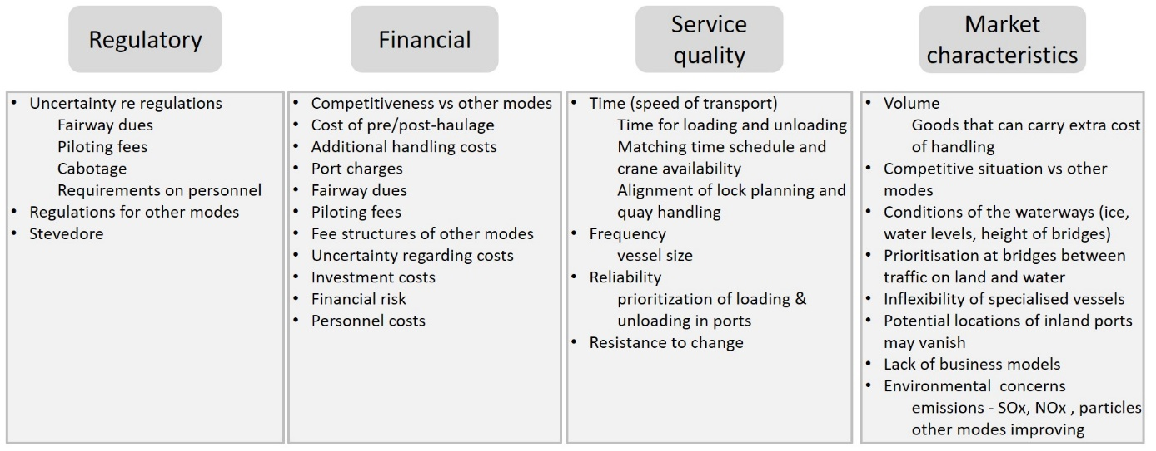

Figure 1: Barriers and key issues for implementation identified from literature

Case descriptions
To provide some background to the cases, the use of IWW in Sweden differs from Continental Europe in the sense that IWW connects the sea with two large lakes with ice conditions and rather high waves. Lake Vänern, the largest lake in the EU, is connected to the sea and Port of Gothenburg via the River Göta and Lake Mälaren via locks in Stockholm and Södertälje. With container transport on IWW being rare in Sweden, ports along the inland waterways do not operate services for container shipping and equipment, such as proper container cranes, are missing. Container transport may differ from other types of IWW transport (mainly bulk) in the type, volume and value of goods. Also, the distance to the quay is often close in industries traditionally using the waterways. Container transportation makes it possible though to consolidate goods of different types and from different goods owners.

Two entrepreneurs with ambitions to start offering IWW container services are described below. Figure 2 highlights the IWW as well as the locations of the start and end points, where both cases frequent Göteborg, while case Barge turns around in Trollhättan, and case Feeder has a longer journey and turns in Kristinehamn. The actors involved are similar in both cases: the focal company has the role of shipping lines, and interacts with vessel operators, companies sending and receiving goods (shippers), road hauliers (performing the pre- or post-haul by truck), forwarders arranging the transport on behalf of shippers, seaport terminal, port authorities, inland port terminal, municipalities, the Swedish Transport Agency (draws up regulations and grants permits) and Swedish Maritime Administration (e.g. provides pilots).

Case Barge consists of starting up a container shuttle between Gothenburg and Trollhättan on the river Göta Älv, a distance of approximately 80 kilometres. Five locks are passed on the way. The idea is to transport relatively large flows of goods from shippers in both directions. Initially one shipper with large goods flows from Trollhättan to Gothenburg and another shipper with large goods flows in the opposite direction have shown interest in transferring their goods from truck to IWW transport. An IWW vessel will be brought in from within EU. The focal company in case Barge is still defining the business model. A proof of concept of the route was run in 2017 showcasing barge transport from Göteborg to Vänersborg (close to Trollhättan), unloading and loading onto truck. A partnership with a vessel owner has been established.

Case Feeder consists of starting up a container shuttle between Gothenburg and Kristinehamn on the river Göta Älv and lake Vänern. Six locks are passed on the way. Lake Vänern has stricter rules regarding vessels than Göta Älv due to higher waves. The vessel to use will be able to perform shipping on open sea (IMO vessel). The idea is to consolidate goods from and to many shippers in the region around Kristinehamn and offer a timetable with a minimum frequency of 2 departures per week from Kristinehamn.

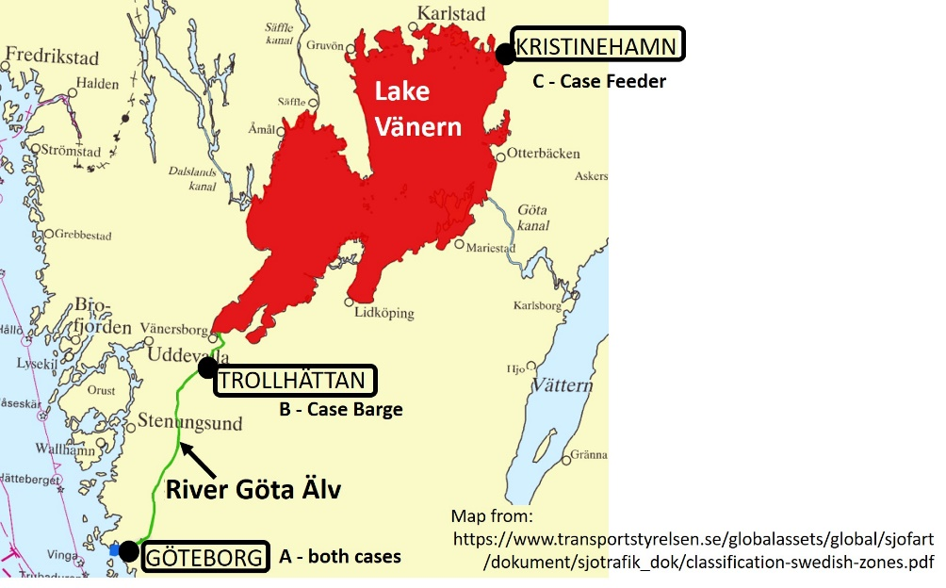

Figure 2: Showing start and end points for the two cases.

Results
As described above, previous studies have revealed barriers and key issues for increased use of IWW. Many of these barriers are evident in the studied cases. This section explains how some of the barriers and key issues can be managed, in particular through the involvement of actors with various motives, drawing on findings in the two Swedish cases. The strategies used by the entrepreneurs to overcome the barriers are summarised in Figure 3.

Some of the key regulatory issues for implementation relate to the fee structure for IWW, including fairway dues and piloting fees. Entrepreneurs starting up IWW transport need to interact with regulatory actors to understand the fee structures, e.g. where piloting is required, fees for piloting, rules regarding exemptions, and possibilities of exemption during start-up. Also, in Sweden, there is a need to increase knowledge among regulatory actors regarding IWW transport, for example since the IWW directive is new and not yet applied to container transport. The entrepreneurs in the studied cases have tried to lobby with regulatory actors to increase their understanding of characteristics of container transport on IWW, to ensure that these particulars are taken into consideration for regulations of water transport in general. Initiatives to increase knowledge have been undertaken, such as seminars and the proof-of-concept. Also, the benefits of assigning responsibility for modal shift and use of inland waterway transport has been put forward.

Some of the key financial issues for implementation relate to the port, i.e. port charges. For the seaport terminal new goods flows from traffic on IWW result in differences in unloading, loading, handling, operational cost of equipment, storage, labour and possible investments needed. For example, the existing cranes in the sea port terminal are built for larger vessels and thus have lower productivity for smaller IWW vessels. The entrepreneur needs to be aware of these issues when communicating regarding port charges and the costs that the port terminal may need to cover. On the other hand, the port needs to be aware of the particular characteristics of the IWW set up, especially since it differs to their normal clients, but also the additional traffic of goods IWW can bring to the port. This may help the port realise that the normal fee structure needs adaptation. After clarifying these issues, negotiations between the entrepreneurs and the port terminal resulted in agreeing a fee structure adapted to port calls for IWW vessels (Case Feeder).

Another key financial issue for implementation concerns the inland ports. These rarely get container transports, and may therefore need to invest in facilities and equipment, such as cranes, or, to enable call at the port, adapt the quay for new vessel types. To manage risks during start-up a crane can be rented or bought second-hand. The entrepreneurs in the cases have interacted with the inland ports to explain how IWW transports can be seen as a new business opportunity. Containerized IWW wil, not only attract additional goods flows, but also create opportunities for added value services, such as stuffing, storage or a depot for empty containers. Offering stuffing and storage services would require interaction between the inland port and the shippers. Setting up a depot for empty containers would benefit shippers that are located closer to where containers need to be returned, and the associated container demurrage costs. It might also bring benefits to the local municipality, in terms of creating new jobs and making the region attractive to companies. Setting up a depot would require agreements between the depot and shipping lines that own the containers.

Two key issues for implementation related to the service quality are frequency and reliability. A frequency of service at least twice a week was needed according to discussions between the entrepreneurs and shippers, and a timetable established. To establish a timetable it is necessary to consider internal operations of and interactions with seaport and inland ports. The service should not call at the port too seldom. Also, the timetable needs to be adjusted to the schedule of the main line, both so that containers do not have to be stored long in the port, but also because this will affect the capacity in the seaport. Furthermore, arrival punctuality of the main line is not precise as weather conditions may cause delays, and the inland service needs to take this into account, so that the vessel is not scheduled to leave before the containers are loaded. Meanwhile, it is of interest to the port that the vessel spends as short time as possible in the port. The entrepreneurs in the study prepared timetables with information regarding closing that were provided to shippers. Regarding reliability, it is important for the port to be able to plan work and capacity utilisation. Reliability is also an important aspect when trying to convince shippers and forwarders to use IWW services. Hence, the entrepreneurs had to establish trust among actors that considered reliability as an essential feature of logistical services. Consequently, despite that a proof of concept had been performed, the necessity of arranging for back-up solutions that could be implemented with short notice was considered. This, in turn, requires agreements between the entrepreneur and hauliers.

A key barrier related to market characteristics is attracting the volumes that are necessary for a business to be viable. For start-up this meant establishing continuous flows with specific volumes, as well as securing the initial volumes necessary to start the businesses. Most shippers do not have enough volume to fill a vessel, and thus several shippers need to be interested and contacted by the entrepreneurs. In the studied cases many shippers showed great interest in the IWW solutions presented, but it took time and effort to get them to sign letters of intent. One strategy was to ask shippers to commit a smaller percentage of their volumes initially. Another strategy was to target shippers with very large volumes to quickly accumulate enough volume. Marketing arguments regarding environmental improvements compared to road transport were persuasive but the cost had to be competitive. Moreover, for the business to work for shipping lines, there has to be sufficient volumes in both directions, while, shippers often do not have shipments in both directions. Thus, the entrepreneurs targeted shippers with large flows in opposite directions to ensure capacity utilisation. The proof-of-concept was important to show the feasibility.

Another key issue for implementation related to market characteristics is the first/last mile of transport. First/last mile transport between inland port and shipper is needed since not all shippers are located by the riverside or the port. Shippers may want to only be in contact with one transport provider for the sea leg as well as the first/last mile. The entrepreneur can then offer transport on land for the first/last mile. To arrange this service entrepreneurs need to establish partnerships with hauliers. These hauliers need to ensure that capacity in terms of vehicles are available when needed. Also interaction with forwarders is needed. If forwarders are buying the sea transport they may arrange the last/first mile, thus requiring a different offer from the entrepreneurs. Furthermore, since shippers want to be able to compare the cost of the IWW service including first/last mile, with other modes, forwarder, haulier and shipping line need to agree to cost-sharing between main leg and first/last mile.

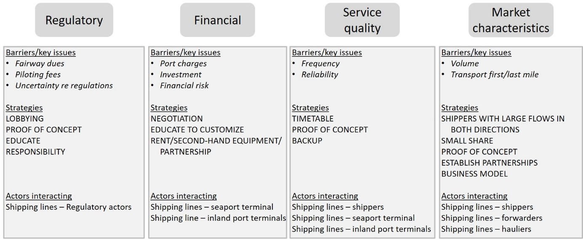

Figure 3: Strategies for managing barriers and key issues for implementation and actor interaction

Concluding discussion
Many of the barriers and key issues for implementation of modal shift to IWW described in earlier studies, were also found in the studied cases of entrepreneurs starting container shuttles. In the Swedish context certain barriers carry more or less weight compared to what would be the case in other countries. For example, the conditions of the Swedish waterways are generally good with regards to water levels, width and depth of the waterway, or height of bridges. Instead, the main issue appears to be that key stakeholders have limited experience of barge and container transport on IWW. This means that motivating and convincing actors comes high on the agenda for entrepreneurs. A key result of this paper is therefore the need for involvement of various actors to realise modal shift, identifying which type of actors and for the specific topics that are related to those groups. While many barriers may explain the rarity of container transport on IWW in Sweden, this article describes how entrepreneurs may manage associated barriers.

To realise modal shift the entrepreneurs need to use various strategies to overcome the barriers and manage key issues for implementation in the best way. This has been done by proof of concept; negotiation with key stakeholders in the transport chain; using general technical solutions and contrasting the Swedish situation for IWW-based service providers with what is common practice elsewhere in Europe. The proof of concept-runs, through both locks and in ports, have decreased barriers both in number and in scale. The proof of concept showed stakeholders that there are viable solutions and provided much publicity. The entrepreneurs engaged in a “learning by doing” which is costly and requires patient investors as well as flexible and interested stakeholders in the transport chain. Negotiations with key stakeholders have been used to circumvent some of the financial barriers, i.e. the high costs associated with water transport (e.g. port charges were lowered). Other costs (e.g. pilot fees) were assessed as being remarkable, from an international standpoint, and expected to diminish over time. By using general technical solutions, such as renting, leasing or partnering, costs associated with hardware/equipment were decreased. This allows lower initial investments, but tends to result in a higher total cost over time, partially due to not being adapted to the specific situation. On the other hand, it provides flexibility and lowers exit costs in the case of bankruptcy.

By explicitly comparing the Swedish situation with transport on IWW in countries such as the Netherlands and Germany, the entrepreneurs have managed to create a debate about the sensibility the Swedish transport policies – that often favour road transports over train or water. Thus, the entrepreneurs have highlighted the regulators’ lack of attention to issues related to IWW. This does not guarantee that the situation will improve but a likely scenario is that rules would harmonise with those that can be found in the parts of Europe that has a more flourishing IWW-sector. Such a development would enable the establishing of services providers in the IWW-sector and lead to several positive impacts on the Swedish transport system as a whole. First, it would enable the shifting of less time-sensitive container goods away from the currently strained road- and rail-networks. Second, it could lead to positive environmental impacts, especially if the self-propelled barges or the ships rely on cleaner fuels such as LNG. Third, the establishment of IWW-service providers in Sweden would also mean that a “new” industry will appear with the potential for new jobs, even though there might be some cannibalization of jobs in other parts of the transport sector. Fourth, an increased use of the shipping lanes would raise the importance of the quality of those lanes and make it more financially justifiable to maintain locks and channels, something that is currently debated at a national level.

As legislation, taxes and fees paid for waterway transport were identified as key barriers, and the interaction with regulatory actors and influencing policy decisions were identified as very important, this paper provides valuable insights for policy makers. Descriptions of the realisation of modal shift and specifically regulatory and financial barriers that policy makers can influence can provide input to their decision-making and help future implementation of container transport on IWW. For these barriers (such as fairway dues and piloting regulations) comparisons between different countries would be valuable. An understanding of the actual process towards realisation is also valuable to stakeholders of importance to realise a modal shift, such as shipping lines, inland port terminals, seaport terminals, logistics providers and shippers. This paper also describes the specific topics in which these actors should be involved and through their participation can facilitate modal shift to IWW.

The results presented in this paper provide three principal lessons that relate to, and have implications for, modal shift and innovation research. First, they show the necessity of flexible business model design (by the entrepreneur) to attract both customers and other stakeholders in the transport chain. Second, they stress the importance of influencing the policy discourse through examples. Third, it is clear from the practical experiences that to realise modal shift the perception of IWW transport needs to change, which the entrepreneurs have tackled persistently through communicating, promoting, educating and lobbying. Further research could map strategies used in other countries to manage barriers for implementation of IWW services or compare container transport with other types of transport on IWW.

References
- Baird, A. J. (2007), 'The economics of Motorways of the Sea', Maritime Policy & Management, Vol. 34, pp.287 - 310.
- Browne, M., Woxenius, J., Dablanc, L., Cherrett, T. & E., M. (2017), 'Port cities and urban logistics', The Logistics Research Network (LRN) conference, Southampton, 6-8 September.
- Caris, A., Limbourg, S., Macharis, C., van Lier, T. & Cools, M. (2014), 'Integration of inland waterway transport in the intermodal supply chain: a taxonomy of research challenges', Journal of Transport Geography, Vol. 41, pp.126-136.
- CBS (2016), http://statline.cbs.nl/statweb/publication/?dm=slnl&pa=83101ned, Centraal Bureau voor de Statistiek, 2017-03-02
- Flodén, J., Bärthel, F. & Sorkina, E. (2017), 'Transport buyers choice of transport service – A literature review of empirical results', Research in Transportation Business & Management, Vol. 23, pp.35-45.
- Fridell, E. (2011), Emissionsberäkningar för Vänersjöfart för BACAB (Emission assessment for Lake Vänern shipping for BACAB), IVL, Gothenburg.
- Garberg, B. (2016), Regeringsuppdrag: Analys av utvecklingspotentialen för inlands- och kustsjöfart i Sverige (Government investigation - Analysis of the potential for inland and coastal shipping in Sweden), Swedish Maritime Administration, Norrköping.
- Garcia-Menendez, L. & Feo-Valero, M. (2009), 'European Common Transport Policy and short-sea shipping: Empirical evidence based on modal choice models', Transport Reviews: A Transnational Transdisciplinary Journal, Vol. 29, pp.239 - 259.
- Konings, J. W. (2009), Intermodal barge transport: Network design, nodes and competitiveness, thesis, TRAIL Research school, TU Delft, Delft.
- Medda, F. & Trujillo, L. (2010), 'Short-sea shipping: An analysis of its determinants', Maritime Policy & Management, Vol. 37, pp.285–303.
- Meers, D., Macharis, C., Vermeiren, T. & van Lier, T. (2017), 'Modal choice preferences in short-distance hinterland container transport', Research in Transportation Business & Management, Vol. 23, pp.46-53.
- Olsson, F. & Ronold, E. (2017), Hinder och incitament för reguljär containertrafik via inlandssjöfart (Barriers and incentives for regular inland container shipping), thesis, Department of Business Administration, University of Gothenburg, Gothenburg.
- Otterström, V. & Torpfält, S. (2016), Inlandssjöfart - från teoretisk möjlighet till potentiellt utförande (Inland shipping - from theoretical possibility to potential realisation), thesis, Department of Business Administration, University of Gothenburg, Gothenburg.
- Trafikanalys (2016), Godstransporter i Sverige – en nulägesanalys, Rapport 2016:7
- Trafikanalys (2017), Shipping goods 2016, Statistik 2017:19, Sveriges officiella statistik, Report available at https://www.trafa.se/sjofart/sjotrafik/
- Treiber, A. & Bark, P. (2018), Förutsättningar för ökad inlandsvattensjöfart i sjöar, skärgårdar och kustområden (Conditions for increased inland shipping in lakes, archipelagoes and coastal areas), TFK, Stockholm.
- Wiegmans, B. & Konings, R. (2015), 'Intermodal inland waterway transport: Modelling conditions influencing its cost competitiveness', The Asian Journal of Shipping and Logistics, Vol. 31, pp.273-294.
- Vierth, I., Mellin, A., Hylén, B., Karlsson, J., Karlsson, R. & Johansson, M. (2012), Kartläggning av godstransporterna i Sverige (Survey of freight transport in Sweden), VTI, Linköping.

