**HOW CORRECT WERE THEY? – A COMPARISON OF LOGISTICS/SUPPLY CHAIN PRACTITIONER AND EDUCATOR VIEWS OF NEAR-TERM OIL PRICE WITH THE ACTUAL OIL PRICE**

***Yongmei Bentley1, Guangming Cao1, Ramakrishnan Ramanathan1 and* Roger Bentley2**

*1University of Bedfordshire, Luton, UK*

*2Petroleum Analysis Centre, Ireland*

1. **Introduction**

This research focusses on the impact of oil price on the logistics and supply chain (SC) industry, and initially examined two research questions:

1. What have been views of logistics and SC managers, and those that teach these disciplines, of the impact of the fall in oil price, from greater than $80/bbl for nearly all of 2007 to 2014 (and around $120/bbl for a considerable part of this period!), down to around $35/bbl at the start of this research, and subsequent increase up to ~$60/bbl at the last survey date? (And with this price, at the time of writing in June 2018, now around $75/bbl.)
2. What did these professionals expect will be the future price of oil over the near and medium term, and hence the consequent impacts on their industries?

To answer these questions, a semi-structured questionnaire survey was designed and handed out to the target audience by the lead author at a range industry logistic and SC events and conferences. The audience comprised middle and senior managers in logistics and SC companies, and in other companies where logistics and SC activities are a significant part of the total business, as well as academics at senior lecturer level and above in universities who teach logistics and SC topics. Three rounds of survey were conducted, covering the period from February 2016 to the end of 2017, with a total of 70 valid responses being analysed.

Given that time has now passed, and current and recent actual oil prices are known, in this paper we look at how well the groups surveyed were able to forecast the price of oil, and hence to expect the impacts on the logistics and SC industries of the oil price changes that have resulted. Note that a widely-held view among many analysts, not only in the logistics and SC industries, is that the oil price is too complex to forecast reliably. This view is not well founded, and the Annex sets out the fundamental drivers for oil price change; and, as importantly, explains how people’s *expectations* of future oil price have evolved over time.

In this paper we include forecasts from the IEA of oil price out to 2040. These show that the price of oil is expected to continue climbing in real terms, to again reach levels above $120/bbl in the not too distant future. Such oil prices are likely to have significant impacts across all of society that need to be understood, including within the logistics and SC industries.

1. **Literature Review**

It might seem obvious that the price of oil has a significant impact on the logistics and supply chain industries. This is because a high oil price adds directly to the fuel bills of much of the transport involved, and also to most other costs by way of the embedded fuel costs of nearly all activities. But surprisingly, while general reference is often made to this linkage, we have found relatively few studies that have looked at this in an analytical or quantitative way.

In terms of quantitative impacts, one study for example is that by Ronen (2011) on the effect of oil price on containership speed and fleet size. Among more broadly-based studies is that by Christopher and Holweg (2011) who point out that generally for logistics ‘variability is detrimental to performance’ (Page 63) and argue that: ‘in the light of increasing turbulence [which in their view includes oil price shocks, as well a global recession] a different approach to SC management is needed’. These authors hold that ‘most current SC management models emanate from a period of relative stability’ and that ‘there is considerable evidence that we will experience increasing turbulence in the future’.

More recent papers include that by Ramanathan (2016), who explored energy characteristics across the world, and highlighted logistics costs to businesses in the current outsourcing scenario. And an excellent recent paper is that by Busse et al. (2017), who write: ‘Because of the major contribution of logistics to the greenhouse gas effect, logistics research has begun to address the topic of energy, but it has not yet targeted the role of energy within logistical decision-making processes.’ This agrees with our findings, that overall there appears to be a rather limited literature examining the energy logistics/SC linkages in any detail (let alone vs. oil price), suggesting a useful avenue for research.

1. **Research Objectives**

The primary objectives of this research have been to understand the impacts of oil price on logistics / SC activities, primarily through the views of managers and educators involved with these industries. The research recognised three main considerations: Firstly, that the anticipated impact of oil price on logistics and SC activities is likely to be a function of time-horizon. For example, a high fuel cost is likely to reduce profitability in the short term, but over the longer term is likely to encourage adoption of more efficient vehicles, their more efficient use (e.g., ‘reverse logistics’), and fuel switching (e.g. to compressed natural gas). Secondly, that the period of high oil price from 2007 to 2014 placed stress on many economic activities, including on logistics and SCs, and led to wide-spread discussion of ‘peak oil’ (Bentley, 2016). And finally, the recent period of low oil prices (below 50/bbl) caused many to reappraise this view.

1. **Research Methodology**

To answer these research questions a series of questionnaire surveys were targeted at experts in the field: primarily middle and senior managers in logistics and SC companies; those in other (usually large) companies such as major retailers, where logistics and SC activities are a significant part of the total business; and senior researchers and academics in the logistics and SC discipline, to know where academia stands on the topic. The research followed the ‘key informant’ approach to data collection, by choosing respondents because of their specialized knowledge of the topic (Bagozzi, et al. 1991).

The semi-structured questionnaire asked about the impacts of the recent changes in the oil price on the logistics and SC activities within their own organisations (if managers); or of their understanding of such changes more generally (if lecturers). The questionnaire also asked respondents of their views of the likely price of oil over various future periods out to 10 years’ hence, and of the consequent changes they anticipated on logistics and SC activities. The survey included a number of ‘open-ended’ questions, as well as space for wider comments, to allow respondents to amplify their views.

To obtain a good response rate and to ensure that replies were received only from the target groups, the questionnaires were individually handed out and collected by the lead author, at a range industry logistic and SC events, and at related UK and international conferences. In addition, the survey form was kept short (10 questions), and anonymous, to assist the high response rate; in the event, of over 90%. In addition to the target group, a small number of professionals within the oil industry were also surveyed to gain a more informed ‘insider view’ of the likely future evolution of the oil price over the time-frame considered. To-date three main survey rounds of have been conducted, covering the period from February 2016 to December 2017.

1. **Research Findings**

Research findings from the first survey round are given in Bentley et al. (2016); and from the second in Bentley et al. (2017). Responses were analysed using both qualitative and quantitative methods (via SPSS). Questions 1 to 3 asked about the category of organisation of the respondent, the organisation’s size, and the respondent’s role within the organisation. Of the respondents, 38% were in senior managerial positions in logistics and SC companies, and a similar percentage were academics within universities. About two-thirds of the respondents were from large organisations having >250 employees. Overall, the sample of respondents were diverse in terms of industries covered, organization sizes, and positions held; in line with the research goals.

Questions 4 to 6 focussed on the recent changes in oil price, from > $80/bbl for most of the period from 2007 up to 2014, down to ~$35/bbl at the time of the first survey round, and back up to ~$45 to $50/bbl by the second round. Analysis of these responses are given in Bentley et al. (2016; 2017). Questions 7 to 9 focussed on the future price of oil, and asked respondents:

* Q7: Their expectations of this price at six future dates, see Table 1 below.
* Q8: Their reasons underlying these price expectations.
* Q9: How their predicted oil prices would impact future logistics and SC activity.

Table 1 shows that respondents’ views on likely future oil prices exhibited a general trend that oil price will be similar or lower in the short-term, but higher in the long-term. However, as shown, price expectations were diverse, and quite polarised between high vs. low prices.

|  |  |  |  |  |  |  |
| --- | --- | --- | --- | --- | --- | --- |
| ***Length of time*** | ***<$30/bbl*** | ***$30-40/bbl*** | ***$40-60/bbl*** | ***$60-90/bbl*** | ***$90-120/bbl*** | ***>$120/bbl*** |
| 3 months | 13.5%* (7^) | 30.8% (16) | 51.9% (27) | 3.8%(2) | - | - |
| 6 months | 14.3% (7) | 16.3% (8) | 61.2% (30) | 8.2%(4) | - | - |
| 1 Year | 7.8% (4) | 21.6% (11) | 39.2% (20) | 27.5% (14) | 3.9% (2) | - |
| 2 years | 6.4% (3) | 8.5% (4) | 29.8% (14) | 42.6% (20) | 10.6% (5) | 2.1% (1) |
| 5 years | 10.6% (5) | 0% | 21.3% (10) | 31.9% (15) | 27.7% (13) | 8.5% (4) |
| 10 years | 12.8% (6) | 0% | 17% (8) | 27.7% (13) | 19.1% (9) | 23.4% (11) |

*\**Valid percentage calculated excluding missing values. ^ Frequency. $/bbl: US $ per barrel

Table 1: Respondents’ expectations of the oil price in the near-term, and longer-term

As mentioned, several of the questions were ‘open-ended’ in that they allowed respondents to give details of their views. On future oil price these views were fascinating, and help explain the wide range of oil price estimates given in Table 1. A view of a low price 10 years’ hence (of <$30/bbl) followed logically from the explanations; for example: “*More and more new energy sources will be introduced*”; while a view of a high price estimate 10 years’ hence, of >$120/bbl, also followed logically from the view that: “…*oil will become more of a scarce resource*.” More generally, where a low oil price 3 to 10 years out was envisaged, this was due to an expectation of a very significant rise in low-carbon non-oil transport. Conversely, those seeing a high oil price 3 to 10 years out pointed to the world’s increasing appetite for oil, coupled with anticipated constraints on its production.

Now we turn to the specific question raised in this paper: How good have respondents’ views on future oil prices been so far? Results from the earliest survey (those in June 2016) are shown in Table 2.

|  |  |  |
| --- | --- | --- |
|  | **June 2016 prediction** | **Actual oil price** |
| **Sep-16** | 42.92 | 49.07 |
| **Dec-16** | 38.27 | 55.13 |
| **Jun-17** | 49.13 | 50.19 |

Table 2: Respondent views of future oil price, vs. actual price. (Reflects 27 answers)

In Table 2, the column ‘June 2016 prediction’ gives the average of respondents’ June 2016 predictions for the oil price at the future dates shown. For example, these predictions made in June 2016 were for the oil price 3-months (thus Sept. 2016), 6-months (Dec. 2016), and 1-year (June 2017) ahead. The column ‘Actual oil price’ gives approximately monthly average prices for Brent oil, taken from http://www.livecharts.co.uk/MarketCharts/brent.php. The 2, 5 and 10-year forecasts are not included as at the date of this analysis so far there are no actual oil price data to compare. These data (i.e., forecasts made in June 2016) are shown top left in Figure 1, with subsequent forecast shown similarly. It is clear from this Figure that the respondent views of the oil price three months, six-months, and 1-year ahead were consistently lower than the actual oil prices.

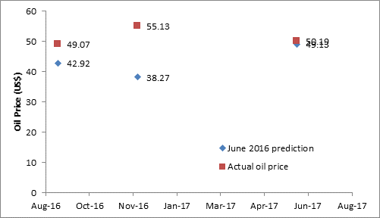 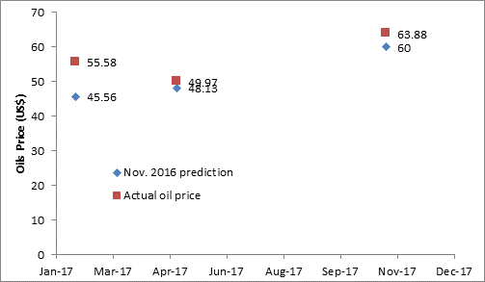

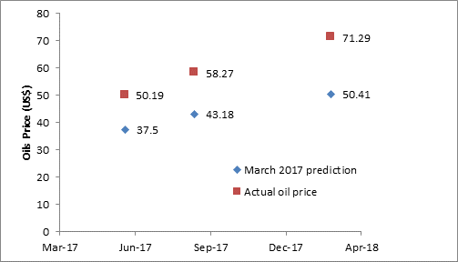 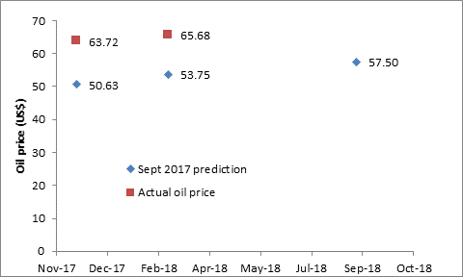

Figure 1: Comparison of respondents’ views made at four different dates of the oil price for 3 months, 6 months and 1 year ahead, with the actual prices at these dates

1. **Discussion and Conclusions**

**6.1 Discussion**

In underestimating the rise in oil prices, these professionals managing, and teaching about, the logistics and SC industries are in good company. As Figure 2 shows, one the world’s foremost oil forecasting bodies, the IEA, consistently under-forecast the price of oil over the period 2004 to 2007. During this period, they simply extrapolated the oil price at about the then-current price to the end of their forecast horizons. The Annex explains the constraints in global production of *conventional* oil that drove the prices rises from about the year 2004. But due to limitations in the IEA’s modelling at that time, these drivers of the price rise were not adequately understood. This situation changed in 2008, after the IEA had carried out detailed analysis of oil field decline rates. With these decline rates now in their model, the difficulty of meeting future demand for oil without significantly increasing oil prices became clear. This is shown in Figure 2, which since 2008 consistently gives an expectation for the real-terms oil price by 2030 to be in the $115 to 140/bbl range.

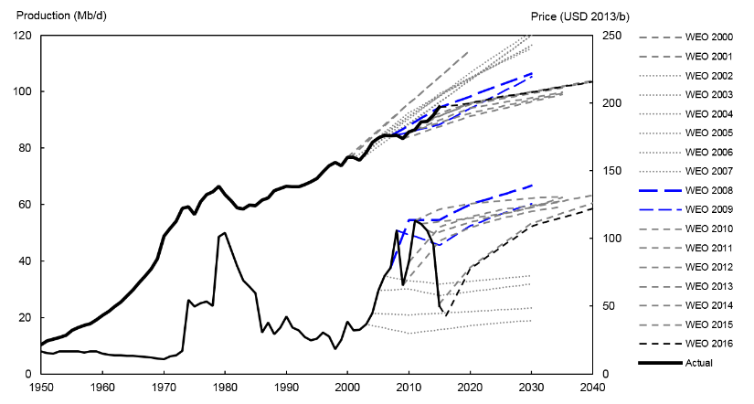

Source: Wachtmeister et al. (2018)

Figure 2: Historical world oil production and price from 1950 to 2015, and projections for world oil supply and oil prices from central scenarios of WEO 2000-2016.

However, little in oil forecasting is simple. The advent of light-tight (‘shale’) oil caught just about everybody by surprise, though the rapid increase in production of this class of oil is now incorporated in nearly all modelling (including in the IEA’s, in Figure 2). But the new uncertainty is whether reductions in oil *demand*, driven by the need to avoid too-serious climate change and other reasons, will trump the supply constraints built into the models of the IEA and others. Quite a number of respected organisations now hold this view of ‘peak demand as the driver for peak production, before peak supply’, including DNV-GL, the World Energy Council, Citi Bank etc. But the more ‘mainstream’ modellers, such as the IEA, ExxonMobil, BP, as well as most of the ‘independents’ such as Rystad Energy and Globalshift Ltd., maintain that while light electric vehicles will indeed see rapid increases in the market, overall oil demand will continue to increase, due to increased oil demand from heavy transport, ships, planes, and petrochemicals.

Who will be right is a fascinating topic for discussion. But it would seem wise for the logistics and SC industries to be at least prepared for the significantly higher oil prices that are forecast both by the ‘mainstream’ organisations and a number of the ‘independents’.

**6.2 Research limitations**

We recognise that the research reported here has limitations. It would benefit from a larger number of respondents and drawn from a wider spectrum of organisations. The research also has the intrinsic problem that the surveys were carried out at different dates, and hence prices of oil. The research started at what was a particularly low point in the recent trajectory of oil prices (at ~$35/bbl), and hence, importantly, at a time when expectations from a range of ‘expert commentators’ were for the price to go lower still; with $20/bbl and even less being widely mentioned! By contrast, currently (June 2018) the oil price has climbed back to ~$75/bbl, and there is far less talk of lower prices. These ‘market expectations’ naturally affect the replies of respondents.

**6.3 Conclusions**

The main conclusions from this whole research project have been:

1. A wide range of expectations of the future price of oil emerged from the earlier part of this study, from both senior practitioners and educators; with estimates for the price 10 years hence ranging from below $30/bbl to over $120/bbl.
2. Explanations for this wide range were generally logical. Those that foresaw a low oil price expected that new energy sources would come on-stream significantly over this timeframe, while those that foresaw much higher prices held the view that these new sources were not likely to be especially significant, coupled with a view that oil supply itself was likely to be constrained.
3. An important finding was the proportions of respondents that supported these various views of future oil price. While nearly a quarter saw the oil price in a decade’s time as likely to be very low (<$30/bbl), the majority saw this price as being in the $60-$90/bbl range, i.e., *lower than the price* for most of the period 2007 to 2014! Only a quarter of respondents thought the oil price 10 years hence likely to be >$120/bbl.
4. It was noticeable that no respondent suggested that the oil price could go high enough to *reduce* logistics and SC activity overall.
5. When comparing oil price views of respondents to the prices that have since occurred, the respondents consistently under-estimated the price rises that have taken place.

To set the findings into context, we note that virtually all current ‘mainstream’ oil forecasts, from organisations such as the IEA, the US EIA, oil majors and consultancies, see the global supply of *conventional oil* as being increasingly constrained from now on, with the result that most of any additional ‘liquids’ global supply that is required in future must come from the intrinsically expensive non-conventional oils; or from ‘other liquids’, such as coal-to-liquids or biofuels. This - absent ‘peak demand before peak supply’ - suggests higher oil prices into the future, combined with the possibility of significant constraints on supply.

By contrast, the results of the surveys reported here suggest that the likelihood of such constraints are not yet in the thinking of most of those managing, and teaching, logistics and SCs. It is hoped therefore that this paper can help inform industry and academia of the possible oil price risks ahead; and in particular, contribute to the planning that will be required for the medium and longer term oil supply challenges that companies may well face.

**References**

* Bagozzi, R.P., Youjae, Y. & Phillips, L.W. (1991), ‘Assessing Construct Validity in Organizational Research’, *Administrative Science Quarterly*, vol. 36, pp. 421-458.
* Bentley, R.W. (2016). *Introduction to Peak Oil*. Lecture Notes in Energy, Vol. 34; Springer.
* Bentley, Y., Cao, G., Ramanathan, R. & Bentley R.W. (2017), ‘Impact of Recent and Anticipated Changes in Oil Price on Global Logistics and Supply Chain Activity – Further Findings on Practitioner and Educator Opinions.’ *Proceedings of Logistics Research Network Conference,* 6-8 September 2017, Southampton Solent University, UK.
* Bentley, Y., Bentley, R. and Cao, G. (2016), ‘The Impact of Oil Price on Global Logistics and Supply Chain Activities – A Survey of Practitioner and Educator Opinions’. *Proceedings of* *Logistics Research Network Conference*, 7-9 September 2016. University of Hull UK.
* Bentley, R.W. & Bentley Y. (2015a), ‘Explaining the Price of Oil 1861 to 1970 - The Need to Use Reliable Data on Oil discovery and to Account for ‘Mid-point’ Peak’. *The Oil Age*, Vol. 1 (2): 57-83. Available at: www.theoilage.org
* Bentley, R.W. & Bentley Y. (2015b), ‘Explaining the Price of Oil 1971 to 2014 - The Need to Use Reliable Data on Oil discovery and to Account for ‘Mid-point’ Peak’. *Energy Policy*. Vol. 86: 880-890.
* Busse, C., Regelmann, A., Chithambaram, H. & Wagner, S.M., (2017), ‘Managerial perceptions of energy in logistics: An integration of the theory of planned behavior and stakeholder theory’, *International Journal of Physical Distribution & Logistics Management*, Vol. 47, Issue 6: 447-471.
* Campbell, C. J. and Bentley, R. W. (2016). ‘Observations on the present low price of oil’. *The Oil Age*, Vol. 2, No. 1, pp 1 – 8.
* Christopher, M. & Holweg, M. (2011), ‘Supply Chain 2.0: Managing Supply Chains in the era of Turbulence’. *International Journal of Physical Distribution & Logistics Management*, 41 (1), 63–82.
* Inman, M. (2016). *The Oracle of Oil – A Maverick Geologist’s Quest for a Sustainable Future*. W.W. Norton & Co. Inc.
* Ramanathan, R. (2016), ‘Energy and environmental issues in international business.’ *Journal of Contemporary Management and Development Studies*, 4(1), 44-60.
* Ronen, D. (2011), ‘The effect of oil price on containership speed and fleet size’. *Journal of the Operational Research Society*, Volume 62 (1), 211-216.
* Wachtmeister, H., Henke, P. & Höök, M. (2018), ‘Oil projections in retrospect: Revisions, accuracy and current uncertainty’. *Applied Energy*, No. 220 (2018) 138-153.

**Appendix. The Drivers of Oil Price: An Historical Perspective**

Here we look briefly at the fundamental drivers of oil price, and set these in an historical perspective. For the half-century from 1920 to 1970 large volumes of *conventional* oil were discovered globally (Bentley, 2016). These volumes were *much in excess* of demand, even though the latter was growing rapidly. Consequently, despite widespread attempts at market support, the price of oil fell steadily from about $30/bbl (in current real-terms) in 1920 to close to $10/bbl (real-terms) in 1970. This long price decline helped support major increases in many forms of economic activity, including in the transport associated with logistics and SC activities. But then came the first ‘oil shock’ in 1973, with its sharp rise in price (Figure A1). When coupled with the second price shock in 1978, the view developed among most analysts, and also the general public, that global oil supply was likely to ‘run out’ fairly soon. This view was supported by the size of the global proved (‘1P’) oil reserves at that date; and was expressed most dramatically by President Carter’s 1977 speech, where he described tackling the energy crisis as the ‘Moral Equivalent of War’.

 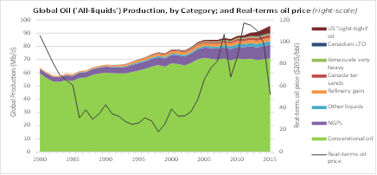

Figure A1: Left-hand graph: Global oil production, and oil price: 1965 – 2016. Price averaged >$80/bbl for most of 2007 to 2014 (and >$100/bbl for a considerable part of this period.)

Vertical bars (left-hand scale): Global ‘all-oil’ production, in millions of barrels/day. Solid line (right-hand scale): Annual-average real-terms oil price, in 2016$/bbl. Source: BP *Statistical Review 2017*; based on an original plot by E. Mearns.

Right-hand graph: Global production of ‘All-liquids’. Global production of conventional oil has been on-plateau since 2005 despite an on-average high oil price.

Data from US EIA (crude-plus-condensate, NGPLs, other liquids, and refinery gain); other categories from Laherrère et al. ‘Oil Forecasting – Data Sources and Data Problems, Part-1’, *The Oil Age* (2) 3; 2016. Real-terms oil price: BP *Stats. Review*.

However, an oil price shock around 1970 had in fact *long been correctly anticipated* by those analysts (mostly scientists) that used ‘resource-based’ oil forecast models. These showed that US would reach its peak of *conventional* oil production between about 1965 and 1970, and since the US was then the major oil supplier outside of OPEC, short-term global supply constraints were to be expected. Moreover, the general view in the late-70s to early-80s that global oil would ‘*run out’* soon was itself at variance with similar ‘resource-based’ oil forecast models for the world as a whole. These showed that enough oil had been discovered *globally* for total conventional oil production to continue to increase rapidly up until around the year 2000, before only then starting to decline.

These global ‘resource-based’ models were indeed correct (Figure A1, left-hand graph), and after the 1970s price shocks, large volumes of new oil came on-stream from *already discovered* provinces, including Alaska, Mexico, the North Sea and elsewhere. In face of this new supply, OPEC initially cut production to maintain price, but Saudi Arabia, who took the bulk of these cuts, gave up the game in about 1985, and the price of oil fell dramatically.

Unfortunately, on the basis of the new - and sustained - low price for oil after 1985, and hence the realisation that the widely-accepted ‘oil running out’ view had not been correct, the majority of analysts switched instead to an ‘oil cornucopia’ view, driven by the concept that oil reserves were simply inventory that could be replaced as needed. Despite the continued warnings from the global ‘resource-based’ models that supply difficulties of global *conventional oil* production were to be expected from about year 2000, this ‘cornucopia’ view dominated, and thus the rapid rise in oil price after 2003 (back to the 1978 real-terms levels of $100/bbl and above) came as a shock to most. The widely-cited reason for this rise in price was the increased demand for oil, particularly in Asia, rather than the correct reason of global resource constraints on the supply of conventional oil (see Figure A1, right-hand graph).

The above an important narrative and is given as background to the oil price expectations investigated in the research described above. For further detail on these changes in oil price, and the public expectations of price, see Bentley & Bentley (2015a, 2015b), Campbell and Bentley (2016), Bentley (2016), and Inman (2016).