THE SIGNIFICANCE OF CYNEFIN FOR COMPLEX INFRASTRUCTURE PROJECTS

Mohamed M. Naim*, Jon Gosling¹ and Bill Hewlett²
¹Cardiff University, UK
²Costain Ltd.

Introduction
There is a recognition in supply chain management research that there is a spectrum of supply chain types and that there is no ‘one size fits all' for the best logistics and management approaches (Christopher et al., 2006, de Leeuw and Fransoo, 2009). Engineer-to-order (ETO) systems, of which infrastructure projects are an example, have distinct logistics attributes when compared to ship-to- stock (STS), make-to-stock (MTS), assemble-to-order (ATO) and even make-to-order (MTO) environments (Gosling and Naim, 2009, Yang, 2013). ETO supply chains are recognised as having customised products, often as ‘one-offs’ in the form of unique ‘projects’ or ‘programmes’, higher degrees of uncertainty and relatively long lead-times. These characteristics call for the adoption of appropriate project management approaches; where inappropriate approaches are used, for instance due to lack of preparedness, capability and capacity, such ETO activities typically run over planned time and / or budget.

Yet, often in supply chain research, we find that there is an assumption that the contextual environment is relatively well ordered and structured. With much research undertaken in ATO and MTS environments, such as the electronics, automotive and food sectors, it is valid to categorise them as such as many organisations have ‘leaned’ their operations to reduce uncertainty and complexity so that the material flows are ordered and simple. In more MTO environments, such as the aerospace sector, where there is some supply chain research, the system is more complicated, with a wide range of components and subassemblies coming from many different vendors in dispersed geographical areas creating products to prescribed lead-times. We find that research on engineer-to-order (ETO) supply chains, such as in infrastructure project management, is far more limited but where it does exist there is a predominance of the translation of ‘lean’ techniques (e.g. Tezel et al., 2017). As Flyvberg et al. (2003, p. 73) noted with respect to megaprojects,

“too many…. studies…. of megaprojects assume projects to exist in a predictable Newtonian world of cause and effect where thing go according to plan. In reality, …things happen only with a certain probability and rarely turn out as originally intended.”

Challenging the assumptions that it is always possible to order the world around us, the Cynefin framework (Kurtz and Snowden, 2003) is a phenomenological framework that provides a classification system that allows us to understand the nature of the ‘habitat’, or ‘cynefin’ (a Welsh word) within which the project exists. The Cynefin framework classifies contexts in terms of order (simple and complicated) and un-order (complex and chaotic), highlighting the need for different managerial approaches for each of the four domains.

Given the multifaceted nature of ETO we question the tendency to ‘force’ the same form of managerial interventions as found in complicated or simple environments onto complex infrastructure projects. Hence, we aim to ascertain the relevance of the Cynefin complex domain’s recommended managerial approaches to major infrastructure project supply chains.

A cooperative enquiry approach is utilised by which the authors from academe and practice contemplate the value of the Cynefin framework, citing its referencing and / or exploitation in relevant previous research, and reflect on its meaning for the construction industry. We contextualise the different approaches from each domain and then determine how to frame expectations for the industry’s project managers. Cynefin’s validity is tested by interrogating various complex infrastructure case studies according to their characteristics.

The nature of ETO systems
Recent research has questioned whether there is a homogenous grouping of project based supply chains called ETO. Wikner and Rudberg (2005) note that, for MTO to MTS supply chains the product design is decoupled from production and distribution, and is actually operating as a ‘make-to-stock’ process. Hence, this relates to the fact that in those environments the design is a separate new product introduction or development process separate from the product delivery process, while in an ETO context the product design and material flow execution are part and parcel of the same process.
Using the decoupling principle, Wikner and Rudberg (2005) then go on to surmise that two distinct ETO types exist, with a third that lies in between. The first ETO type, termed ‘engineer-to-stock’ is associated with the BTO context where, prior to an actual customer order being received, there are product designs ready-made, waiting in ‘stock’ for a customer order. Alternatively, the pure ETO situation is where a design of a product, and its associated production, is not initiated until there is an actual customer order placed. Sitting in-between these two extremes we may find existing design being modified in an ‘adapt-to-order’ situation.

Wikner and Rudberg’s (2005) thesis was extended, enhanced and empirically tested in the construction sector by Gosling et al. (2017). Figure 1 shows the resulting categorisation of ETO types, namely, Research, Codes and Standards, and Existing Designs. While Wikner and Rudberg’s (2005) proposition was based on the conceptual extension of the decoupling concept from production to engineering through a process of logic, Gosling et al. (2017) motivated their study from the perspective of project complexity, uncertainty, risk and mitigation approaches, such as through varying contractual arrangements or degree of innovation. Nevertheless, Gosling et al. (2017) summarised their findings as Figure 1 that utilises the degree to which the customer, or client, engages with the ETO process visualised via the order penetration point.

In ‘existing designs’ previous designs from other project will be available as if ‘in-stock’ to be utilised ‘as-is’ (completed design), or various elements or components from various existing designs are integrated into a new design (finalised design), or an existing design is adapted (adapted design). Here we find relatively low levels of uncertainty and standard solutions being offered to customer requirements. In the ‘codes and standards’ category, designs are developed from formal codes of practice exemplified by British Standards, Eurocode guidelines or those published by institutes such as the American Concrete Institute. A ‘new design’ would result from using established codes, standards and principles to develop new designs. In ‘integrate codes’, the design is a result of the development of new codes integrated with established codes. This will require a formal process of either seeking a “departure” from the existing code or the rewriting of the appropriate code. In ‘develop codes’ new codes are established based on ‘engineering research’. Hence, in ‘code and standards’ the level of uncertainty is higher when compared to ’existing designs’ so that there is some innovation required to exploit existing ‘engineering research’ and/or code and standards. There is some degree of customisation for the client.
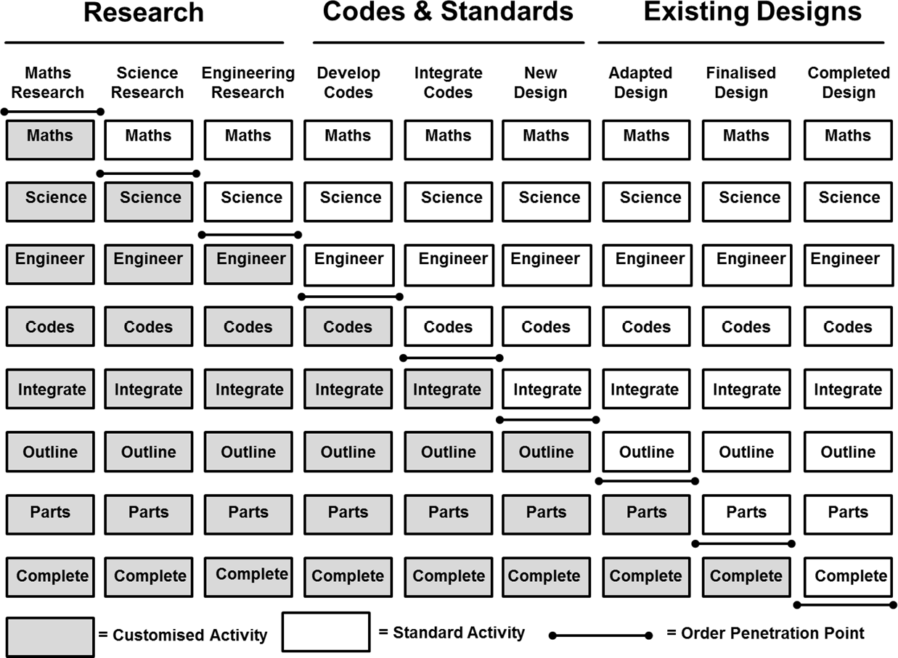

Figure 1: Continuum of Engineering Categories and Subclasses (Gosling et al. 2017)

Within the ‘research’ category designs require fundamental research or research development to be undertaken on a ‘to-order’ basis. For ‘Engineering research’, the testing of materials, principles or applications is necessary, while in ‘science research’ the theoretical grounding may exist but the application is uncertain. For ‘mathematics research’ the theoretical principles are unclear and may not exist at all. In this category we will find the highest degree of uncertainty, and hence risk, associated with developing a fully tailored and highly innovative solution.

Cynefin and its application to construction and ETO systems
The Cynefin framework, which we sometimes refer to simply as Cynefin, the Welsh word for habitat, was developed as a phenomenological construct to provide a sense of the nature of the world we live in (Kurtz and Snowden, 2003, Snowden and Boone, 2007). Figure 2 provides the visual representation of the Cynefin domains, Known, Knowable, Complex, Chaos and Disorder, as described by Kurtz and Snowden (2003). While the descriptions and definitions of the various domains has been expanded and adjusted in later descriptions (e.g. Snowden and Boone, 2007) the overall tenor has remained the same.

Cynefin classifies contexts that we may find ourselves in, in terms of ordered, Known and Knowable (Kurtz and Snowden, 2003), later referred to as Simple and Complicated (Snowden and Boone, 2007) and unordered, Complex and Chaotic, advancing the need for different managerial approaches for each of the four contextual domains. In order to determine which domain we may find ourselves in usually requires an element of discussion, maybe discourse and ultimately agreement or consensus among different stakeholders. Hence, we may actually find ourselves in a fifth domain, wherein the discourse has led to disagreement and there is no shared understanding of which of the other four domains we are currently in. In this instance, a possible further (fifth) management approach is needed: finding consensus!

In the Known domain, cause and effect relationships are easily understood and statically modelled, it is relatively easy to predict the future and there is a dominance of standard operating procedures and benchmarking to determine best practices. Here, managers will exploit sense making, use classic classification techniques and then determine appropriate responses to events. We ourselves would suggest that classic industrial engineering tools and techniques come to the fore, with the use of such tools as Pareto or ABC analysis, fishbone diagrams and linear programming.

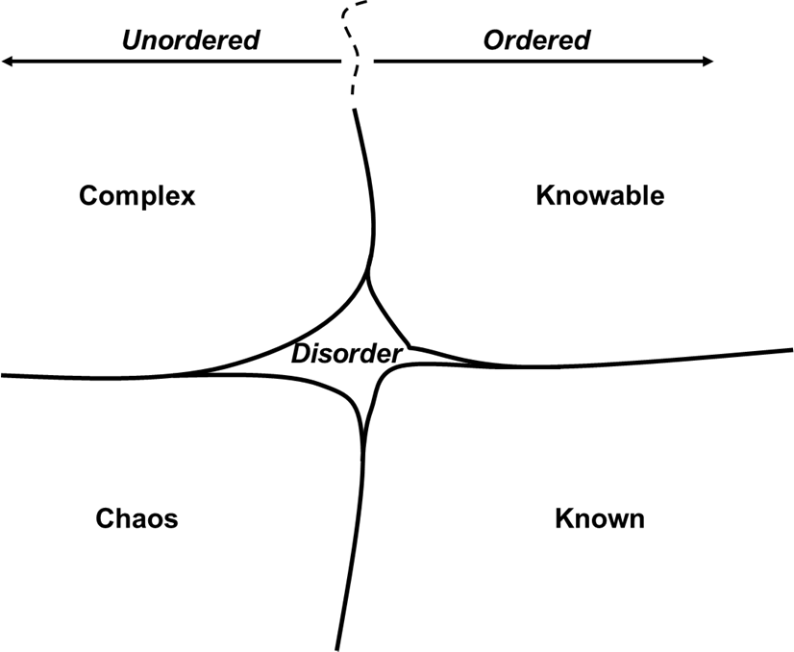
For the Knowable domain, cause and effect is still clearly visible and forecastable, but the sources and sinks of events are separated by time and space. Managers still exploit sensing strategies, evaluating and assessing gathered data, and determining response strategies for exploitation in any given readily predictable scenarios. Here, dynamic modelling may be utilised, such as systems dynamics management flights simulators, to ‘play’ with different scenarios.

Figure 2: The Cynefin domains (Kurtz and Snowden, 2003)

Cause and effect in the Complex domain is only apparent ‘after the event’ and, while patterns of behaviour do emerge and may be understood, there is no perfect repetition. Classic quantitative / systematic approaches that we may exploit in the ordered domains are not useful here, nor in the Chaos domain. We need to capture different perspectives of the same situation from different stakeholders, most likely in the form of narratives, to probe our environment in order to understand the situation we find ourselves in, which allows us to better sense and respond to events. Systems thinking approaches, such as soft systems methodology with ‘rich pictures’ tools and CATWOE analysis provide us with the means to manage our situation.

The primary approach in the Chaos domain is crisis management, such that actions are undertaken as a reaction to particular events as cause and effect is not discernible at all and there is no time to analyse a situation. So, the modus operandi here is to act first, then sense the outcomes of the actions in order to determine appropriate next-step responses. The Chaos domain may be undesirable, say, due to a catastrophic failure, or it may be created in order to instigate innovation.

Cynefin has found some traction in construction and engineering spaces, although rigorous, detailed and empirically based research is sparse. Koskela and Kagioglou (2005) give an expose of the Cynefin framework and briefly espouse its relevance for the construction sector as a whole and, in passing, indicate the potential of the Last Planner® tool, a production planning system, “to bring the process to the known domain” while acknowledging that, in order to do so, there is a need to explore the environment that a construction project may find itself in before doing so. Interestingly, Koskela and Kagioglou (2005), make no mention of the disorder domain.

In another article on the construction sector, with only a passing reference to the Cynefin framework, Rooke et al. (2007) again make the assertion that the aim of exploiting Cynefin is to understand which domain you are currently in but to enforce a form of order. Similarly, Tommelein (2014) promotes lean principles to drive all situations into, or to remain in, the Known domain.

In the more general ETO discipline, a notable contribution is by Vollmar et al. (2017), who relay their experience of the application of Cynefin in Siemens AG with inputs from engineers in the energy generation, energy transmission and high-speed train sectors. Vollmar et al. (2017) argue that Cynefin was originally developed for the management discipline and therefore needs translation for ETO environment. We do not agree with this argument, because our original point of reference with Cynefin was with the IBM Systems Journal (Kurtz and Snowden, 2003), which reads quite generically, while perhaps Vollmar et al. (2017) may have encountered Cynefin via the HBR paper (Snowden and Boone, 2007).

In any case, Vollmar et al. (2017), while ignoring the disorder domain, translate the Cynefin framework domains into four engineering scenarios, such that,

Known → Easy Engineering – engineering here exploits existing standardised designs and may include some simple and limited adaptations of existing solutions. This scenario works on repeatable processes dealing with limited complexity.

Knowable → Perfect Engineering – the focus is on the delivery of large scale projects, requiring integration of existing technological solutions with the aim of achieving ‘optimum’ solutions for the whole life-cycle of the artefact being delivered. There is a heavy reliance on engineers’ experience.

Complex → Pioneer Engineering – this scenario is associated with a high degree of complexity involving implementation of ‘first-of-a-kind’ projects, defined as any aspect of the project that is new e.g. the client, brief or technological requirements.

Chaos → Crisis Engineering – this is presented as an undesirable state requiring a set of skills to cope with serious situations.

Vollmar et al. (2017) conclude that there is the danger that most ETO companies in Europe work on the assumption that only the ‘Easy Engineering’ scenario exists. Hence, complexity and unexpected events cause considerable disruption because the coping mechanisms do not exist via ‘Easy Engineering’ approaches.

Reflections
The Vollmar et al. (2017) scenarios has some analogue with our own perspective of Cynefin and synergy with the ETO categories proposed by Gosling et al. (2018). But we also have some criticism, which may be due to the different sectors that we are dealing with.

The notion that ‘one-size-fits-all’ creates performance and commercial dangers is particularly apposite, very much in line with our own thinking and criticism of modern industry. It is also synonymous with general logistics approaches, for example, as per Fisher (1997) and de Leeuw and Fransoo (2009). Also, we counter the claim from much of the lean construction literature, see for example from above, Koskela and Kagioglou (2005), Rooke et al. (2007) and Tommelein (2014), that the Known domain is the only desirable state as, with careful consideration of the significance of each domain, there are opportunities to be had in each one.

We believe there is a mapping of the ETO categories with the Cynefin framework, and hence with Vollmar et al.’s (2017) scenarios;

- The Existing Designs category may be seen as in the Known, where we utilise, or slightly adapt, as in ‘Easy Engineering’, existing design to deliver to the client brief. This category may be applied also to individual components within a more complex design. There needs to be a high level of certainty.

- In Codes and Standards there is similarity with the Perfect Engineering’s ‘optimum’ integrated solutions development based on engineering experience, which has analogue with developing design based on code and practices, which is a collection of engineering know-how. A caveat, however, is that the operational environment needs to be pretty much fixed, for instance within a factory enclosure, or for construction engineering, where weather and other variables can either be predicted of will have little impact. We do not actually believe that ‘Perfect’ is entirely appropriate but, rather in line with the Cynefin ‘knowable’ terminology, here we could define the domain as ‘perfectible’, that is, where a striving for perfection is both realistic and worthwhile.

- The Pioneering Description, where ‘first-of-a-kind’ solutions are derived is in line in part with our Codes and Standards category, in this case where the operational environment brings considerable uncertainty, and overlaps with our Research category, where a particular situation warrants innovation or starting from first principles or the development of experimental testing to deal with situations that are total new or have not been encountered before.

- The Chaos description one hopes would be encountered only fleetingly, and might result from the manifestation of an unexpected outcomes or low frequency high impact risk, for instance, or from more creative sources, of which more below.

As can be seen from the above, the Vollmar et al. (2017) interpretation of the Cynefin does not necessarily correlate 100% with the ETO categorisation, which has been developed primarily for complex infrastructure projects and has a finer degree of granularity. Firstly, Vollmar et al. (2017) place large complex projects within the Perfect Engineering scenario, while our experience is that ETO categories find relevance in all of the Cynefin domains. Secondly, Vollmar et al.’s (2017) scenarios describe system ‘states’, which is a danger in itself, as Kurtz and Snowden (2003) point to, as Cynefin is a perception framework, not a definition of state. Perhaps when Vollmar et al. (2017) talk of Siemen AG’s industry sectors they do so from the manufacturing aspects of the machinery rather than the civil engineering; in civil engineering the operating environment, for many reasons, contains uncertainty. Indeed, this might explain why major programmes, such as transport metros or HS2, can struggle as there is a cultural clash between Perfect (or Perfectible) Engineering, which is an expectation in the manufacturing engineers’ domain, and Pioneering Engineering, where civil engineers see themselves as residing.

We believe the disciplinary boundaries are a prominent theme in infrastructure and built environment projects, where the various professional institutions, trades, and industry bodies have developed different traditions and worldviews over long time periods. For instance, in cases where some think the project should be ‘perfectible’ an old guard will defend ‘pioneering’ and espouse the management techniques that go with pioneering; this can lead to significant clashes and waste.
As we previously noted, Vollmar et al. (2017) rather step around Crisis Engineering, and seem not to embrace it as something that can be done much about. In line with Kurtz and Snowden (2003), we disagree. There is much that can be done to set up systems for early warning, be ready with reactions, prepare the team to keep positive and focussed, prepare people to be self-sufficient, set clear guidelines to support dispersed decision making, as will be needed if crisis strikes.

Also, we may wish to create a situation where we want to instigate innovation and, as Peters (1989) promoted, we may end up ‘Thriving on Chaos’. For example, for situations where there are definite end goals but there is rightly an expectation that the course of action will need radical re-thinking, and getting the team out of its comfort zone. Another examples is where a project is reliant on (genuine) research (where the findings of the research are genuinely not foreseeable and could be highly variable) this might be the case. For instance, where a new type of solution is envisaged, but the new solution relies on a new technology which is yet to be proven, a completely different solution would need to be envisaged if the specific new technology did not work.

We also note that of the papers we have cited that refer to Cynefin none embrace the central Disorder domain. We believe this is an omission, as we need to heartily embrace the central zone and see it as a point of particular value in the Cynefin. On a project, if different parties disagree on the domain, the project is in ‘Disorder’ and disorder will certainly be the case. This will be manifested in misunderstandings, breakdown of teamwork, conflict and demotivation. This is a disaster for an ETO project, in our view worse than being in the ‘wrong’ domain.

Our interpretation of the Cynefin for complex projects
Relating ETO examples to the domains of the Cynefin requires some care, requiring consideration of both the work content itself and also of the variables that influence it, such as, location, regulations and legal frameworks, supply chain, weather conditions, what risks manifest / which do not, customer
/ client requirements, third party stakeholders, scale and interdependency of different elements, and unexpected results for experimentation and innovation, or unexpected condition of historic fabric once opened up during the works, and so forth. Add to this that all of these factors may change with time; for instance the client team might be substituted during a project and the new team bring a new interpretation, or neighbours might change their attitudes once they become aware of just what is going on ‘over the hoarding’. Here are or thoughts:

Known / Easy: the components associated with speculative build housing, retail parks, and for the project as a whole only when the different influencing variables remain unchanged which in reality will be unlikely for any major construction project, other than at component level. Here we will find repeatability of designs with maybe some variations to accommodate local circumstances e.g. external cladding to fulfil planning regulations. There is the expectation that standard operating procedures govern the project management approach, exploiting various tools such as program evaluation and review technique (PERT) or critical path analysis (CPA). Hence we ensure certainty of quality, time and cost, making sure people strive for perfection, have thoroughly thought things through, spending time and money on prototyping, developing highly detailed engineering specifications, and enhancing efficiency though ‘lean’ techniques. This domain is fragile however. For instance, a specific supplier might go out of business, exchange rates or import constraints might vary. Unless we are prepared, the ‘known and easy’ suddenly becomes chaos.

Knowable / Perfectible: erection of a single span bridge of simple design, where the influencing variables show change but there is a perception that they are manageable and perfectible, and a perfect plan can and, importantly, should be formulated and enacted. In such a case, we still remain in an ordered domain and the problem at hand may be mastered, for instance, by comprehensive briefing with the client yielding no novel specifications, or geological ground testing confirming there are no unique circumstances about the location. Management here may utilise scenario planning, coupled with a traditional risk register, exploiting the project team’s expert opinions to determine a number of different feasible designs for the client and highlighting potential hazards.

Complex / Pioneering: first of a kind work such as a London Rail Terminus rebuild, which includes multiple influences and stages of work, many stakeholders, as well as a long and protracted duration.
Here, we find the influencing factors are more unpredictable than in previous domains. Possible management techniques are to develop a robust plan with an emphasis on revaluation, renegotiation and responsiveness to changing circumstances to retain stability of the project as a whole, as well as ensuring a big picture perspective to ensure objectives are met and not to focus on cost. The management approach will be to establish a multidisciplinary integrated project team to ensure the breadth and depth of stakeholder involvement. Typically the project team tends to involve the ‘experts’ but representatives of all stakeholders, such as from the local populace, should be included. In this domain; the focus is on people, to build collaboration and trust. There is far less emphasis on immediate costs and there needs to be flexibility regarding budgets. The seeming paradox that a focus on cost reduction drives cost up is explained by considering how short term cost reduction undermines the ability of the team to respond to the emerging complexity; short term costs should be seen as investment, that will yield their return in due time: no investment, no return and we are poorer for it. As codified and procedural management approaches are inappropriate, instead “narrative techniques are particularly powerful in this space” (Kurtz and Snowden, 2003) where multiple stakeholders’ perspectives are needed, including those of third-parties with significant risk exposure such as local communities, to aid decision makers i.e. the risk managers.

Chaos / Crisis Engineering: We envisage many types of scenario, but in all cases the project needs to Transform from Chaos into a more stable domain as rapidly as it can. In the safety realm, the Bow-tie approach (Zhang and Guan, 2018) gives equal weight to avoiding crisis as it does to managing the outcome; this approach is used where it is simply uneconomic to plan to avoid every conceivable negative outcome. In cases of structural collapse or earthquake for instance, immediate life safety is the priority and all else must cease. A second type of scenario is where a single ‘project’, or ‘contract’, within a broader programme suffers a radical change of priorities as a consequence of the changing climate in the whole programme. For instance, on a long metro system, each station starts as its own contract; in time opening the railway becomes the priority and the individual project priorities are subsumed; viewed from the perspective of the Project Manager for the individual station, this can be hugely chaotic. In this scenario we need to build resilience into the project, so that the team is ready for any disturbances, they can respond and recover. In another scenario there may be a small part of the project which becomes chaotic: perhaps an area of historic fabric is found to be unstable and cannot be incorporated into the final design as envisaged, needing a review both technically and with planning authorities. The strategy now is to box off this chaotic element, isolate a dedicated team to deal with it, and ensure good order is maintained elsewhere.

Based on our reflections, we also see a set of positive scenarios in the chaotic domain, as exemplified, for instance, in Thriving on Chaos (Peters, 1989), and we propose this as a stimulus for innovation. We are aware on an example from Gosling et al. (2017) involving the development of a new technique manufacture large scale optics. A project team were commissioned to undertake a feasibility study to provide the mirror component for a large scale telescope. The project made use of developments in nanotechnology in order to polish to extremely well-defined tolerances. Given the very experimental set-up it could be classified as residing in the Complex / Pioneering domain, bringing together scientists and bespoke technology. The polishing and smoothing process involved was unproven and hence a major risk. The client instigated an open brief, but with supporting structures to encourage innovation, which allowed for the impromptu instigation of different approaches to refine the process.

Discussion and conclusions
Something we would like to see more of is further consideration of management techniques aligned with each domain, especially if the project is in the Disorder zone. In the latter case, stopping the job to get alignment of thought, or at any rate acceptance of the legitimacy of different perspectives, thinking and management methods for different aspects of the project, is probably the right action. The management approach to disorder will likely be in the form of conciliation and arbitration, either achieving consensus or agreeing to disagree through the accommodation of worldviews. We should also note that the domain may define the management approach or vice versa. As highlighted in the literature review there has been advocacy of lean construction, which we then argue entails work in the ordered domains.

As a caveat, we would say that the appropriate domain is a function of component and timescale – a Complex project, like a live rail terminus rebuild might be Pioneering as a whole, but will have aspects which are Easy / Known, Perfect / Knowable and Crisis / Chaos in parts. While ‘a part’ in this context might be defined against certain criteria, in reality it amounts to what management technique is appropriate. Our point is that a wide range of approaches and attitudes are likely to be needed even in a single project. We advocate a need for new ways of risk assessment and de-risking with respect to Complex / Pioneering types of projects, in which narrative forms guide project teams, who must hear the voices of all stakeholders, and will need to embrace a wide palate of management techniques in response, varying with timeframe, scale (component vs. the project as a whole) and what risks manifest, what do not. Existing risk registers are based on simple one-to-one relationships between cause and effect and often miss the interconnectivity between different causes and different effects. Hence, existing risk management approaches, where the assumption is that the projects is ‘ordered’, are susceptible to cross suddenly into the ‘chaos’ if patterns of behaviour deviate from the ‘risk register model’ norm. The Cynefin framework enlightens our thinking, and the concept of journeys through the Cynefin, as responses are developed and are enacted, changing their domain as this happens, in itself gives a narrative which is easily grasped and makes sense of the complex and emergent in a world which craves certainty.

References
- Christopher, M., Peck, H. and Towill, D. 2006. “A taxonomy for selecting global supply chain strategies”, International Journal of Logistics Management, 17 (2), 277-287.
- de Leeuw, S. and Fransoo, J. 2009. “Drivers of close supply chain collaboration: one size fits all?”, International Journal of Operations & Production Management, 29 (7), 720-739.
- Fisher, M. 1997. “What is the right supply chain for your product?”, Harvard Business Review, March/April, 105-116.
- Flyvberg, B., Bruzelius, N. and Rothengatter, W. 2003. Megaprojects and risk: an anatomy of ambition, Cambridge University Press, Cambridge, UK.
- Gosling, J. and Naim, M. M. 2009. “Engineer-to-order supply chain management: A literature review and research agenda”, International Journal of Production Economics, 122 (2), 741-754.
- Koskela, L. and Kagioglou, M. 2005. “On the metaphysics of production”, 13th International Group for Lean Construction Conference, 19-21 July, Sydney, Australia, 37-45.
- Kurtz, C. F. and Snowden, D. J., 2003. “The new dynamics of strategy: Sense-making in a complex and complicated world”, IBM Systems Journal, 42 (3), 462-483.
- Peters, T. J., 1989. Thriving on chaos: handbook for a management revolution, Pan Books, London, UK. Rooke, J., Molloy, E-M., Sinclair, M., Koskela, L., Kagioglou, M., Siriwardena, M. and Siemieniuch, C., 2007. “Models and Metaphors: Some Applications of Complexity Theory for Design, Construction & Property Management”, CIB World Building Congress, 14-17 May, Cape Town, South Africa, 2764- 2775.
- Snowden, D. J. and Boone, M. E., 2007. “A Leader’s Framework for Decision Making”, Harvard Business Review, 85 (11), 68-76.
- Tezel, A., Koskela, L. and Aziz, Z. 2018. “Lean thinking in the highways construction sector: motivation, implementation and barriers”, Production Planning & Control, 29 (3), 247-269.
- Tommelein, I. 2015. “Journey towards lean construction: pursuing a paradigm shift”, Journal of Construction Engineering and Management, 141 (6), 04015005-1 - 04015005-12.
- Vollmar, J., Gepp, M., Palm, H. and Calà, A., 2017. “Engineering framework for the future: Cynefin for Engineers”, Systems Engineering Symposium (ISSE), 2017 IEEE International, Vienna, Austria.
- Wikner, J. and Rudberg, M. 2005. "Integrating production and engineering perspectives on the customer order decoupling point", International Journal of Operations & Production Management, 25 (7), 623-641.
- Yang, L. 2013. “Key practices, manufacturing capability and attainment of manufacturing goals: the perspective of project/engineer-to-order manufacturing”, International Journal of Project Management, 31 (1), 109-125.
- Zhang, Y. and Guan, X., 2018. “Selecting Project Risk Preventive and Protective Strategies Based on Bow-Tie Analysis”, ASCE Journal of Management in Engineering, 34 (3), 04018009-1 - 04018009-13.

