RURAL SUPPLY CHAIN MANAGEMENT: A LITERATURE REVIEW AND RESEARCH AGENDA

Pietro Evangelista¹, Bettina Williger², Girma Gebresenbet³ and Ulrich Müller-Steinfahrt⁴
¹ Institute for Research on Innovation and Services for Development (IRISS), National Research Council (CNR), Naples, Italy
² Fraunhofer Center for Supply Chain Services, Nuernberg, Germany
³Swedish University of Agricultural Sciences, Uppsala, Sweden
⁴University of Applied Science Wuerzburg-Schweinfurt, Wuerzburg, Germany

Introduction
With the ongoing trend of people moving to cities and residential areas close to the city, there is a growing need to supply urban areas with limited infrastructure and restricted space. Many studies on the supply chain of cities or megacities have been done in recent years, while rural areas, which are changing as a result of the urbanisation, have so far been little researched. However, changes in rural areas require lessons to be learned. A lack of infrastructural offer, limited job opportunities and declining supply offers reduce the attractiveness as a place of residence and work and foster depopulation of rural areas (Eurostat, 2017). For example, the goods for daily needs cannot be readily obtained by many citizens in rural areas, public transport is often sparse and not easy to use, and local food retailers lose their appeal or are not often economically sustainable (i.e., Williger & Wojtech, 2018). The supply chain in rural areas is often fragmented due to scattered settlement and production and it leads to high logistics cost, particularly transport cost, and significant environmental impact. This is particularly true in the context of rural agriculture production were the delivery of means of production (such as fertilizer and machinery and collection of produce) are not coordinated, the load capacity utilization level of vehicles is low and varies between 10% and 95% (Gebresenbet and Ljungberg, 2001).

So far, the current challenges of a robust, economical and efficient supply have been largely related to the supply of manufacturing production facilities, retail or end customers without a differentiation according to region-specific conditions. Research activities were more related to cities from a spatial perspective (Lagorio et al., 2016). With the topic of smart urban logistics, insights were collected in relation with urban areas. There has been hardly any focus on rural areas, regions and countries having a distinct rural settlement structure. One of the main reasons for the poor focus on rural logistics and supply chain management is the low attractiveness and challenges to design efficient value-added chains to the end customer. An interesting example is the case of some postal and parcel service providers in Germany, Austria, Denmark and UK, which deliver letters and parcels in rural areas only once or twice a week (see https://wearecitizensadvice.org.uk/are-rural-consumers-getting- a-bad-deal-with-parcel-delivery-e8b6a70dd874). Many universities and research institutions that deal with logistics or supply chain management have focused their research efforts predominantly on the industrial supply, retail supply and strategies on the e-commerce initiated supply of the end customer without any spatial reference. In addition, although the subject areas of geography, settlement structure and agricultural sciences are related to rural areas, they often lack to focus on the logistics problems in these areas.

For these reasons, research is needed on how rural areas can be supplied with sustainable and economically viable solutions in the future. In order to understand the state of knowledge in the context of RSCM, a systematic literature review has been conducted. In this way, it is possible to identify existing studies and related findings as a starting point for developing further research. The idea behind this paper was generated during a comprehensive two-day workshop held at the Fraunhofer Centre for SCS in Waischenfeld (Germany) on December 2017. The workshop aimed at identifying relevant topics and potential research avenues for RSCM (for more information: Prockl et al., 2018). Nine international experts (including the authors of this paper) with knowledge on rural issues and supply chain management research participated in the workshop.
The section following this introduction describes the methodology and the search strategy adopted. The third section provides details about the results of the descriptive analysis, while the fourth section reports the results of the content analysis. The fifth section discusses the results achieved. Some concluding remarks and future research avenues have been outlined in the last section.

The method used to conduct the systematic literature review and results
The methodology approach adopted in this paper has been adapted from the works of Tranfield et al. (2003) and Seuring and Müller (2008), and it comprises the following four steps:

- Search strategy and materials retrieval. In this step, on the basis of some existing papers and the researchers experience, the following set of relevant keywords have been identified: “Rural”, “Rural supply chain management”, “Rural distribution”, “Rural logistics” and “Rural market”. Such keywords have been applied in combination on the Scopus and Web of Science (WoS) databases. 207 documents in total were initially identified using the above keywords in the title, abstract and keywords of documents. The outputs obtained from the two databases were compared and this allowed the elimination of duplicates. In a further step, two inclusion/exclusion criteria were established. The first criterion relates to the inclusion of documents having linkages with logistics and SCM in rural context, while documents with no liaisons with rural logistics and SCM issues were excluded. The second criterion involved the inclusion of papers with a management and economics focus. Papers focusing on technical and political aspects have been considered not directly related with the topic investigated and then excluded. Finally, after the application of the two above criteria, the final sample consisted of 38 documents (see table 1).

 | Scopus | WoS
Documents retrieved | 77 | 130
Duplications within each database | 16 | 10
Net of duplicates within databases | 61 | 120
Duplicates between the two databases | - | 6
Net of duplicates between databases | 61 | 114
Papers out of the scope (first and second criteria) | 34 | 103
Final sample of papers | 27 | 11

Table 1: Phases and outputs of the search strategy

- Descriptive analysis. The selected material has been analysed for outlining formal characteristics of the final sample in terms of distribution of papers over time, the methodology adopted, and the countries where empirical studies have been conducted.

- Identification of relevant topic areas. In this step, three relevant topic areas have been identified and each paper was assigned to one topic area only. To identify the topic areas, it was used a mixed method based on a deductive and inductive approach. Firstly, the potential topic areas have been identified before the documents have been analysed (deductive approach). In a subsequent step, the topic areas identified in the previous phase have been further scrutinised and revised on the basis of the in depth analysis of the prevalent focus of each of the document selected in relation with its main purpose (inductive approach). Moreover, before to assign a document to a specific topic area, it has been compared, contrasted and critically evaluated by the authors. Subsequently, the documents in each topic area have been clustered on the basis of common themes. This allows further classifying the papers in homogeneous sub-topic areas.

- Content analysis and results. In this final step, the documents included in each topic and sub-topic area have been analysed. The aim was to detect relevant issues and provide the base for interpreting results. The following two sections provide details about both descriptive and content analysis.

Descriptive analysis
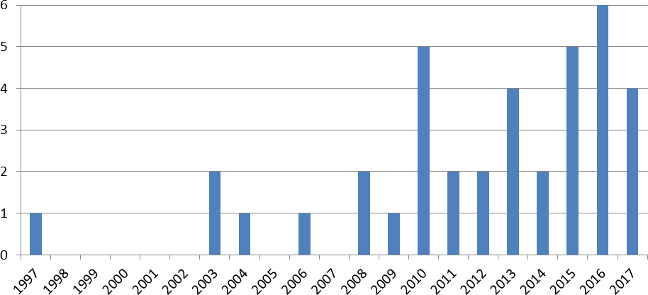
In this phase, the formal characteristics of the selected papers included in the final sample have been analysed to identify some key features. In total, the sample contains 23 journal papers, three book chapters, and 12 conference papers. With regard to the distribution of the papers over time (see figure 1), the earliest document was published on 1997.

Figure 1: Distribution of papers over time (N=38)

From 1997 until 2008, there has been a relative low interest in this research area with only six publications in this period and with some years with no publication at all (from 1998 until 2002). From 2008 onwards, the number of publications increased significantly with three publications per year on average.

The vast majority of the selected papers applied quantitative (n=14) or qualitative (n=11) methods (see figure 2). Only two papers adopted mixed methods (n=2) and 11 papers were considered to be of a conceptual nature.
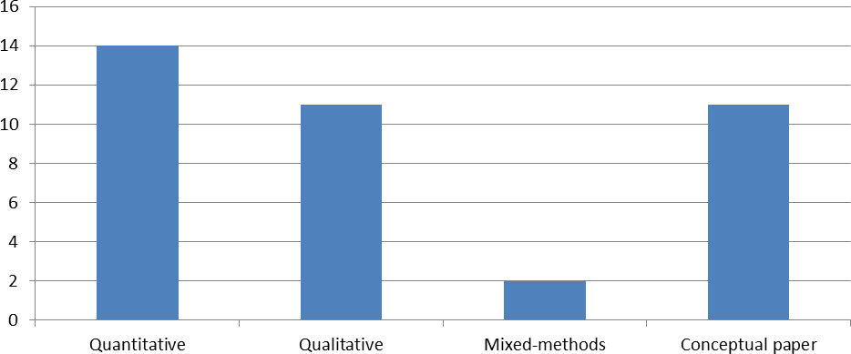

Figure 2: Distribution of papers by research method (N=38)

Figure 3 provides the distribution of selected papers reporting empirical studies (only 25 papers out of 38). Most of such studies relate to China (n=10) and the UK (n=7). Further empirical studies were conducted in India (n=2), U.S. (n=2), and Australia (n=1). Only three studies involved European continental countries.
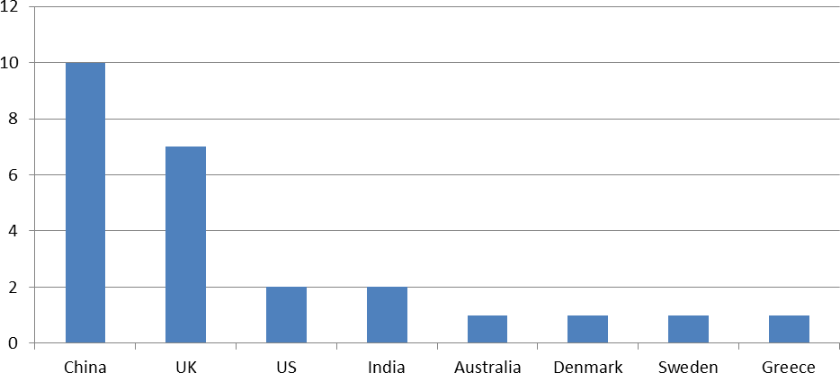

Figure 3: Distribution of papers by country of the empirical study (N=25)

Content analysis
Table 2 provides the distribution of the 38 selected papers by the topic and sub topic areas identified. The following sub-sections provide a summary of the content of the selected papers for each of the four topic and sub topic areas.

Topic areas/Sub-topic areas |  | # papers
TA.1 - Rural retail and distribution |  | 13
Shopping and out-shopping behaviour | 2
Distribution and transport | 8
Retail strategy and channel | 3
TA.2 - Digitalisation and ICT in rural areas |  | 15
Implications of online shopping | 3
E-commerce | 6
ICT and platforms | 6
TA.3 - Supply chain models and capabilities in rural areas |  | 10
Operational issues in managing rural supply chain | 3
Supply chain capabilities | 4
Supply chain models | 3
Total |  | 38

Table 2: Categorisation of papers by topic area and sub-topic area

Topic area 1: Rural retail and distribution
This topic area includes 13 papers analysing retail and distribution issues in rural areas. The first two papers investigated consumer shopping behaviour in rural areas of U.S. and India. The work of Miller and Kean (1997) focused on analysing consumer in-shopping behaviour through a number of factors affecting consumer out-shopping in the Midwest area of US. Among other factors, the authors found that the low importance attributed to customer service in consumer in-shopping behaviour. The paper of Venugopal (2012) investigated the out-shopping behaviour of rural consumers in India and identified that the decision concerning what and where to buy could be influenced by the urban orientation of consumers. The paper provides suggestions to outline a distribution plan for consumer goods companies interested in expanding in the rural markets of India.

The second sub-topic area deals with distribution and transport issues in rural context. A number of papers is focused on China and their common denominator is to address the problem of minimising logistics costs in rural areas through the optimisation of distribution networks. Using a simulation tool, Nie et al. (2010) proposed a two-direction logistics system model focused on agricultural products. The outcome of the simulation indicates a substantial improvement in logistics efficiency. Similarly, Huang (2012a) provides a new model to locate the optimal rural logistics distribution centre. Haoping (2010) discusses several strategies to improve the post logistic network in Henan. The main strategies relate to service innovation and market expansion. Zhang et al. (2015) suggested a planning model of rural distribution network. Considering the diversification of loads, the work identifies a model that is able to provide economic and environmental benefits. Zhuang et al. (2016) proposed a rural forward and reverse logistics network design using the Pinggu district of Beijing as an example. The work of Hageback and Segerstedt (2004) analysed the potential benefits that co-distribution may have in rural areas. Through a number of interviews involving both local companies and companies providing transport services to and from Pajala (Sweden), the authors discovered that companies receive and distribute goods with a low frequency and the loading capacity of vehicles is often less than 50%. This implies that to lower transportation costs and increase delivery services co-distribution is necessary to reinforce the competitive abilities of companies in Pajala. The work of Vachani and Smith (2010) was aimed at understanding how customers get access to products and services in rural areas. Using five case studies in India, the authors pointed out the importance of cross- sector collaboration among multinationals companies, NGOs and governments and identified a number of factors influencing the development of “socially responsible distribution” such as infrastructure shortcomings, lack of information, knowledge and skills, and low bargaining power.

The papers dealing with retail strategy tried to fill the gap concerning the lack of specific academic studies in rural retailing. The paper of Byrom et al. (2003) developed a typology of strategic alternatives for retailers in rural areas of Scottish islands. Jasim and Vinoth (2017) studied factors affecting retailer preference towards PepsiCo products and problems faced in distribution channel in the rural market of India. Based on interviews with retailers, the authors examined their preference towards PepsiCo products and problems faced in managing distribution channels in rural areas.

Topic area 2: Digitalisation and ICT in rural areas
This topic area has been divided in the following three sub areas: implications of online shopping, e-commerce, and ICT and platforms. Three papers address the sub topic area “Implications of online shopping” with regard to residents and retailers of island communities. An empirical study by Calderwood and Freathy (2014) reveals that online shopping has modest potential to reduce shopping related travel of residents. In a more recent study, Freathy and Calderwood (2016) illustrate that online shopping is a competitive threat to the local retail economy, and that retailers need react to such developments. The threat of online shopping for local retailers is also the subject of the paper by Schiffling et al. (2015). Interviews with local retailers reveal their problems as well as strategies for the economically sustainable operation of local retail shops.

The sub topic “e-commerce” is addressed by six papers that deal with general concepts and solutions for rural e-commerce activities, collaboration of SMEs via internet portals, and the application of e-commerce to the agricultural sector. Leong et al. (2016) present a case study with two e-commerce villages in rural China. The authors identified critical actors in a rural e-commerce ecosystem, the use of ICT, as well as unintended consequences of e- commerce in rural areas. Sun (2017) summarised the research on rural e-commerce in China: rural areas are seen a consumption market for e-commerce and e-commerce has a lot of potentials for the development in rural areas. In one of the earliest studies in this topic area, Sanders et al. (2010) explored the use and the effectiveness of private and public/charity managed internet portals in rural SMEs e-commerce activities. Interviews with 69 SMEs reveal that there were no perceived differences between the types of internet portals. Andreopoulou et al. (2011) discussed the website features to be accounted when designing a collaborative website for e-commerce purposes. Therefore, the authors analysed 44 websites of rural enterprises with regard to predefined quantitative and qualitative criteria. The optimum group can be used as a benchmark for other e-commerce websites. Carr et al. (2013) explored factors influencing the willingness of SMEs to share knowledge online in business networks in rural areas. Interviews with 198 SMEs show that the main factors associated with willingness to share knowledge online were the willingness to share knowledge face-to-face, the intensity of Internet use, and indirectly entrepreneurial factors. Wang et al. (2016) investigated e-commerce with a special focus on the agricultural sector. Although e-commerce has a high economic potential for farmers and agriculture, it has encountered several challenges. The authors performed a game analysis over the cooperation between farmers and other stakeholders, and they conclude that farmers need to dynamically adjust the cooperative relationships with other stakeholders.

The sub topic area “ICT and platforms” includes six papers illustrating how the use of ICT and information platforms can change the rural supply chain. Javid and Paridh (2006) addressed the potential of technology-based solutions to optimize distribution routes and reduce inefficiency of rural supply chains. Using the example of a company in rural India, they discuss possible technologies that can be used to determine a user's location via a mobile device. Sharma et al. (2008) proposed a low-cost security solution that can prevent theft and fraud in rural supply chains in developing countries. Gao (2015) investigated how the Internet of things may improve the quality of the agricultural supply chain on a conceptual level. Deichmann et al. (2016) proposed a framework for the benefits of ICT in the agriculture sector of developing countries and they subsumed that the benefits do not show in practice to the extent that might be expected so far. The paper by Yiming and Jia (2017) highlights the potentials of information platforms for urban and rural logistics. The paper presents functional requirements as well as implications for the functional overall structure of these platforms.

Topic area 3: Supply chain models and capabilities in rural areas
This topic area includes ten papers concerning operational issues in managing rural supply chain supply chain capabilities and models in rural areas. Three papers relate to operational issues in managing rural supply chain. The paper of Stanton and Burkink (2008) aimed at identifying strategies to facilitate small farmer participation in international supply chains for fresh produce. The authors carried out a questionnaire survey in a sample of U.S. fresh produce importers. The findings indicate that U.S. importers are not uniformly pessimistic about the ability of small farmers to meet their demands. In general, importers are interested in transactions in which the product meets consumer and government expectations and is grown on the buyer’s terms, the grower is reliable over time, the transaction is simplified, and the grower handles transportation. The paper of Yun and Lingyun (2011) investigated the logistics demand forecasting problems in rural logistics context. Using the BP neural network method, the authors analysed the logistics demand forecasting in the rural area of Chongqing (China). Xu et al. (2013) applied the Six Sigma method to rural logistics to optimise agricultural processes. The case study of Shouguang in Shandong province (China) was investigated to illustrate how the application of the Six Sigma method allows reducing logistics costs and streamlining vegetable logistics. The work also points out the differences between the Six-Sigma method and the traditional management methods in the area of quality control.

Supply chain capabilities in rural areas are another topic that has been investigated in the extant literature. The work of Liu and Fu (2015) adopted the fuzzy matter-element approach to build an index system including rural economic environment, logistics capability and logistics potential. The authors provided a comprehensive evaluation of logistics capability in Hebei province (China) through a quantitative survey using data from 2006 to 2013. The results show that in rural logistics environment, logistics capability is rising rapidly.

Three papers addressed the sub topic area “Supply chain models” through developing statistical models or algorithms, and building up conceptual frameworks on the rural supply chain. Using the example of China’s agriculture, Jiang and Yang (2009) developed a new algorithm for improving rural logistics construction. Kumar and Babu (2013a) identified factors that might influence the rural supply chain in India. In a second step, they modelled and categorised the relationships between these factors in order to derive implications for the management of rural supply chain. The paper of Kumar and Babu (2013b) studied whether marketing and supply chain in rural areas differ from traditional approaches known in the field. The authors built up a conceptual model for a better RSCM.

Discussion of results
This section discusses the results of the literature review from both the descriptive and the content analysis. Interesting elements emerged from the descriptive analysis. With regard to the year of publication, a significant growth of papers in this area from 2008 on indicates a growing interest in the topic even. However, the global number of published papers remains low. About the country of study, the data suggest that an almost equal number of papers based on empirical analysis originated from both developing (12 papers) and developed countries (13 papers). Among the developing countries, the papers refer to China and India. As far as developed countries, ten papers refer to non-EU countries such as UK, U.S., and Australia. Only three papers refer to EU countries (Denmark, Sweden and Greece). In conclusion, there is a scarcity of papers analysing RSCM issues in the EU countries, as well as a lack of studies comparing RSCM in different countries. The distribution of papers by research methods indicates that most of the papers used quantitative or qualitative methods. This trend leads to belief that future studies need to focus on multi-methods approach as RSCM is an emerging topic. The share of conceptual papers (around 30%) indicates that RSCM is a research field in an infancy stage.
From the content analysis point of view, the analysis of the papers included in each of the three topic areas allows to consider different perspectives concerning RSCM research and to identify some relevant research gaps. It is well known that customer service is a fundamental component of logistics and SCM. One of the main characteristics of rural areas is the sparse population in very large (remote) areas. This poses inevitably the problem on how to provide a satisfactory level of customer service in rural areas that is reflected by a number of relevant implications on the management of logistics and the supply chain in those areas. This specific aspect appears under-researched in the extant literature. More specifically, there is the need to investigate more in depth the trade-off between customer service and logistics costs in rural areas. In fact, logistics in rural areas is often more costly due to the small-scale of manufacturers and the scattered settlement and production. The provision of a satisfactory customer service is then a challenge, which leads to higher logistics costs, particularly transport cost. Considering the above issues, the collaboration between logistics service providers in rural areas is necessary for co-distribution aimed at reducing the higher costs of logistics. Co-distribution in rural areas has been another issue that has not received a great attention in the current literature on RSCM. Managing logistics and SC in rural context requires specific knowledge and capability. Very few studies addressed this point. Besides, ICT and digitalization have been found to be an emerging topic in the field of RSCM. This is not surprising, as empirical studies suggest that Internet and ICT availability positively relate to production gains (Tu & Sui, 2011) and economic growth (van Gaasbeck, 2008). Most papers in this topic area have been published later than 2010. In these years, the internet 2.0 made available new forms of cooperation and communication via e-commerce. The relatively high share of papers dealing with e- commerce (15%) shows that e-commerce has high potential for customers as well as retailers in rural areas. E-commerce was related to new consumption patterns, more diversity and availability of products and services, as well as new ecosystems for retailers.

Finally, all papers lack a definition of RSCM. This may be considered as a further signal of the early stage in which the current literature on RSCM is. The lack of a RSCM definition might be the result of the lack of theoretical foundations in this area. From the analysis of the selected papers, it emerges a very limited use of theories and theoretical discussions, while most of the papers are based on empirical analyses.

Some future research avenues in RSCM
This paper provides an overview of research conducted on RSCM over the last 20 years. Three different topic areas have been identified that are all relevant for managing rural logistics and supply chain and that raise open questions for future research avenues.

The first topic area relates to rural retail and distribution. In this topic area, the research works analysed provide a fragmented picture about physical distribution, transport and retail strategies issues in rural areas. For example, it is not clear if the centralised or decentralised approach to physical distribution better fits the characteristics of rural areas. This will have relevant implication for the management of freight transport and retail strategies in those areas. Future research should also focus on the identification of a specific framework for analysing such issues in an integrated way. A further gap in the existing literature consists in the lack of papers dealing with the impact of RSCM on the environment. Logistics and SCM in rural areas have a relevant environmental impact due to the significance of transport in the life cycle of many rural products, including food products. In relation to digitalization and ICT, few technological-based solutions have been considered for managing logistics and supply chains in rural areas. Future research could focus on the design of successfully operating rural ecosystems, and on the adoption of the Internet of Things for managing shipments in rural areas and secure rural supply chains. Another key focus for further research should be the development of innovative business models that can help ensure economic viability in rural areas (i.e., integration of stakeholders through ICT and platforms). The third topic area deals with supply chain models and capabilities in rural areas. The existing papers assess the capability need in a generic way without identifying the areas in which such capabilities are requested. Further research is needed to investigate more in-depth which kind of specific capabilities are necessary to support the development of an effective RSCM approach.

Finally, relevant dimensions can be identified to propose a definition of RSCM. This literature review identified three relevant topic areas. In fact, the rural retail and distribution area may be considered the physical dimension of RSCM. The digitalisation and ICT area may be considered the technological dimension of RSCM. The supply chain models and capabilities area provides insights into the operational and people dimension of RSCM.

According with the above three dimensions, the main focus of RSCM is on the design of specific supply chain models and management of physical and informational processes leveraging appropriate capabilities in order to secure and efficient and effective supply of rural population. Following this approach, it is essential for RSCM to design supply chain models based on retail and distribution systems and supported by ICT and digital technology and appropriate capabilities. The above three dimensions have some clear overlapping with the framework proposed by Prockl et al. (2018). The authors identified four main layers as foundation elements of a framework to study RSCM. The rural logistics layer involve the flows systems for delivering goods and services. The rural innovation layer consists in the definition of new business models and the selection of appropriate ICT and related technology. The rural policy layer incorporates institutions, regulations, governance and policies, while the rural community layer involves citizenship, consumer behaviour and community life.

On the basis of the above inputs, it is possible to propose the following definition of RSCM: “Rural supply chain management is based on the design of specific supply chain models and involves the management of physical, information and financial flows between the point of origin and the point of consumptions in rural areas through interacting with the institutional and governance systems to meet the requirements of local communities”.

Beside the three dimensions identified in this paper, further research should investigate the two missing layers identified by Prockl et al. (2018) that are rural governance/policies and rural community.

Acknowledgements
The Bavarian Research Alliance via the BayIntAn Promoting Cooperation Program funded the workshop on RSCM held in Nürnberg (Germany) on December 2017. We highly appreciate this support.

References (for the full list of references, please contact the authors)

