INCREASING THE USE OF INLAND WATERWAYS – EVALUATING APPROACHES FOR IDENTIFYING GOODS FLOWS FOR MODAL SHIFT

Vendeal Santén¹, Nick Riley², Sara Rogerson¹, Martin Svanberg¹ and Mahsa Zolfaghari²
¹SSPA Sweden AB, Göteborg, Sweden
²University of Hull, Hull, UK

Introduction
Inland waterway transportation (IWT) is a more climate-friendly and energy efficient transport option compared to road transportation (European Commission, 2018). Politicians on both national and European level have raised the need for utilizing inland waterway transportation to a larger extent, in order to reduce environmental impact and revealing congestion from the roads. Such ambitions are visible in strategic plans, both nationally as well as on European level. Netherlands has the largest share of IWT within EU, where 18% of amount of goods are transported in inland waterways (CBS, 2016). This figure can be compared to only 0,7% in Sweden (Trafikanalys, 2016), and less than 0.1% in UK (Eurostat 2017), despite that there are inland waterways available for transportation, showing the potential for an increased use of IWT in these regions.

The political focus on developing IWT solutions are also evident in several large EU-funded projects within the area; recently finished Prominent-project, ongoing EMMA-project and recently started IWTS (Inland Waterway Transport Solutions) project. Prominent had a focus on innovations with regards to greening the IWT sector, while Emma and IWTS has a focus on increasing the modal shares of IWT within the Baltic and North sea regions respectively. In IWTS, case studies are included in the Swedish and UK geographical areas, which address the challenges of underutilized inland waterways in specific regional areas within Sweden and UK.

Previous studies on modal shift to IWT do point out barriers related to a number of areas, such as regulatory, e.g. piloting regulations in the Swedish setting (Garberg, 2016), financial, e.g. additional handling costs (Wiegmans and Konings, 2015), service quality, e.g. long transport time (Meers et al., 2017), and market characteristics, e.g. competitiveness in relation to other transport modes (Vierth et al. 2012). In particular, related to market characteristics, to find the critical volume of goods for modal shift is one key issue for starting up new logistics solutions on the inland waterways (Meers and Macharis, 2015; Garberg, 2016; Andrén and Lexius, 2017).

However, it is not obvious how to identify such critical volumes of goods. Meers and Macharis (2015) use the following parameters to identify the most suitable freight flows (locations or companies) for modal shift to intermodal transport services: container volumes currently transported by road, prices of unimodal road transport and intermodal alternative, time required for post-haul transport and type of goods transported. They also showed that short post haulage distance is important for intermodal transport to be competitive.

Based on that there are a number of aspects that are crucial to assess in order to identify goods for modal shift to IWT, there is no straight forward way to analyse these in one approach, rather a combination of approaches are needed. To map the current goods flow there are different approaches to use. Westin et al. (2016) report on three approaches for mapping goods flows; regional data collection through interviews and surveys, official statistics, and modelling approaches. Previous studies report on challenges in finding detailed goods flow data on regional and local level (Westin et al., 2016; Grönvall and Johnsson, 2017). In particular, Grönvall and Johnsson (2017) reports on lack in knowledge among actors of the goods flows on a regional level. This is also supported in the study by
Vectura (2012) and Andrén and Lexius (2017), stating that one reason is that the logistics set up is steered from a central function in the company and thereby there are difficulties in distinguishing volumes at a regional level.

Since there is a challenge in how to map goods flows, it is of interest to study alternative approaches for such analyses. The purpose of this paper is therefore to describe methodological approaches for identifying goods flows for modal shift and evaluate their application in the two cases of Sweden and UK, as part of the IWTS-project. The approaches are AIS-data analysis and software tools for analysis, visualization and simulation.

The approaches for goods flow analysis are evaluated in two cases. Each case consists of a geographical area where inland waterways are currently underutilized, 1) the Göta Älv river and lake Vänern in the south-western part of Sweden, and 2) the Aire & Calder Canal linking the Humber Estuary to the city of Leeds in the UK. The cases are described in the next session, followed by the approaches used for goods flow mapping in each case, in which results from the mapping exercise are exemplified and the value of such mapping are evaluated against aspects that are crucial to assess in order to identify goods for a modal shift to IWT.

Case descriptions

The Göta Älv river and lake Vänern
Göta Älv river, with a length of 93 km, has its mouth at the city of Gothenburg, located in the middle of the west coast in Sweden. The inlet is in the south of lake Vänern, the largest lake in Sweden, just at the city of Vänersborg. Göta Älv river and lake Vänern is under the Swedish Inland Waterway regulations, and categorized as zone 3 (wave height up to 0,6 m) and zone 1 (wave height up to 2,0 m). This means that it is possible to navigate with inland waterway vessels on both zone 1 and 3, although up to this date, such vessels do not operate in the area, only seagoing ships. No container vessels operate on the inland waterways, which also means container transportation on the river is rare, and previous studies have identified a potential for containerized goods to be transported on the IWW (Andersson et al., 2016). Today, all transshipment of containers in the port of Gothenburg is made between land based modes and ships, not ship to ship.

To sail the river means also passing six locks, setting prerequisites for the sizes of the vessels allowing for a maximum length of 87 m, width of 12,6 m and depth of 4,7 m. The type of goods transported on Göta Älv and Vänern today consist mainly of paper, wood and agricultural products (Andersson et al., 2016). In the area there are several large forest industries, which is the main sector for export goods. Import goods are of varying type.

Two logistics actors have ambitions of starting up container shipping on the inland waterways, 1) barge operations on Göta Älv River, from port of Gothenburg to Vänersborg, and 2) feeder from port of Gothenburg to Karlstad in the north of Vänern. For the logistics actors aiming for starting IWW operations, it is not an obvious task how to overcome challenges identified. Challenges in the Swedish context are reported in Rogerson et al. (2018), such as a high cost of inland waterway shipping, e.g. port charges has the largest share of the operational costs, fairway dues and piloting fees, also making a large contribution to the total cost picture, technical specification of ships, equipment at ports and available quays, e.g. for unloading and loading goods and in particular the volume available and service level (e.g. frequency and lead time) necessary for meeting goods owners requirements. Also, the transport solution for the first and last mile need to be in place. The Swedish case is a hinterland transport chain, meaning that the transport is between a sea port and hinterland and thus only haulage by truck at one end.

The Aire & Calder Canal
The UK Canal & River Trust is responsible for around 3300 km of inland waterways with a diversity of uses from leisure to commercial. Currently around 1 million tonnes of freight per annum are carried although this figure represents a significant decline from around 4.5 million tonnes in the early 1990’s. Shifting freight transport from road to inland waterways is generally seen as environmentally desirable with benefits measurable in terms of reductions in CO₂ emissions, noise, traffic, pollution and accidents. However, in the UK significant challenges are presented due to the current state of the inland waterways infrastructure and the established freight routes. These challenges include a variety of canal widths, low bridges, ageing vessels, lack of or inappropriate trans-modal facilities as well as a low level of public perception of waterways potential.

Within the IWTS-project, we have chosen to focus, within the UK, on the Aire & Calder Navigation (shown black in Figure 1 below) as it connects the industrial conurbation of Leeds, Bradford and Wakefield through to the Humber Estuary, via Goole. Hence, the inland waterways in the area has the possibility of short-sea connections with mainland European ports including Rotterdam and Amsterdam.

Historically, the UK canal network developed to carry bulk products including coal, wool, steel and aggregates between specific locations. The residual freight carried today is still very much focused on bulk products although recent innovations have seen diverse goods including rice, steel, oil and fly ash being carried. There is also the possibility in general to carry abnormal loads which would be very challenging to carry by road.

In terms of vessel sizes, the Aire & Calder Navigation can currently accommodate vessels of length 61m with a beam of 6.1m and draught of 2.5m and headroom of 3.6m, carrying typically 600 tonnes. This is typically equivalent to 21 lorry loads. In the future, infrastructure changes could be made to accommodate Euro Class II barges which are slightly shorter but need an extra 0.5m in beam and an extra 0.1 to 1.1m in headroom.

The challenges associated with increasing the use of waterways transport include identification of appropriate goods flows and routes and increasing public understanding of the potential usage. Ideally both the source and destination of goods carried should have direct access to the inland waterway and many waterways were originally established in this way. However the decline in use of the waterways in the UK has seen many wharves and terminals disappear under modern development therefore road or rail segments often need to be included in the route, with consequent costs associated with transshipment.

The area around the Aire & Calder Navigation currently includes a wide diversity of manufacturing much of which could potentially be carried by inland waterways. Examples include building materials (glass, bricks, and roof tiles), steel, oil, chemicals, recycled waste products and biomass. In this project, we are identifying a number of potential demonstrator freight routes, assessing the relative costs and environmental benefits and finding ways to publicize these demonstrators.

Approaches used to identify goods flows for modal shift
In this section, a description as well as an evaluation of the applied approaches is made with regards to aspects that are crucial to assess in order to identify goods for a modal shift to IWT. The approaches are used to map the goods flow (the Swedish case), and the potential capacity for, and benefits of, a modal shift (the UK case). The approaches and learnings are described for each case below.

The Göta Älv river and lake Vänern
One first step to identify goods flows for modal shift is to understand current transportation pattern. In the Swedish case, challenges relate to what volumes exist to be shifted and what service level is required from the operation. Based on current existing shipping operations, lessons can be learnt, for example of: frequency required, which ports to call and vessel capacity available to have a service running in different segments.
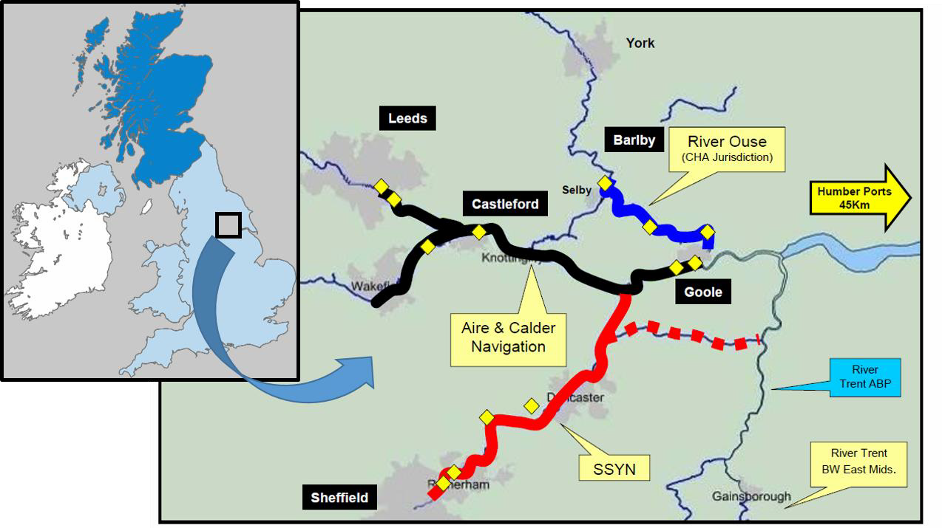
Figure 1: Location of Aire & Calder Canal showing connection with Humber Estuary

In shipping, data from AIS (automatic identification system) offers an interesting possibility to map traffic patterns on the inland waterways today. All ships above 300 GT are obliged to use AIS transponders and transmit messages with short intervals regarding static data (e.g. ship type) and dynamic data (speed, direction etc.). AIS-data has successfully been used by multiple other fields of maritime research, e.g. to measure emissions (Jalkanen et al., 2012), to develop methods to avoid collisions (Qu et al., 2011) or to optimize navigation through ice (Löptien and Axell, 2014). AIS has also been pointed out as a tool for developing traffic statistics (Vierth et al., 2012) and in Santén et al. (2017) Swedish coastal shipping was analysed.

The approach is to use AIS-data to map current traffic on the inland waterways Göta Älv and Vänern and identify traffic pattern in terms of which ports to call, frequency of operations, and types and sizes of vessels operating. This provides a foundation for characterizing traffic patterns and thereby identify how current shipping businesses are set up. AIS-data from the Swedish Maritime Administration 2016, stored at a local database at SSPA, is used in the analysis. For the analysis, software tools are used for the purpose of collecting traffic data for vessel routes operating on the inland waterways, and for visualizing the routes and distribution geographically. Software tools used for these purposes were PgAdmin (PostgreSQL Tool) and QGIS (Open Source Geographic Information system).

AIS-data analysis contributes to understanding current traffic pattern (during 2016) with regards to port calls, vessel types and their capacity, links between ports and the network in which vessels operates. The result show, e.g., the number of inland ports used for cargo vessels operating today and the number of port calls in each port, see Table 2, as well as number and type of vessels calling inland ports, see Figure 2. As evident from the figures, there are limited number of port calls in the area within 2016 (849) in which most vessels are general cargo vessels, and no container vesses. Further details about the traffic in terms of lead time, frequency and time at berth for each port makes it possible to distinguish the service level that are achieved for current goods flows. For a better understanding about the reliability of the service, number of disruptions in operation can be studied by analyzing lead time variations for each link. Links to other ports within Sweden, and the share of traffic calling international ports makes an understanding of how current goods flows utilize the IWT today as well as its network of ports. Figure 3, visualizes how the network of inland waterway ports are connected to ports around the Swedish coast.

Port | Number of departures
Lidköping | 171
Vänersborg | 148
Gruvön | 105
Otterbäcken | 96
Karlstad | 89
Kristinehamn | 82
Sture | 68
Hönsäter | 37
Skattkärr | 16
LillaEdet | 16
Nol | 14
Skoghall | 7
Otterbäcken | 96
Total | 849

Table 1: Ports and number of departures in the Swedish case

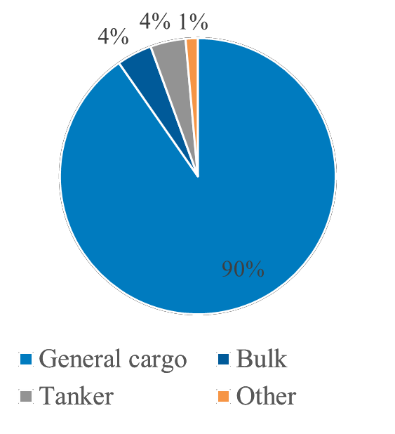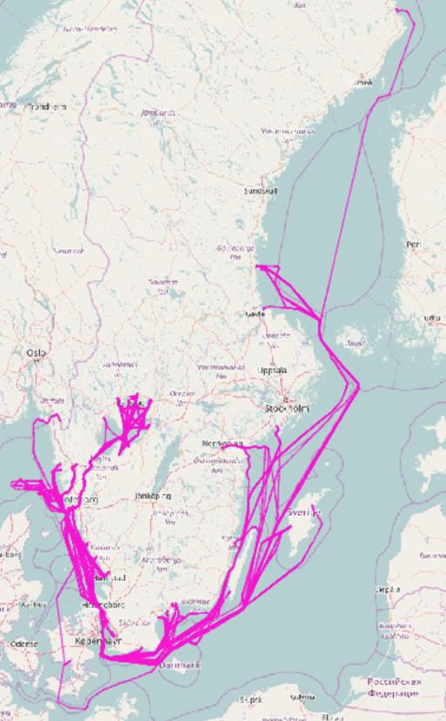

Figure 2: Number of departures per vessel type in Göta Älv river and lake Vänern
Figure 3: Visualisation of the connection between inland waterway ports and ports around the Swedish coast.
In order to provide a deeper understanding of the goods volumes for the operating conditions of IWW shipping, the AIS data analysis could be complemented with port statistics, and from these statistics volumes of unloaded and loaded goods at each port call could be studied.

The Aire & Calder Canal
In support of attempts to improve utilization of the canal for goods transportation, we have adopted two approaches. Firstly, to implement a number of software tools to allow comparison of available transport modes and routes in terms of appropriate indicators and secondly to adopt a coherent approach to identification of candidate goods flows.

Software Tools for Analysis, Visualization and Simulation
We have compared different software packages for visualization and analysis of the capacity of inland waterways. Suitable packages should be able to produce results including flowcharts and route summaries using high-level user interfaces (including terrain features, transport modes and requirements) whilst avoiding the need for extensive low-level programming code. As a result, two packages were identified: Arena (Simio) and R.3.5 (which is open source) and these used for subsequent analysis. Simio has good simulation capability as well as statistic analytics. We have used Simio to investigate by simulation the capacity of the new barges’ including transhipment of goods and vessel traffic control. In the simulation we also include associated freight data flow and have investigated the use of various radio communications technologies (including RFID and LoRaWan to enable internet-based visibility of freight data, via a suitably security-protected Internet-of-Things (IoT) server (The Things Network, TTN).

Geospatial Module for Mapping Route Distance and CO₂ Emission
When attempting to predict the benefits of a potential modal shift from roads to Inland Waterways transport it is necessary to incorporate a geospatial module and database of CO₂ emissions for various engines and fuel types. This functionality is being programmed based on R-Studio software and a Shiny Application is created for easy interface and integration purpose. This geospatial mapping system is a module which can be used in navigation or logistics or similar location-based applications to get real time location, routes and distance and direction data. This data is then plotted onto a map to visualize a route and can be used for real time analytics, statistical analytics or geospatial plotting. The journey time is calculated from real coordinate points along the path. The route is determined by defining the start and destination points, allowing determination of route distance and emission to compare each route. After doing this it is possible to get data just by providing the origin location and destination location. This data is then processed and cleaned to do data analytics and statistical analytics on it. The data point would be plotted according to the route on the map.

A visual animation is provided allowing the user to open a Graphical User Interface (GUI) and specify the starting and end points of the route. When the user hovers their screen pointer over any point plotted along the route, the information including CO₂ emission, distance, speed and time of each journey at that particular point is displayed. There is possibility to add other information, if it is required.

Identification of new freight flows
Three steps to improvement of freight flow on inland waterways may be identified:

- Undertake survey of existing freight flows in the region;
- From above, identify those that have potential for modal shift;
- Identify potential new freight flows into or out of the region.

In support of the third point above we are undertaking an audit of all businesses whose premises are close to the waterways. For each business we identify the volume of goods to be moved, the transhipment potential and the resulting investment that would be needed to implement the modal shift. Figure 4 shows an example of the data extracted, for a short section of the River Hull.
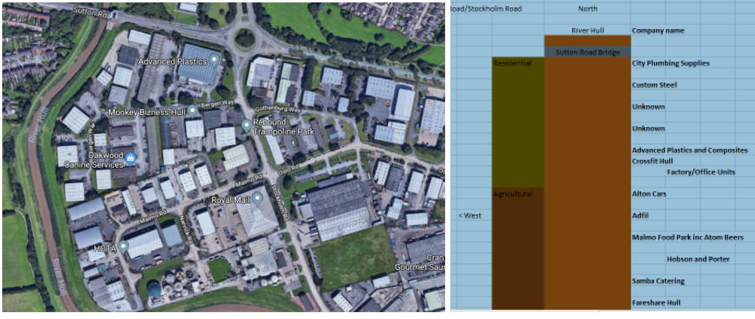
Figure 4: Example of business audit for potential modal shift to waterways

In the Aire & Calder region we have applied the methodology outlined in earlier sections and have identified candidate businesses for modal shift. The next stage is to analyse their transport requirements in further detail and to examine the real-world implications for modal shift. Several lessons have already be learned and many of these arise from detailed practicalities. For example, one company sold land that had access to the canal – this land is now covered in new houses. In another case a short-term successful use of the waterways concluded with scrapping the barges that had been used.

Conclusions
Use of inland waterways for transportation of goods in Sweden and in Great Britain significantly lags behind current best practice in Europe. We have presented experiences from applying approaches for identifying goods flows for modal shifts in two regions (in the UK and in Sweden), in each case providing examples of how the results contribute in the work towards increasing the usage of IWT.

As shown in the Swedish case, analysing AIS-data provides understanding about current traffic situation on the inland waterways related to service level required in today’s shipping as well as the capacity available. Possible parameters to analyse are, for example, no. of port calls, vessel types and their capacity, links between ports as well as the network in which vessels operates. Additional analysis based on AIS-data provides information about lead time, frequency, reliability and time at berth for each port.

In the UK case, software tools incorporating a geospatial module and database of CO₂ emissions for various engines and fuel types are used to visualize and simulate potential benefits of using IWT in a plotted map. Mapped information are, for example, routing, distance, emissions, speed and time of each journey.

Alternative approaches include identifying companies with big goods flows and interviewing them about share of their goods flow with potential for shift to IWW transport; sending survey to companies in geographical areas near the IWW asking for their goods volumes; and survey or interview of forwarders. For information regarding price of transport, time of transport and type of goods, other data sources are needed.

Mapping goods flow to identify goods for a potential modal shift is a step in identifying measures which need to be implemented to improve utilisation of the waterways. In both cases significant work has to be undertaken in order to create any significant impact. Our current EU-sponsored (by Interreg North sea) IWTS-project offers the potential to start to effect such changes.

References
- Andersson, T., Malmquist, M., Johansson, J., Kåregård, A. Ökade godsvolymer på Vänern.
- Andrén, K. & Rexius, L.. (2017), Pilotprojekt GOTA – Rapport 1 - Genomförbarhetsstudie (Pilot Project GOTA - Report 1 – Feasability study), Seadvise, Göteborg, Sweden.
- CBS (2016), http://statline.cbs.nl/statweb/publication/?dm=slnl&pa=83101ned, Centraal Bureau voor de Statistiek, 2017-03-02
- European Commission (2018), Inland Waterways – What do we want to achieve?, https://ec.europ a.eu/transport/modes/inland_en [Accessed 2018-07-01]
- Eurostat (2017), Your key to European Statistics, http://ec.europa.eu/eurostat/web/transport/d ata/main-tables
- Garberg, B. (2016), Regeringsuppdrag: Analys av utvecklingspotentialen för inlands- och kustsjöfart i Sverige (Government investigation - Analysis of the potential for inland and coastal shipping in Sweden), Swedish Maritime Administration, Norrköping.
- Grönvall, E., Johnsson, P. En kartläggning av godsflöde aktuellt för förflyttning från väg til sjö mellan Göteborg och Uddevalla. Bachelor thesis. Chalmers.
- Jalkanen, J. P., Johansson, L., Kukkonen, J., Brink, A., Kalli, J. & Stipa, T. (2012), 'Extension of an assessment model of ship traffic exhaust emissions for particulate matter and carbon monoxide', Atmospheric Chemistry and Physics, Vol. 12, No. 5, pp. 2641-2659.
- Löptien, U. & Axell, L. (2014), 'Ice and AIS: ship speed data and sea ice forecasts in the Baltic Sea',
- The Cryosphere, Vol. 8, No. 6, pp. 2409-2418.
- Meers, D., & Macharis, C. (2015), 'Prioritization in modal shift: determining a region’s most suitable freight flows', European Transport Research Review, Vol. 7, No. 3, pp 23.
- Meers, D., Macharis, C., Vermeiren, T. & van Lier, T. (2017), 'Modal choice preferences in shortdistance hinterland container transport', Research in Transportation Business & Management, Vol. 23, pp.46-53
- Qu, X., Meng, Q. & Suyi, L. (2011), 'Ship collision risk assessment for the Singapore Strait', Accident Analysis and Prevention, Vol. 43, No. 6, pp. 2030-2036
- Rogerson, S., Santén, V., Svanberg, M., Williamsson, J. & Woxenius, J. (2018), 'Modal shift to inland waterways: Dealing with barriers in two Swedish cases', The Logistics Research Network (LRN) conference, Plymouth, 5-7 September
- Santén, V., Svanberg, M., Rogerson, S., Andersson, A. Kartläggning av svensk kustsjöfart genom AIS data. SSPA. Report no. RR41157556-02-00-A.
- Trafikanalys (2016), Godstransporter i Sverige – en nulägesanalys, Rapport 2016:7
- Vierth, I., Mellin, A., Hylén, B., Karlsson, J., Karlsson, R. & Johansson, M. (2012), Kartläggning av godstransporterna i Sverige (Survey of freight transport in Sweden), VTI, Linköping.
- Wiegmans, B., & Konings, R. (2015), 'Intermodal Inland Waterway Transport: Modelling Conditions Influencing Its Cost Competitiveness', The Asian Journal of Shipping and Logistics, Vol. 31 No. 2, pp. 273-294.
- Westin, J. (2016), Fördjupade godsflödesanalyser för Trafikverket region Nord och Mitt (In-depth goods flow analysis for Swedish Transport Administration region North and Middle), CERUM rapport No. 44/2016, Umeå, Sweden.

